

**Goods to Person Order Picking System**

**WCS <-> PLC Interface Specification**

**Toll Fashion GTP**

Dematic Project No. P06418

Dematic Document Ref: P06418_WCS-PLC

Author: Bryan Moutrie

Document Revision: A5

Date: 16/03/2017

Number of Pages: 119



Information in this document is subject to change without notice. No part of this document may be reproduced or transmitted in any form or by any means, electronic or mechanical, for any purpose, without the express written permission of Dematic.

© 2017 Dematic Pty. Ltd. All rights reserved

This document contains confidential information, trade secrets and/or know-how which is the property of Dematic, and may not be disclosed to any third party without the written permission of Dematic.

Product and company names herein may be the trademarks of their respective owners.

Dematic Pty. Ltd.

24 Narabang Way

Belrose

NSW 2085

Australia

ABN: 43 118 204 425

Tel: +61 2 9486 5555

www.dematic.com.au

Release Dates

| Release | Release Date | Author | Section | Description |
| --- | --- | --- | --- | --- |
| A1 | 2016-9-15 | BMo | All | Initial Draft |
| A2 | 2016-9-29 | BMo | All | Updated Topological Layout |
| A3 | 2016-10-26 | BMo | Throughout  5.3.3, 5.3.4.3  5.6.4.3,  Table 45  5.6.3  5.5.3, 5.5.4.2  4.1.8.2  5.2.3, 5.4.3,  5.8.3  6  4.1  4.1.3  3.5, Table 1  4.2.11.4.7,  5.7.4.2  4.1.8.3.1  4.1.7.5  5.2.3, 5.4.3,  5.8.3 | Area naming changes:   * Invoicing 🡪 Documentation * Satchel 🡪 Packing Station * Pack and Hold 🡪 Despatch Buffer   Additional messaging point locations on  RapidPick tote outfeed for over height  Carrier types/sizes added for cartons  with normal lid or coloured lid  LPA locations moved  GOH line revised with eCommerce  document inserters  Handling flex locations section added  Multishuttle messaging sequence  amended  Diagrams updated to match document  Struck out N/A DCI messages and codes  Corrected DCI deleted/lost behaviour  Updated port number to 2001 (from 102)  Height, Length and Width fields added to  DATCOM telegram  Pass-through mission sequence  amended to three missions  BO, BE, SN, DN should be valid event  codes for inter-aisle transfer  WCS not to send TUMI at drop station |
| A4 | 2017-02-20 | PSmy | Various | Internal review and update |
| A5 | 2017-03-16 | DFO | Telegram size & Lip messages | Internal review and update |

Referenced Documents

| Ref | Document Reference | Rev | Source | Document Name |
| --- | --- | --- | --- | --- |
|  | DCI_Common_V1.43_en.pdf | 1.43 | Holger Cremer  EU R&D  Dematic | Common Definitions Dematic Controls Interface (DCI) |
|  | DCI_Transport_V1.33_en.pdf | 1.33 | Holger Cremer  EU R&D  Dematic | General Transport Telegrams Dematic Controls Interface (DCI) |
|  | DCI_MSC_V1.52.1_en.pdf | 1.52.1 | Holger Cremer  EU R&D  Dematic | Multishuttle Control System (MSC) Dematic Controls Interface (DCI) |
|  | | | | |

Approvals

| Dematic Approvals | |
| --- | --- |
|  |  |
| **Name** | Richard Masters |
|  |  |
| **Title** | Project Manager |
|  |  |
| **Company** | Dematic Pty. Ltd. |
|  |  |
| **Signature** |  |
|  |  |
| **Date** |  |
|  |  |
|  | |
|  |  |
|  |  |
|  |  |
|  |  |
|  |  |
|  |  |
|  |  |
|  |  |
|  |  |
|  |  |

Contents

1 Scope and Intended Reader 1

1.1 Purpose 1

1.2 Scope 1

1.3 General 1

1.4 Intended Audience 1

2 Glossary of Terms 2

2.1 Abbreviations & Definitions 2

3 Network Connections 3

3.1 Physical Network 3

3.2 Network Protocol(s) 4

3.3 Client / Server Model 4

3.4 Dual Redundant WCS Nodes 5

3.5 Establishing the Connection(s) 5

3.6 Physical MHE Start-up and Shutdown 6

4 Messaging Protocol(s) 7

4.1 DCI Protocol 7

4.2 DATCOM Protocol 36

5 Material Flow and Control 52

5.1 System Overview 52

5.2 Multishuttle (Order Buffer) 55

5.3 Order Fulfilment 59

5.4 Multishuttle (Product) 68

5.5 Finishing 71

5.6 Documentation & Lidding 76

5.7 Sorter 83

5.8 Multishuttle (Despatch Buffer) 86

5.9 Decant 89

6 Conveyor Layout & Messaging Points 94

6.1 System Overview 0

6.2 Multishuttle (Order Buffer) 1

6.3 Order Fulfilment 3

6.4 Multishuttle (Product) 8

6.5 Finishing 9

6.6 Documentation & Lidding 10

6.7 Sorter 13

6.8 Multishuttle (Despatch Buffer) 15

6.9 Decant 16

List of Tables

Table 1 Connection Configuration 5

Table 2 Network Addressing 6

Table 3 DCI start-up and restart procedure 8

Table 4 DCI data default 9

Table 5 DCI message structure 10

Table 6 Message return codes 11

~~Table 7 SETT message structure~~ 13

Table 8 TU message structure 14

Table 9 STRQ message structure 18

~~Table 10 FTRQ message structure~~ 19

~~Table 11 FTDF message structure~~ 20

~~Table 12 STMF message structure~~ 21

~~Table 13 LORQ message structure~~ 21

Table 14 Multishuttle transport mission types 26

Table 15 TU message structure – Multishuttle 28

Table 16 STAT message structure – Multishuttle 29

Table 17 Additional Multishuttle STAT objects 30

Table 18 STAX message structure – Multishuttle 31

~~Table 19 SETD message structure – Multishuttle~~ 32

~~Table 20 DCRQ message structure~~ 32

~~Table 21 DCSH message structure~~ 33

~~Table 22 DCSH message structure~~ 33

Table 23 Summary of included DCI telegrams 34

Table 24 TU event codes 35

Table 25 PLC States 36

Table 26 General Telegram Format 41

Table 27 Telegram Header 41

Table 28 Telegram Tail 42

Table 29 Material Flow Telegram 42

Table 30 Unit Load Status 43

Table 31 Profile Status ASCII equivalents 44

Table 32 Profile Status Bits 45

Table 33 System Status Message 45

Table 34 System Status 46

Table 35 Equipment Status Message 47

Table 36 Function group status 47

Table 37 Empty tote line fill level 47

Table 38 Conveyor loop running status 48

Table 39 Empty carton induction running status 48

Table 40 Carton sizes available from carton erector 48

Table 40 Start Stop Format 49

~~Table 41~~ ~~Equipment Status Message~~ 50

~~Table 42~~ ~~Alarm Status~~ 50

Table 43 Summary of DATCOM Messages 51

Table 45 Materials to be handled 53

Table 45 Multishuttle (Order Buffer) PLC(s) 55

Table 46 Functional Groups - Multishuttle (Order Buffer) 55

Table 47 Messaging Points - Multishuttle (Order Buffer) 56

Table 48 Order Fulfilment PLC(s) 59

Table 49 Functional Groups – Order Fulfilment 59

Table 50 Order Fulfilment functional group match table 59

Table 51 Messaging Points – Order Fulfilment 60

Table 52 Carton sizes available from carton erector 62

Table 53 Carton size to be made by carton erector 63

Table 54 Multishuttle (Product) PLC(s) 68

Table 55 Functional Groups - Multishuttle (Product) 68

Table 56 Messaging Points - Multishuttle (Product) 69

Table 57 Finishing PLC(s) 71

Table 58 Functional Groups – Finishing 71

Table 59 Messaging Points – Finishing 72

Table 60 Online Order PLC(s) 76

Table 61 Functional Groups – Documentation & Lidding 76

Table 62 Messaging Points – Documentation & Lidding 77

Table 63 Sorter PLC(s) 83

Table 64 Functional Groups – Sorter 83

Table 65 Messaging Points – Sorter 84

Table 66 Multishuttle (Despatch Buffer) PLC(s) 86

Table 67 Functional Groups - Multishuttle (Despatch Buffer) 86

Table 68 Messaging Points - Multishuttle (Despatch Buffer) 87

Table 69 Decant PLC(s) 89

Table 70 Functional Groups – Decant 89

Table 71 Messaging Points – Decant 90

# Scope and Intended Reader

## Purpose

The purpose of this document is to describe the interface between the WCS and the Dematic conveyor control PLCs within the TOLL – Fashion automated Goods to Person System.

## Scope

This document defines the WCS-PLC interface, which is concerned with:

* Establishing a communication connection between the two systems.
* Initialising the level 3 systems (PLC) during ‘Start-Up’.
* The messages that are passed between the two systems during normal operations.
* Exception conditions.

## General

The initial sections of this document describe the general procedures for communications between the WCS and the PLCs, and apply for all PLCs. There is then a section for each area controlled by a PLC, defining the interface-related functionality for the PLC in that area. There is then a detailed definition of each message.

## Intended Audience

The intended readers of this document are:

* Dematic Project Team
* DAI Project Team

# Glossary of Terms

## Abbreviations & Definitions

|  |  |
| --- | --- |
| Term | Definition |
| TCP/IP | Transport Control Protocol/Internet Protocol |
| LAN | Local Area Network |
| ISO TCP | Implementation of RFC1006 additional protocol layer on standard TCP/IP protocols. |
| HMI | Human Machine Interface |
| LHD | Load Handling Device |
| IT | Information Technology |
| WCS | Warehouse Control System |
| MHE | Materials Handling Equipment |
| PE | Photo-Electric Cell |
| PLC | Programmable Logic Controller |
| MFC | Material Flow Controller |
| ASRS | Automated Storage and Retrieval System |

# Network Connections

## Physical Network

The WCS is connected to each PLC by means of an Ethernet LAN supporting the ISO on TCP protocol. Figure 1 below shows a high-level network overview of the system. Details of the network are described in the rest of this section.

**NOTE:** Not all PLCs may use the ISO on TCP layer. Some may use native TCP/IP.

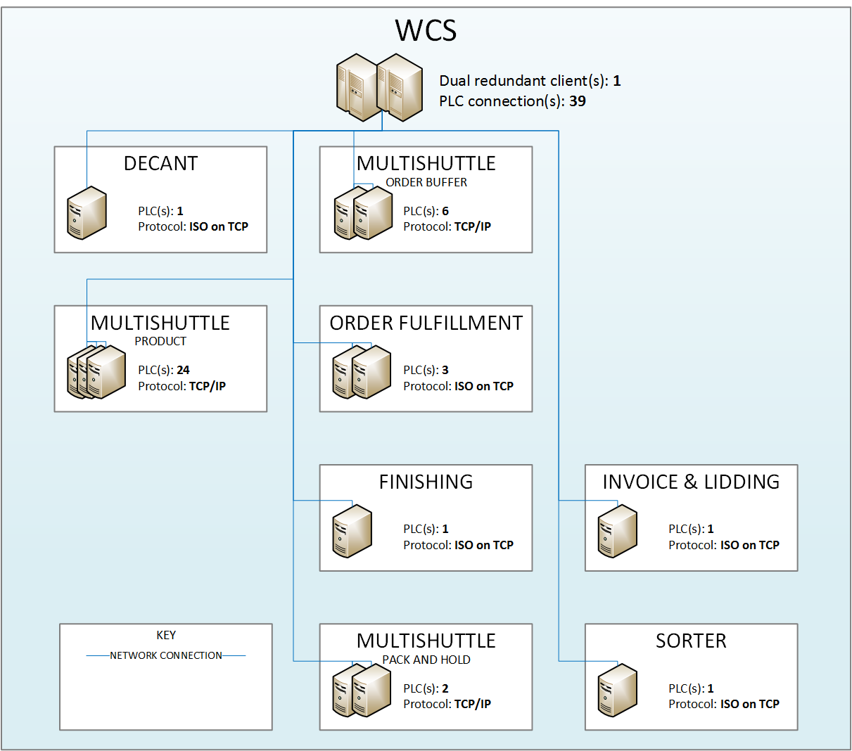

Figure 1 Network overview

### Physical Connections

Each PLC is connected to the LAN via an RJ45 UTP twisted pair connector. All Ethernet LAN network equipment and cabling is provided by Toll.

## Network Protocol(s)

The following network protocol(s) are to be used:

### ISO on TCP

A single bi-directional socket is implemented to support the message exchange between each PLC and the WCS. This socket connection supports dual bi-directional communication for ISO on TCP protocols, so messages may flow in both directions.

ISO on TCP is a reliable connection-orientated protocol, which guarantees the integrity of messages that are delivered from one connection partner to the other. Implementation of RFC1006 provides additional handshaking and message length data to applications at either end of the link.

All messages are acknowledged automatically as part of the TCP/IP protocol, and if there is an error or corruption in a message, then the message is re-sent (at the TCP/IP level); this is transparent to the application.

### TCP/IP

For some PLCs RFC1006 may be omitted. In this case pure TCP/IP connection is used. Therefore both communication partners have to deal with uncompleted messages and more than one message in one block.

All messages are acknowledged automatically, and if there is an error or corruption in a message, then the message is re-sent; this is transparent to the application.

## Client / Server Model

The Client / Server model defines the status of the individual connection partners within a system.

The Server passively waits for connection requests from a Client and when such a request is received, a connection is negotiated. The Client actively makes a request for a connection with the Server. Either partner may close the connection. Once a connection is established, messages may flow in either direction.

Each PLC will act as a Server and the WCS as the Client for the purposes of establishing connections in this system. The WCS Client will normally be the partner to close connections.

## Dual Redundant WCS Nodes

Two WCS machines shall be used in a dual redundant arrangement, with one duty node and one standby node.

Only the duty WCS node will open communications with each PLC. The standby WCS node will not attempt to open communications to each PLC. Under normal operation it is not permitted for one WCS node to become duty node if there is already a WCS node running in duty mode. Only in very exceptional circumstances e.g. the inter-machine link between WCS nodes fails and both nodes believe they are the duty server, will each node attempt to connect to the PLC.

If the PLC has healthy links to a WCS node already open, it will refuse connections from the remaining WCS node.

## Establishing the Connection(s)

Each PLC will be interfaced to the WCS via a TCP/IP socket connection. The duty WCS will request a TCP connection from each PLC, which will then acknowledge the request and make the connection.

In addition, where advised, the RFC1006 protocol shall be implemented by the WCS. This protocol will be implemented on the PLC side by configuring the connection as an ISO on TCP connection. The WCS will then send a Connection Request to the PLC to establish an RFC1006 protocol connection. The PLC acknowledges with an RFC1006 Connection Confirm. The connection is then ready for message exchange.

Table 1 below shows the configuration for the network connections:

Table 1 Connection Configuration

| **SUBSYSTEM**  **NAME** | **CABINET**  **NAME** | **PLC**  **TSAP ID/**  **PORT** | **WCS**  **TSAP ID/ PORT** | **CONNECTION**  **TYPE** |
| --- | --- | --- | --- | --- |
| Multishuttle – Product | *n*E1* | 2001 | 2001 | TCP/IP |
| Multishuttle – Despatch Buffer | *p*E1# | 2001 | 2001 | TCP/IP |
| Multishuttle – Order Buffer | *q*E1† | 2001 | 2001 | TCP/IP |
| Order Fulfillment | CC51 | ‘PLC51’ | ‘WCS51’ | ISO on TCP |
| Order Fulfillment | CC52 | ‘PLC52’ | ‘WCS52’ | ISO on TCP |
| Order Fulfillment | CC53 | ‘PLC53’ | ‘WCS53’ | ISO on TCP |
| Finishing | CC54 | ‘PLC54’ | ‘WCS54’ | ISO on TCP |
| Documentation & Lidding | CC61 | ‘PLC61’ | ‘WCS61’ | ISO on TCP |
| Sorter | CC62 | ‘PLC62’ | ‘WCS62’ | ISO on TCP |
| Decant | CC63 | ‘PLC63’ | ‘WCS63’ | ISO on TCP |

\**n* = all integers from 01 to 24 inclusive (fixed 2 digits)  
#*p* = all integers from 25 to 26 inclusive  
†*q* = all integers from 27 to 32 inclusive

Table 2 below shows the network addressing for the PLCs:

Table 2 Network Addressing

| **SUBSYSTEM**  **NAME** | **CABINET**  **NAME** | **IP ADDRESS** | **SUBNET MASK** | **GATEWAY ADDRESS** |
| --- | --- | --- | --- | --- |
| Multishuttle – Product | *n*E1* | TBA | TBA | TBA |
| Multishuttle – Despatch Buffer | *p*E1# | TBA | TBA | TBA |
| Multishuttle – Order Buffer | *q*E1† | TBA | TBA | TBA |
| Order Fulfillment | CC51 | TBA | TBA | TBA |
| Order Fulfillment | CC52 | TBA | TBA | TBA |
| Order Fulfillment | CC53 | TBA | TBA | TBA |
| Finishing | CC54 | TBA | TBA | TBA |
| Documentation & Lidding | CC61 | TBA | TBA | TBA |
| Sorter | CC62 | TBA | TBA | TBA |
| Decant | CC63 | TBA | TBA | TBA |

\**n* = all integers from 01 to 24 inclusive (fixed 2 digits)  
#*p* = all integers from 25 to 26 inclusive  
†*q* = all integers from 27 to 32 inclusive

## Physical MHE Start-up and Shutdown

Physical start-up and shutdown of the conveyors is performed locally, either by a button connected to a PLC, or using the SCADA System. This is performed separately for each PLC. There is no control to allow the WCS to start-up or shutdown conveyors.

# Messaging Protocol(s)

## DCI Protocol

### Overview

The DCI protocol can be used over ISO on TCP and TCP/IP connections within an Ethernet Local Area Network (LAN). Using the DCI protocol, multiple telegrams can be sent as one message (called blocking). The DCI standard defines a number of telegram categories, including ones that extend others.Those which are included in this system are:

* Common (Detailed in Reference Document 1)
* General Transport (Detailed in Reference Document 2)
* Multishuttle (Detailed in Reference Document 3)

If the WCS detects a communications failure to any PLC, the WCS should log this and then attempt to re-connect (automatically or manually). The WCS must always send a disconnect message before a connection request, even at initial start-up.

The PLCS are independent as far as routing control is concerned.

i.e. If the WCS can communicate with a PLC then it can control routing of unit loads on this PLC, regardless of the state of other PLCS.

### Start-up and Restart

Table 3 below describes the start-up and restart sequence when WCS and the PLC are connected.

Table 3 DCI start-up and restart procedure

| **Step** | **WCS events** | **PLC events** | **Description** |
| --- | --- | --- | --- |
| 0 |  |  | No communication between WCS and PLC. |
| 1 |  | TCP/IP listen (passive) | PLC is online. |
| 2 | TCP/IP connect (active) |  | WCS establishes a connection to the PLC. |
| 3 | Unacknowledged messages are sent | Unacknowledged messages are sent | Both parties send any unacknowledged message to the other party. |
| 4 | Un-transmitted messages | Un-transmitted messages | Both parties send any un-transmitted messages. The respective receiver acknowledges the receipt. |
| 5 | Status request of the entire system |  | WCS requests any status information. |
| 6a |  | Status messages (STAT) of device is sent | Availability information is sent for each device or device group. |
| ~~6b~~ |  | ~~Status messages (STFI) of filling levels are sent~~ |  |
| ~~6c~~ |  | ~~Status messages (STMF) of material flow is sent (optional)~~ |  |
| 6d |  | End of status messages (STEN) is sent | All status messages are sent. |
| ... | ... | ... | Normal operation. |

### Carriers Deleted by the PLC

At any position in the system the PLC may send a TUCA – Transport Unit Cancel with status ‘MA’. This indicates a carrier has been manually deleted by the conveyor PLC.

Status ‘MA’ stands for manual intervention and will only be sent as a result of an operator action to delete a carrier. This would typically occur at a messaging point where no transport order has been received or there is a mechanical issue with equipment.

When the WCS receives an TUCA with status ‘MA’ for a tote / carton it should set the tote/carton to missing until is reappears at a downstream messaging point and sends a TUDR.

### Remap

The WCS maintains information of all active carriers in the system. If the connection between the WCS and the PLC(s) is lost then the WCS must be resynchronised with the PLC(s). This requires the details of selected carriers on the system to be sent by the PLC to the WCS. The types of locations for which remap data will be sent are:

* All locations in Multishuttle subsystems

A LORQ – Location Request is sent by the WCS for each remap location. For each of the locations listed above, the PLC responds with a TUNO – Transport Unit Notification Message. The message contains all the details about the carrier. If the location is empty, default data is sent.

### Messaging

#### Structure

All messages have the same structure, this consists of: a header, a body and a footer. Messages use the ISO-8859-15 character set, though not printable or readable characters should be avoided. If a field is not completely filled, the following default data should be used as in Table 4:

Table 4 DCI data default

|  |  |  |
| --- | --- | --- |
| **Type** | | **Dara default** |
| A | Alphanumeric | Significant character left-justified filled with “.” (dots), e.g.  “CCPI02NP01....” |
| N | Numeric | Significant character right-justified filled with “0” from beginning, e.g. “00003142” |

The DCI message structure is shown in Table 5 on the next page.

Table 5 DCI message structure

|  |  |  |  |  |
| --- | --- | --- | --- | --- |
| **Byte** | **Name** | **Type** | **Length** | **Description** |
| 01 | Start of message | A | 1 | “/” |
| 02 | Flow control | A | 1 | “.” = no acknowledge required  “R” = acknowledge required  “A” = acknowledge flag |
| 03-06 | Message name | A | 4 | Name of message. See Table 23. |
| 07-10 | Sender | A | 4 | Sender-ID of message.  For example: “WCS1” |
| 11-14 | Receiver | A | 4 | Receiver-ID of message.  For example: “CC01” |
| 15-18 | Cycle number | N | 4 | Number of message, starts with “0001”. It is incremented (general +1) by sender for every new message. If a message is repeated, the number will not be incremented.  Note: It is possible that increments can be greater than 1, skips are allowed. No synchronization mechanism is needed or required, no detection of skips. Cycle number just identifies a given message. The cycle number will continue after re-connection and not be reset. Upon an overflow it starts with “0001” again. |
| 19-20 | Return code | A | 2 | Return value. See  Table 6 below. |
| 21-22 | Number of blocks | N | 2 | Number of blocks used in the message. It is used to have the ability to pack multiple messages in a single message. If “00”, no message body is used. |
| 23-24 | Type of blocks | A | 2 | “NG” = no logical grouping (default)  “LG” = logical grouping of blocks. See part 4.1.5.2. |
| 25-28 | Length of message | N | 4 | Length of the entire message in bytes including all blocks, the SOM and EOM characters. |
|  | *Message body* |  | *n* | *Content of message.* |
| n+ 29-30 | End of message | A | 2 | "##" |

Table 6 Message return codes

| **Return codes** | **Description** |
| --- | --- |
| “OK” | No error occurs. |
| “MU” | Message name is unknown. The message is not processed any further. |
| “SU” | Sender-ID is unknown. The message is not processed any further. |
| “RU” | Receiver-ID is unknown. The message is not processed any further. |
| “LE” | Length of message doesn’t fit. The message is not processed any further. |
| “BF” | Receive buffer capacity exhausted. The sender must buffer the message and repeat it until it can be accepted by the receiver. The waiting time between a repetition is 30 sec. |
| “GE” | General protocol error, all errors not specified above. The message is not processed any further. |

In the case an error is detected within the header, the specified response is sent to the sender and the message will be rejected by receiver. After an error has been detected the processing of messages continues as usual.

**NOTE:** Re-transmissions are acknowledged with “OK”.

#### Blocking mechanism

To include more than one message body (telegram) in one message (one header), the following two options can be used:

* Without logical grouping
  + Used to reduce message traffic. Each message body is kept separate and is not logical interlinked with the others.
  + Header settings: Number of blocks >= “02” Type of blocks = “NG”
* With logical grouping
  + Used to process several messages together.
  + Header settings: Number of blocks >= “02” Type of blocks = “LG”  
      
    If no blocking is used, i.e. if the number of blocks is 1, the ‘Type of Block’ is set to “NG”.  
      
    The PLC sends blocked messages with logical grouping automatically if more than one Transport Units handled simultaneously. This is carried out when:
    - More than one TUs picked or dropped in one fork cycle or
    - More than one TUs notified at Pick Station.

**NOTE:** Even if the transport missions from WCS are grouped – especially logical blocked – their execution by PLC might be done independent from each other.

#### Message buffer

Messages generated by the PLC for locations in which no remap data is sent to the WCS will be buffered until they are successfully sent to the WCS. In the event of a communications loss to the WCS, these messages will be preserved and sent when communications are re-established.

In the case the message buffer within the PLC is full and no TU response message could be sent to WCS, the PLC stops order processing and all movements in a defined position. This scenario might happen if the PLC loses connection to the WCS.

In general the size of the message buffer depends on the physical memory size of the PLC.

#### Message showers

Message showers issued by a misbehaving communication partner can cause significant negative impact on the overall operation of the receiving system (denial of service attack).

The receiver can declare a telegram as “bougs” when it has the identical user data (header is not considered) as its predecessor and is received within less than 1s after its predecessor.

“Bogus” telegrams are disregarded, i.e. no further logical processing happens on the receiver side. An acknowledgement with EventCode “General Error” (GE) is sent.

#### Message acknowledgment

The sender is able to force a logical acknowledgement for a message from the receiver by setting the Flow Control.

The acknowledgement message means that the partner has received and stored the message persistently. It does not mean that he has processed the message. Processing happens after sending the acknowledgement.

Do not mix up the acknowledgement with a confirmation or completion message which is sent after the receiver has performed the required action!

When acknowledgement is turned on, the sender will wait for an acknowledgement before he sends the next message over this logical channel. The same message is sent after timeout (~ 30 s).

The acknowledgement message must use the same sequence number as the message to be acknowledged. Only header including SOM and EOM characters without body will be sent.

It is allowed to mix messages requiring acknowledgement and not requiring acknowledgement. Messages not requiring an acknowledgement must be delayed until a still pending acknowledgement from a previous message (requiring an acknowledgement) has been received.

### Common

#### ~~SETT – Set Date & Time~~

~~Sender: WCS Receiver: PLC~~

~~This message is used to synchronize Date and Time between WCS and PLC. If this message is received by the PLC it changes Date and Time to the specified values.~~

~~Table 7 SETT message structure~~

|  |  |  |  |  |
| --- | --- | --- | --- | --- |
| **~~Byte~~** | **~~Name~~** | **~~Type~~** | **~~Length~~** | **~~Description~~** |
| ~~01-28~~ | ~~Header~~ |  |  | ~~See Table 5 DCI message structure~~ |
| ~~29-36~~ | ~~Date~~ | ~~A~~ | ~~8~~ | ~~YYYYMMDD~~  ~~“YYYY” = 2016-nnnn (year)~~  ~~“MM” = 01-12 (month)~~  ~~“DD” = 01-31 (day)~~ |
| ~~37-42~~ | ~~Time~~ | ~~A~~ | ~~6~~ | ~~HHMMSS~~  ~~“HH” = 00-23 (hour)~~  ~~“MM” = 00-59 (minutes)~~  ~~“SS” = 00-59 (seconds)~~ |
| ~~43-44~~ | ~~Footer~~ |  |  | ~~See Table 5 DCI message structure~~ |

#### LIVE – Watchdog

Sender: WCS/PLC Receiver: PLC/WCS

This message is sent if there are no other messages to be sent within a defined timeframe (30 seconds). It provides a means for detecting the loss of a connection.

This message has to be sent by WCS and PLC as well and has to be acknowledged from the respective partner. No message body is required.

If no response could be received it will be repeated (default value 3 times). If there is still no response, the connection is considered as down (‘Offline’).

In the case the connection is down the HMI provides information about the connection status onto a screen. The communication partner which detects the missing acknowledgement will close the connection. The active partner will try to establish it again. Both partners shall provide an additional alarm and/or information.

This procedure continues until the connection is re-established. No manual intervention is necessary.

### General Transport

#### General transport message structure

This message structure is used for various transport unit (TUxx) messages. The TU message may be extended with additional fields for specific applications:

Table 8 TU message structure

|  |  |  |  |  |
| --- | --- | --- | --- | --- |
| **Byte** | **Name** | **Type** | **Length** | **Description** |
| 01-28 | Header |  |  | See Table 5 DCI message structure |
| 29-42 | Source location | A | 14 | Origin location of the TU which is used for information and further tracking (log file) only. It is filled by WCS and copied by PLC. |
| 43-56 | Current location | A | 14 | Current location of the TU. This field is updated by PLC and initially filled by WCS. |
| 57-70 | Destination location | A | 14 | Destination location of the TU to which it is to be transported. |
| 71-92 | TU identifier | A | 22 | Unique number of the TU. |
| 93-96 | TU type | A | 4 | Type of the TU. See Table 45. |
| 97-100 | TU length (xExtension) | N | 4 | Length of TU (direction of transport) in mm. Integer values only. |
| 104 | TU width (zExtension) | N | 4 | Width of TU in mm. Integer values only. |
| 105-108 | TU height (yExtension) | N | 4 | Height of TU in mm. Integer values only. |
| 109-116 | TU weight | N | 8 | Weight of TU in gram. Integer values only. |
| 117-118 | Event code | A | 2 | Status of transport. See Table 24 below. |
|  |  |  | *n* | *System specific message (optional)* |
| n+ 119-120 | Footer |  |  | See Table 5 DCI message structure |

#### TUMI – Transport Unit Mission

Sender: WCS Receiver: PLC

This message is used to send a new transport mission to the PLC or to update an existing one.

An update could be sent by the WCS at any time. Depending on the current lo-cation the PLC decides if the transport mission can be executed or not. If execution is not possible the PLC rejects the mission for formal errors by using the event code (TUEX).

Event code(s): OK

#### TURP – Transport Unit Mission Report

Sender: PLC Receiver: WCS

This message is used as the response of a transport mission from WCS in the case the TU arrives at destination.

This message name is used for positive acknowledgements only. In any other cases TUEX has to be used.

Current location: Here always destination location

Event code(s): OK, MA (to finalise normal operation)

#### TUNO – Transport Unit Notification Message

Sender: PLC Receiver: WCS

This message is used to notify the TU during travel to destination at specified notification points or sent by PLC due to a spontaneous event. This message is optional as long as it is not sent in combination with a TUEX in an abnormal situation.

It is also used to inform the WCS after its request about the location (Current Location) status.

Current location: Updated by the PLC

TU identifier: Filled with default data if location is not occupied.

TU type: Filled with default data if location is not occupied.

TU length: Filled with default data if location is not occupied.

TU width: Filled with default data if location is not occupied.

TU height: Filled with default data if location is not occupied.

TU weight: Filled with default data if location is not occupied.

Event code(s): OK, MA (could be initiated by WCS (TUMI) or from the local visualisation of the PLC)

#### TUEX – Transport Unit Mission Exception

Sender: PLC Receiver: WCS

This message is used as a negative response of a transport mission.

In combination with other simultaneous response messages (TUNO) for Load Handling Devices with more than one TU TUEX is always the last message which is sent by the PLC.

As long as the mission is not started and an exception occurs (TUEX) with event code, the mission will be rejected and not stored. In the case the mission is al-ready started, the mission is stopped and the PLC waits for response from WCS (TUMI).

Event code(s): SE, CE, DE, TU, TH, TS, ~~TW~~, ~~TY~~, ~~TQ~~, ~~ME~~, SN, DN, DU, BO, BE, ~~DO~~, ~~PE~~, MX, ~~BF~~, GE

**NOTE:** There is an ambiguity using event codes for sizing errors:

* For conveyor systems “ME” (in conjunction with the contour bits) is used at an induct station.
* Vehicle like systems (i.e. stacker cranes and Multishuttle) use the more general event codes “TW”, “TS” and “TH”.

**NOTE:** Event codes BO, BE, SN, DN shall be used at inter-aisle transfer locations, despite if Reference Document(s) may say otherwise.

#### TUDR – Transport Unit Destination Request

Sender: PLC Receiver: WCS

This message is used by the PLC to request a destination at any possible location from WCS in the case it is unknown. This should only happen in abnormal situations.

TUDR should not be used to request the next destination if the transport unit arrives its current destination. Use TURP instead.

Destination: Always ‘??????????????’

TU identifier: In anomaly situations it might happen that the TU ID is unknown by the PLC. If this happens a dummy ID is generated and sent by PLC:

“UF-<ppp>-<nnnn>” for unknown units on a location (e.g. TU ID was deleted manually)

“NR-<ppp>-<nnnn>” for units which cannot scanned by an barcode reader (NoRead)

<ppp> = unique PLC number

<nnnn> = running number (“0001” – “9999”)

**NOTE:** The TU identifier, created by the PLC, is a dummy number at this location. If possible this number will be tracked within the PLC, if not (new scanner) another ID will be created. The ID cannot be overwritten by the WCS.

Event code(s): OK, MA (to finalise normal operation), ~~PC~~, ~~PA~~

#### ~~TULL – Transport Unit Left Location~~

~~Sender: PLC Receiver: WCS~~

~~This message is used to inform the WCS that a TU has left its current location or an area. Typically used on infeed or outfeed locations.~~

~~Current location: Location which has been left by the TU~~

~~Event code(s): OK, MA (to finalise normal operation)~~

#### TUMC – Transport Unit Mission Cancel

Sender: WCS Receiver: PLC

This message is used to cancel a mission by the WCS.

Event code(s): OK

**NOTE:**  No special identifier for mission is needed. The mission is identified with the TU identifier.

#### TUCA – Transport Unit Cancel

Sender: PLC Receiver: WCS

This message informs the WCS about a mission cancel which could be initiated locally or from WCS.

Event code(s): OK, ~~MS~~, MI, MA, GE

**NOTE:**  No special identifier for mission is needed. The mission is identified with the TU identifier.

**NOTE:**  If the PLC deletes old missions the WCS is not informed about (no TUCA is sent).

#### STRQ – Status Request

Sender: WCS Receiver: PLC

This message is used by the WCS to request status information of a special device, group or the entire system. It causes status messages and / or material flow messages depending on the requested device from the PLC.

Table 9 STRQ message structure

|  |  |  |  |  |
| --- | --- | --- | --- | --- |
| **Byte** | **Name** | **Type** | **Length** | **Description** |
| 01-28 | Header |  |  | See Table 5 DCI message structure |
| 29-42 | Device identifier | A | 14 | Identifier of requested device. The device names are the location names.  If ID = “ALL” then the status information from all devices are requested. |
| 43-44 | Footer |  |  | See Table 5 DCI message structure |

#### STAT – Status Message

Sender: PLC Receiver: WCS

See the Multishuttle STAT message (4.1.8.5) for a Multishuttle-specific description.

#### STAX – Extended Status Message

Sender: PLC Receiver: WCS

See the Multishuttle STAX message (4.1.8.6) for a Multishuttle-specific description.

#### ~~FTRQ – Fault Text Request~~

~~Sender: WCS Receiver: PLC~~

~~Requests the text for a Fault Code.~~

~~This telegram can be sent manually by the WCS or when encountering a Fault Code for which no fault text exists within the WCS.~~

~~The PLC answers with a FTDF telegram for all requested ‘Fault Code’ / ‘Language’ combinations.~~

~~Table 10 FTRQ message structure~~

|  |  |  |  |  |
| --- | --- | --- | --- | --- |
| **~~Byte~~** | **~~Name~~** | **~~Type~~** | **~~Length~~** | **~~Description~~** |
| ~~01-28~~ | ~~Header~~ |  |  | ~~See Table 5 DCI message structure~~ |
| ~~29-34~~ | ~~Fault Code~~ | ~~N~~ | ~~6~~ | ~~Fault code for which the fault text requests is sent.~~  ~~If 0, the PLC will send the fault texts for all known Fault Codes.~~ |
| ~~35-42~~ | ~~Langyage~~ | ~~A~~ | ~~8~~ | ~~Language according to IS0 639 / ISO 3166. Examples: en, de, fr, en_GB (British English).~~  ~~If empty the PLC will send fault text for all known languages.~~ |
| ~~43-44~~ | ~~Footer~~ |  |  | ~~See Table 5 DCI message structure~~ |

~~It is assumed that all PLCs of the same type will reply with identical texts, e.g. when having 10 PLCs controlling 10 Multishuttle aisles, all of the return the identical fault codes and their corresponding texts. As a consequence, it is sufficient to requests the texts from one aisle (e.g. aisle 1).~~

#### ~~FTDF – Fault Text Definition~~

~~Sender: PLC Receiver: WCS~~

~~As a consequence of a FTRQ telegram, the PLC reports fault text to the WCS.~~

~~If technically possible, this telegram could also be sent unsolicited by the PLC when a text changes.~~

~~In order to increase network communication efficiency, FTDF should blocked without logical grouping (‘NG’). See 4.1.5.2 for further details~~

~~Table 11 FTDF message structure~~

|  |  |  |  |  |
| --- | --- | --- | --- | --- |
| **~~Byte~~** | **~~Name~~** | **~~Type~~** | **~~Length~~** | **~~Description~~** |
| ~~01-28~~ | ~~Header~~ |  |  | ~~See Table 5 DCI message structure~~ |
| ~~29-34~~ | ~~Fault Code~~ | ~~N~~ | ~~6~~ | ~~Fault code for which the text is sent.~~ |
| ~~35-42~~ | ~~Language~~ | ~~A~~ | ~~8~~ | ~~Language according to IS0 639 / ISO 3166.~~ |
| ~~43-44~~ | ~~Event Code~~ | ~~A~~ | ~~2~~ | ~~OK: the requested text could be found~~  ~~NF: invalid fault code value~~  ~~NL: language unknown~~ |
| ~~45-54~~ | ~~Character Set~~ | ~~A~~ | ~~10~~ | ~~Character Encoding:~~  ~~ISO-8859-1, UTF-8 or UTF-16~~ |
| ~~55-234~~ | ~~Text~~ | ~~A~~ | ~~180~~ | ~~Text of the fault code as encoded byte stream~~  ~~In the NOK case, the text field is empty.~~ |
| ~~235-236~~ | ~~Text Version Counter~~ | ~~N~~ | ~~2~~ | ~~The text version counter (01-99) is increased whenever a new version of the message text is available within the PLC.~~  ~~WCS can use this to request new versions of the text by sending a FTRQ telegram.~~ |
| ~~237-238~~ | ~~Footer~~ |  |  | ~~See Table 5 DCI message structure~~ |

~~The current implementation only supports the ISO-8859-1 character set which covers the mostly used western languages. Not supported are for e.g. eastern European languages and the CKJ languages.~~

#### ~~STMF – Status Material Flow~~

~~Sender: PLC Receiver: WCS~~

~~This message is used to report the status of the material flow within the entire PLC area. It is sent as response for a status request and for a start or stop request as well.~~

~~The status of material flow does not have any influence of sending or receiving messages. PLC is able to send and receive messages in any case.~~

~~Table 12 STMF message structure~~

| **~~Byte~~** | **~~Name~~** | **~~Type~~** | **~~Length~~** | **~~Description~~** |
| --- | --- | --- | --- | --- |
| ~~01-28~~ | ~~Header~~ |  |  | ~~See Table 5 DCI message structure~~ |
| ~~29-42~~ | ~~Device identifier~~ | ~~A~~ | ~~14~~ | ~~Identifier of device. The device names are following the specified naming convention for locations.~~  ~~“ALL” = Entire area controlled by this PLC~~  ~~“<ZZ>” = Entire logical zone~~  ~~“<ZZ><AAAA>” = Entire aisle in specified zone~~  ~~“<ZZ><AAAA><GGGG>” = Entire group in specified aisle / zone~~ |
| ~~43-44~~ | ~~Status~~ | ~~A~~ | ~~2~~ | ~~Material flow status:~~  ~~“..” = Status is unknown~~  ~~“ST” = Material flow is started~~  ~~“SP” = Material flow is stopped~~ |
| ~~45-46~~ | ~~Footer~~ |  |  | ~~See Table 5 DCI message structure~~ |

#### STEN – Status End

Sender: PLC Receiver: WCS

This message is used to report the end of status messages if it is requested by WCS (STRQ). No message body is needed.

#### ~~LORQ – Location Request~~

~~Sender: WCS Receiver: PLC~~

~~This message is used by the WCS to request statu~~

~~s information about a location from the PLC. A TUNO message will be responded.~~

~~This feature is used for error recovery situations or synchronization routines.~~

~~Table 13 LORQ message structure~~

|  |  |  |  |  |
| --- | --- | --- | --- | --- |
| **~~Byte~~** | **~~Name~~** | **~~Type~~** | **~~Length~~** | **~~Description~~** |
| ~~01-28~~ | ~~Header~~ |  |  | ~~See Table 5 DCI message structure~~ |
| ~~29-42~~ | ~~Location~~ | ~~A~~ | ~~14~~ | ~~Identifier of location. This identifier follows the specified naming convention for locations.~~ |
| ~~43-44~~ | ~~Footer~~ |  |  | ~~See Table 5 DCI message structure~~ |

#### ~~SETD – Set Device~~

~~Sender: WCS Receiver: PLC~~

~~See the Multishuttle SETD message (4.1.8.7) for a Multishuttle-specific description.~~

#### General example

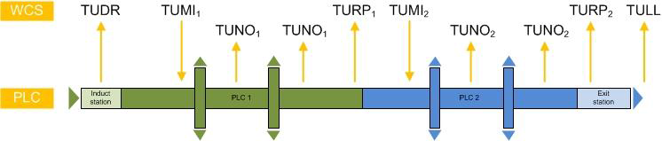

Figure 2 General example of DCI messaging

Typically new transport units coming in the system will be introduced by the PLC via a TUDR (destination request) based on its identification number (ULID).

The WCS responds with TUMI (mission) to assign the transport destination. This happens on the fly, means the TU does not stop, and has to be carried out before first transport decision by PLC is needed (junction).

To ensure temporal uncoupling of the two systems (PLC and WCS) the notification points are sent in the way that destinations from WCS is always duly transmitted before the TU arrives at decision point (approx. 2-5 seconds before).

The PLC responds with a TURP (mission report) when the TU arrives at the assigned destination. The routing function to move the TU to its destination within a limited area can be carried by the PLC. This reduces message traffic and allows a less restrictive (short) message response time as the PLC does not need to request a decision for a destination at any junction.

Nevertheless it is also possible to request a destination at any decision point from the WCS.

On its way to the destination it may be defined to send one or more notification messages (TUNO) to the WCS. These are optional and used usually for visualization purpose.

Further transport missions (TUMI) can be initiated if the TU is entering a new PLC area. Thereby the TU continues its way and does not stop.

If the transport unit has left an automated area the PLC sends a TULL (location left) message to the WCS.

### Multishuttle

#### General principles

The MSC (Multishuttle Controller) is responsible for executing the transport orders. In this regard the MSC manages and controls the necessary equipment (lift, shuttle, rack conveyor, infeed and outfeed lanes).

Conveyor optimizations and avoidance of blockages by equipment are generally performed by the MSC. Should this not be possible at a given time, the transport order is cancelled and a new destination is requested from the WCS.

Generally the WCS is responsible for determining the priorities and sequence of transport orders. The MSC maintains sequence by utilizing the drop index, supplied by the WCS when executing transport orders from a lift to a DS.

The WCS directs the MSC exclusively through the specification of transport orders relative to transport units. The WCS controls no equipment, like the fingers of the shuttle telescope

High-capacity Multishuttle systems have a shuttle that never leaves the level. The lift transports only the transport units.

For improving performance each level has at least two rack conveyors for storage and retrieval operations. In addition, each aisle has at least two lift platforms. Each can handle two transport units.

In delivering the containers to the order-picking locations a specific retrieval sequence is often required of the Multishuttle system. In this case the WCS orders the transport unit first up to rack conveyors and then further to the DS, utilizing the drop index.

The MSC supports three different interfaces to the conveyor system:

* Typical: Pick stations belonging to MSC, drop stations belonging to PLC
* Maximum: Pick and drop stations belonging to MSC
* Minimum: Pick and drop stations belonging to PLC

Unless otherwise stated, the maximum MSC architecture is used.

Please refer to Reference Document 3 for detailed control principles and specifications of the Multishuttle system.

#### Handling flex locations

A flex storage location being addressed by a (x|y) value and having width wbay is subdivided into raster units (RU). A typical value is RU = 50mm.

Raster units are used to place slots within a storage bin. The left hand side of a slot indicates the position of a slot (e.g. P=14 indicates the position of the second slot in the picture below).

The slot width (wslot) is defined as the maximum width of all cases within the slots + a fixed value wgap for the gap necessary for the shuttle telescope. A typical value is wgap = 80 mm.

Slots are not tight to certain raster units but can dynamically be created or deleted. This approach is called dynamic slotting.

The depth of a bin is subdivided into concrete equally sized parts. The depth values are static, i.e. they do not change dynamically as the slot position. All slots share the same depth values.

The following picture shows the principle layout of a storage bin:

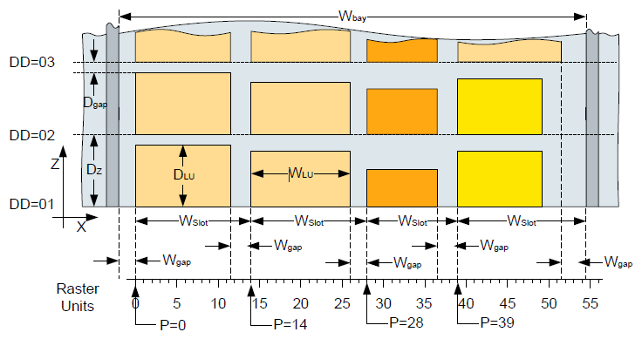

Figure 3 Flex Multishuttle bay

##### Telescope Optimization

For a mixed size slotting scenario, where a smaller case can be stored in front of a larger one (see picture), special care must be taken to avoid a collision of the telescope with the case in the back. Of course, it is always possible to move the telescope back and use the front fingers to push the case to its final position, but this "finger change" results in a performance degradation.

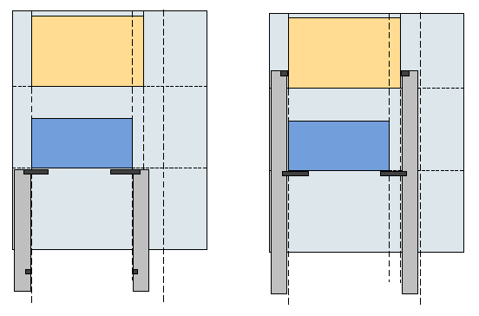

Figure 4 Flex Multishuttle telescope optimization

The two fields "{Source|Destination} Shuttle Extension" in the DCI transport telegram specify the extension of the shuttle axis for unrestricted extension of the telescope for both source and destination.

The shuttle extension has the following properties:

* The shuttle extension is always greater or equal the x-extension of the LoadUnit.
* The destination shuttle extension is always greater or equal the source shuttle extension, i.e. no contraction is possible. This is due to the dragon plates scales at the bottom of the shuttle.
* The maximum difference between source and destination extension is dw = 80 mm
* Mission Telegrams (TUMI)   
  The extension specifies the telescope width which can safely be used by the PLC to extend the telescope, i.e. without risking a collision with a case.
* Mission Reply (TURP)   
  In the confirmation telegram the PLC reports back the actually used extension values. WCS stores this value in the corresponding slot entity for later use.

**NOTE:**  If the case is grabbed with a bigger extension as it actual size it might shift during its travel. Due to this fact, the case must always be picked again with at least the same extension as it has been dropped.

##### Minimum Multishuttle Extension

The dragon-scale plates construction of a flex shuttle can only be shrinked up to a minimum extension of about 170 mm.

The WCS has to ensure that the shuttle extension value being sent in the fields “Source Shuttle Extension” and “Destination Shuttle Extension” (see chap. 4) is not smaller than this minimum value (configurable at the WCS side).If WCS sends a smaller value, MCS will generate a regular fault which is visualized in SCADA / GSMi). The operator has to remove the case and cancel the corresponding mission which implies the sending of a TUCA message.

This document only specifies aspects being specific to Multishuttle systems. Please refer to Reference Document 2 for description of the standard message interface for transport missions.

#### Transport missions

The following transport missions are executable:

Table 14 Multishuttle transport mission types

| **#** | **Mission** | **Description** |
| --- | --- | --- |
| 1 | Storage | TU is moved from PS to bin location |
| 2 | Retrieval | TU is moved from bin location to DS |
| 3 | Shuffle | TU is moved from bin location to another bin location |
| 4 | Pass-Through | TU is moved from PS to DS |

##### Direct Pick-To-Drop Transfers

The WCS has the possibility, in particular while handling a malfunction, to pass-through transport units, i.e. to transport them directly from the PS to the DS.

Direct pick-to-drop transfers are possible only through the rack conveyors and the shuttle.

In systems with sequence formation, the WCS must make sure that the transport units passed through do not destroy the sequence of the retrieved TU flow.

The following list describes the ordering of direct pick-to-drop transfers by the WCS:

1st transport order: PSx 🡪 rack conveyor in level n

2nd transport order: rack conveyor in level n 🡪 rack conveyor out level n

3rd transport order: rack conveyor out level n 🡪 DSy

The rack conveyor is selected by the WCS and its capacity monitored.

##### Quantity of Transport Missions

The MSC is restricted to the following number of transport missions:

* 10 missions per individual shuttle
* 1 mission per conveyor zone (e.g. a rack conveyor consisting of 2 conveyor zones supports two missions)

Due to the fact that transport missions might be cancelled or modified by the WCS during normal operation or anomaly situations, it is recommended that the WCS should reduce the quantity of missions as much as possible. On the other hand breaks caused by mission transfer should be avoided.

##### Optimisation of Missions

The MSC does not optimize multiple Transport Missions in any case. All Transport Missions from the WCS are buffered in a FIFO per aisle and level within the MSC.

#### Multishuttle transport message structure

This message structure is used specific for Multishuttle transport unit (TUxx) messages:

Table 15 TU message structure – Multishuttle

| **Byte** | **Name** | **Type** | **Length** | **Description** |
| --- | --- | --- | --- | --- |
| 01-28 | Header |  |  | See Table 5 DCI message structure |
| 29-118 | Transport |  |  | See Table 8 TU message structure |
| 119-122 | Drop index | N | 4 | Sequence of the retrieval relative to the drop station.  The value is "0" if no sequence is necessary. |
| 123-126 | Shuttle dynamics | N | 4 | Max. dynamics of shuttle in %.  "0100" = 100%, maximum speed (default value) |
| 127-130 | Lift dynamics | N | 4 | Max. dynamics of lift in %.  "0100" = 100%, maximum speed (default value) |
| 131-134 | Source Shuttle Extension | N | 4 | Due to the need to handle mixed Slots this parameter defines the flex axis extension which the shuttle can use at the source location to fully extend the telescopes and use any fingers for Load Unit handling.  If the shuttle has the capability and time to do so, it may also use front fingers for handling and use a narrower flex axis. The minimum flex axis extension is the "TU Length". In confirmation messages the PLC shall set this parameter to the actually used values.  The parameter is always equal or larger than "TU-length". |
| 135-138 | Destination Shuttle Extension | N | 4 | Due to the need to handle mixed Slots this parameter defines the flex axis extension which the shuttle can use at the destination location to fully extend the telescopes and use any fingers for Load Unit handling.  If the shuttle has the capability and time to do so, it may also use front fingers for handling and use a narrower flex axis. The minimum flex axis extension is the "TU Length". In confirmation messages the PLC shall set this parameter to the actually used values.  The parameter is always equal or larger than "TU-length".  Destination Shuttle Extension is always equal or larger than Source Shuttle Extension. |
| 139-140 | Footer |  |  | See Table 5 DCI message structure |

#### STAT – Status Message

Sender: PLC Receiver: WCS

This message is used to inform the WCS about the availability of the Multishuttle devices. If all the aisle devices are of the same state (i.e. all available or all unavailable), the MSC will report only one status for the entire aisle.

The WCS system has to know the following information to enable it to process the status messages correctly:

* Which location names are assigned to each individual system element. I.e. names assigned for infeed rack conveyors, outfeed rack conveyors, lifts.
* Which function group names are within each aisle.
* Which rack conveyors are served by which lift.
* Which function groups are within each level.

With this information the WCS can determine from a single status message exactly what system elements are affected and react accordingly. This information is typically shown in the messaging point diagrams.

Status messages are sent by the MSC on occurrence or due to a request.

Table 16 STAT message structure – Multishuttle

|  |  |  |  |  |
| --- | --- | --- | --- | --- |
| **Byte** | **Name** | **Type** | **Length** | **Description** |
| 01-28 | Header |  |  | See Table 5 DCI message structure |
| 29-42 | Device identifier | A | 14 | Identifier of device. The device names are following the specified naming convention for locations. Possible devices could be:  Entire aisle (ALL), Pick station, Drop station, Stacker crane machine or components of them |
| 43-44 | Availability status | A | 2 | Operation mode and fault state:  "AU" = Automatic mode without any fault. Device is available.  "MA" = Manual mode or maintenance without any fault  "FL" = Short term fault  "OF" = Long term not available  (off or long term fault)  "??" = No operation mode |
| 45-46 | Footer |  |  | See Table 5 DCI message structure |

In addition to the physical objects which can be faulty, there is a set of “special” objects, which can hinder production if they are not in a healthy state. Their status is also reported via a STAT telegram:

Table 17 Additional Multishuttle STAT objects

|  |  |  |
| --- | --- | --- |
| **Name** | **Function** | **Impact** |
| MSAI*<xx>*ESTOP | When any emergency stop is pressed this | The whole aisle is inoperable. |
| MSAI*<xx>*PROFIBUS | The health of the Profibus network is continually monitored. If any problems are detected the status of this object changes to FL.  An appropriate error code is also reported via STAX message. | The whole aisle is inoperable. |
| MSAI*<xx>*ASI | The health of the ASi networks are continually monitored.  If any problems are detected the status of this object changes to FL.  An appropriate error code is also reported via STAX message. | The amount of aisle functionality depends on which ASi node is faulty. |
| MSAI*<xx>*SYSTEM | Where applicable inputs from the fire warning system and Air Pressure healthy inputs can be monitored.  If configured these items can cause the system object to report a change in status.  An error code is also reported (STAX message sent). | Depends on individual  site requirements. |
| MSAI*<xx>*WCS | If an error in communication with the WCS is detected the status of this object changes to FL  An error code is also reported (STAX message sent). | System remains operational – but will not receive any new commands from WCS. |
| MSAI*<xx>*MLxx | If for any reason the maintenance level becomes Inoperable the status of this object changes to FL.  Included in this group are the gate, PSU temperature monitoring and circuit breakers.  An error code is also reported (STAX message sent). | The individual maintenance level is inoperable. |

<xx> = The aisle number

xx = The maintenance level number

For each maintenance level there exists a maintenance level object.

The MSAIxxWCS is to allow local status reporting on HMI.

#### STAX – Extended Status Message

Sender: PLC Receiver: WCS

This message is used to report detailed status information about the availability of PLC devices. In contrast to the STAT message (see TODO), the STAX message is not intended to control the material flow, but is for visualization purposes (SCADA) only.

The STAX message is sent unsolicited by the PLC whenever the status of a device changes.

In addition to that, it is sent upon request by the WCS (e.g. due to a STRQ telegram with device identifier ALL, see /2/). In this context, the STAX telegrams are sent after the STAT but before the STEN.

To be completely independent of the STAT telegram, a STAX with ‘Fault Code’ 0 is sent, when the fault has been reset.

This message is optional.

Table 18 STAX message structure – Multishuttle

| **Byte** | **Name** | **Type** | **Length** | **Description** |
| --- | --- | --- | --- | --- |
| 01-28 | Header |  |  | See Table 5 DCI message structure |
| 29-42 | Device identifier | A | 14 | Identifier of device. The device names are following the specified naming convention for locations.  Extended status message are always sent for concrete locations (i.e. not for virtual locations). |
| 43-48 | Fault Code | N | 6 | Fault code of the device identifying the current fault of the device |
| 49-50 | Classification | A | 2 | The priority of the fault   * ER: Error * WA: Warning * IN: Info |
| 51-52 | Text Version Counter | N | 2 | The text version counter (01-99) is increased whenever a new version of the message text is available within the PLC.  WCS can use this to request new versions of the text by sending a FTRQ telegram. |
| 53-74 | TUID | A | 22 | Barcode currently held by this device  ?????????????????????? – if no load present |
| 75-80 | ABS X Pos | N | 6 | Holds the X axis position in mm if this STAX relates to a shuttle.  000000 – if this STAX is not from a Shuttle |
| 81-86 | ABS Y Pos | N | 6 | Holds the vertical height of the lift in mm if this STAX relates to a lift / lift conveyor  000000 – if this STAX is not from a lift / lift conveyor |
| 87-92 | ABS Z Pos | N | 6 | Holds the LHD position in mm if this STAX relates to a shuttle.  This value can range from -09999 to +09999  000000 – if this STAX is not from a Shuttle |
| 93-94 | Footer |  |  | See Table 5 DCI message structure |

#### ~~SETD – Set Device – Multishuttle~~

~~Sender: WCS Receiver: PLC~~

~~This message is used in general by the WCS to reset a device in fault.~~

~~Table 19 SETD message structure – Multishuttle~~

|  |  |  |  |  |
| --- | --- | --- | --- | --- |
| **~~Byte~~** | **~~Name~~** | **~~Type~~** | **~~Length~~** | **~~Description~~** |
| ~~01-28~~ | ~~Header~~ |  |  | ~~See Table 5 DCI message structure~~ |
| ~~29-42~~ | ~~Device identifier~~ | ~~A~~ | ~~14~~ | ~~Identifier of device. The device names are following the specified naming convention for locations.~~ |
| ~~43-44~~ | ~~Forced Status~~ | ~~N~~ | ~~2~~ | ~~Not used. The device matching the identifier in the SETD message is reset in fault. Put here ‘RS’.~~ |
| ~~45-46~~ | ~~Footer~~ |  |  | ~~See Table 5 DCI message structure~~ |

#### ~~DCRQ – Request Statistics Data~~

~~Sender: WCS Receiver: PLC~~

~~The DCRQ telegram requests statistics data for the specified deice identifier.~~

~~Table 20 DCRQ message structure~~

|  |  |  |  |  |
| --- | --- | --- | --- | --- |
| **~~Byte~~** | **~~Name~~** | **~~Type~~** | **~~Length~~** | **~~Description~~** |
| ~~01-28~~ | ~~Header~~ |  |  | ~~See Table 5 DCI message structure~~ |
| ~~29-42~~ | ~~Device identifier~~ | ~~A~~ | ~~14~~ | ~~Identifier of device. The device names are following the specified naming convention for locations.~~ |
| ~~43-44~~ | ~~Footer~~ |  |  | ~~See Table 5 DCI message structure~~ |

#### ~~DCSH – Shuttle Statistics~~

~~Sender: PLC Receiver: WCS~~

~~The DCSH telegram report statistics data for an individual shuttle. After the DCSH has been acknowledged, the statistics are reset.~~

~~Table 21 DCSH message structure~~

|  |  |  |  |  |
| --- | --- | --- | --- | --- |
| **~~Byte~~** | **~~Name~~** | **~~Type~~** | **~~Length~~** | **~~Description~~** |
| ~~01-28~~ | ~~Header~~ |  |  | ~~See Table 5 DCI message structure~~ |
| ~~29-240~~ |  |  |  | *~~See Reference Document 3 for details on the fields of the statistics sent.~~* |
| ~~241-242~~ | ~~Footer~~ |  |  | ~~See Table 5 DCI message structure~~ |

#### ~~DCLI – Lift Statistics~~

~~Sender: PLC Receiver: WCS~~

~~The DCLI telegram report statistics data for an individual lift. After the DCLI has been acknowledged, the statistics are reset.~~

~~Table 22 DCSH message structure~~

|  |  |  |  |  |
| --- | --- | --- | --- | --- |
| **~~Byte~~** | **~~Name~~** | **~~Type~~** | **~~Length~~** | **~~Description~~** |
| ~~01-28~~ | ~~Header~~ |  |  | ~~See Table 5 DCI message structure~~ |
| ~~29-192~~ |  |  |  | *~~See Reference Document 3 for details on the fields of the statistics sent.~~* |
| ~~193-194~~ | ~~Footer~~ |  |  | ~~See Table 5 DCI message structure~~ |

### Summary of DCI Messaging

Table 23 Summary of included DCI telegrams

| **Name** | **Sender** | **Ack** | **Description** |
| --- | --- | --- | --- |
| ~~DCLI~~ | ~~PLC~~ | ~~Yes~~ | ~~Lift statistics~~ |
| ~~DCRQ~~ | ~~WCS~~ | ~~Yes~~ | ~~Statistics request~~ |
| ~~DCSH~~ | ~~PLC~~ | ~~Yes~~ | ~~Shuttle statistics~~ |
| ~~FTDF~~ | ~~PLC~~ | ~~No~~ | ~~Fault text definition. Defines a new fault code in response to a FTRQ.~~ |
| ~~FTRQ~~ | ~~WCS~~ | ~~Yes~~ | ~~Fault text report. WCS received unknown fault code from PLC.~~ |
| LIVE | Both | Yes | Watchdog |
| ~~LORQ~~ | ~~WCS~~ | ~~No~~ | ~~Location data request~~ |
| ~~SETD~~ | ~~WCS~~ | ~~No~~ | ~~Set a device to the given status.~~ |
| ~~SETT~~ | ~~WCS~~ | ~~No~~ | ~~Set Date and Time within the PLC.~~ |
| STAT | PLC | No | Status message. Status about availability of equipment. |
| STAX | PLC | No | Detailed status information for visualization purposes |
| STEN | PLC | No | End of status messages if requested from WCS. |
| ~~STMF~~ | ~~PLC~~ | ~~No~~ | ~~Status of material flow~~ |
| STRQ | WCS | No | Status request |
| TUCA | PLC | Yes | Transport Unit Cancel. Positive or negative acknowledgment of the cancellation of the transport order. |
| TUDR | PLC | No | Transport Unit Destination Request. The PLC requests a new destination from WCS if the TU has no destination |
| TUEX | PLC | Yes | Transport Unit Exception for negative acknowledgment (event code <> “OK”) of mission. |
| ~~TULL~~ | ~~PLC~~ | ~~Yes~~ | ~~Transport Unit Location Left. The TU has left an area.~~ |
| TUMC | WCS | No | Transport Unit Mission Cancel. Cancellation of the transport order by the WCS. |
| TUMI | WCS | Yes | Transport Unit Mission |
| TUNO | PLC | Yes | Transport Unit Notification Message. Used to send TU in-formation during travel or sent by PLC due to a spontaneous event. Only used for positive acknowledgment (event code = “OK”) and only if TU has not reached destination. This message is optional as long as it is not sent in an ab-normal situation. |
| TURP | PLC | Yes | Transport Unit Mission Report. Execution message of the transport order if TU arrives at destination. Only used for positive acknowledgment (event code = “OK”). |

Table 24 TU event codes

| **Event codes** | **Description** |
| --- | --- |
| “BE” | Bin empty |
| ~~“BF”~~ | ~~The mission buffer for a certain device is exhausted due to too extensive preloading of missions.~~ |
| “BO” | Bin occupied |
| “CE” | Current location does not exist. Detected for locations where this information is required (e.g. induction station) |
| “DE” | Destination location does not exist |
| “DN” | Destination location is not reachable at this point in time (transient error). |
| ~~“DO”~~ | ~~Drop station occupied (detected only if location is available in automatic mode)~~ |
| “DU” | Destination location is unreachable from current location (permanent error). Previous destination will kept and movement proceeded if possible. |
| “GE” | General error, all errors not specified above |
| “MA” | Manual intervention (specifics depend on message type) |
| ~~“ME”~~ | ~~Measurement error during contour / weight check.~~ |
| “MI” | Mission or TU does not exist. |
| ~~“MS”~~ | ~~Mission is already started and cannot be cancelled.~~ |
| “MX” | Mission is not executable |
| “OK” | Normal operation |
| ~~“PA”~~ | ~~Abort palletising operation. Load unit cannot be used for shipping.~~ |
| ~~“PC”~~ | ~~Missing cases during palletising~~ |
| ~~“PE”~~ | ~~Pick station empty (detected only if location is available in automatic mode)~~ |
| “SE” | Source location does not exist. |
| “SN” | Source location is not reachable |
| “TH” | TU too high |
| ~~“TQ”~~ | ~~Different quantity of TUs detected.~~ |
| “TS” | TU is over size |
| “TU” | TU is unknown on this location. Detected for locations where this information is required |
| ~~“TW”~~ | ~~The weight of TU is too heavy~~ |
| ~~“TY”~~ | ~~TU type conflict~~ |

## DATCOM Protocol

### Overview

The connection to the WCS computer is by TCP/IP within an Ethernet Local Area Network (LAN). Communication occurs by the exchange of DATCOM telegrams between the WCS and PLC. DATCOM defines the structure of the telegrams and all the permissible Message Types which will be used to allow both systems to communicate.

There are two basic types of telegram, System Status/Control and Material Flow:

* System Status/Control telegrams are concerned with starting and stopping the system and synchronizing the status of equipment and loads on the system.
* Material Flow telegrams signal carriers arriving at or leaving various decision points in the system.

If the WCS detects a communications failure to any PLC, the WCS should log this and then attempt to re-connect (automatically or manually). The WCS must always send a disconnect message before a connection request, even at initial start-up.

The PLCS are independent as far as routing control is concerned.

i.e. If the WCS can communicate with a PLC then it can control routing of unit loads on this PLC, regardless of the state of other PLCS.

### PLC States

The PLCs may exist in several states:

Table 25 PLC States

| **State**  Code | Description | **Carrier**  Movement | **Mat Flow**  Telegrams | **Status**  Telegrams |
| --- | --- | --- | --- | --- |
| “00” | Unknown | Disabled | Disabled | Disabled |
| “01” | Program Started  *Reserved for other MFCs* | Disabled | N/A | N/A |
| “02” | Ready | Disabled | Disabled | Enabled |
| “03” | Automatic : Movement Disabled | Disabled | Disabled | Enabled |
| “04” | Automatic : Movement Enabled | Enabled | Enabled | Enabled |
| “05” | Semi-automatic :  Movement Disabled.  *Reserved for other MFCs* | Disabled | N/A | N/A |
| “06” | Semi-automatic :  Movement Enabled  *Reserved for other MFCs* | Enabled | Disabled | Disabled |

#### Unknown State “00”

After initialisation the state is “Unknown” (“00”), in this state each PLC is performing its ‘Server’ role, and listening for a TCP/IP connection request.

#### Program Started “01”

This state is reserved for use by other MFCs.

#### Ready “02”

In this state, carrier movement and messaging are disabled.

Each PLC waits for a ‘System Status Report’ telegram (Type 13) from the WCS, in which the status is “02”, the PLC will respond with a ‘System Status Report’ telegrams, with state of “02”. The WCS is reporting to the PLC that it is ready the PLC responds that it too is ready.

**NOTE:**  Although messaging is disabled, ‘Equipment Status’ (Type 10) telegrams will still be sent.

#### Automatic: Movement Disabled State “03”

In this state, carrier movement and messaging are disabled.

Whilst in state “03”, the WCS may do one of three things:

* Send a “System Status Request” telegram (Type 12)
* Send a “Request All Data” telegram (Type 30)
* Send a “Material Flow Start” telegram (Type 14)

**NOTE:** Although messaging is disabled, ‘Equipment Status’ (Type 10) telegrams will still be sent.

#### Automatic: Movement Enabled State “04”

In this state, carrier movement and messaging are enabled.

Whilst in state “04”, the WCS may send a “Material Flow Stop” telegram (Type 15). Material flow is then in a stopped state and the PLC will now change to state “Automatic: Movement Disabled” (“03”) and reply with a “System Status Report” telegram (Type 13).

#### Semi-Automatic: Movement Disabled State “05”

This state is reserved for use by other MFCs.

#### Semi-Automatic: Movement Enabled State “06”

This state is reserved for use by other MFCs.

### Establishment of Communications

Once the WCS has established all the necessary connections, each PLC is directed by the WCS to move through various states during a system Start-Up, so that the whole system is started in a controlled manner.

#### Start-Up

During Start-Up, the WCS and the conveyor control PLCs must be synchronised. This is achieved by the PLCs reporting the status of all conveyors and the location and details of selected carriers on the system.

For each PLC the following sequence occurs:

1. The WCS sends a ‘System Status Report’ telegram (Type 13) with state “02”.   
   **NOTE:**  This is the ‘First Type 13’. The PLC responds with its ‘System Status Report’ telegram, with state ‘02’.

The WCS and PLC are now connected.

1. The WCS sends a ‘System Status Request’ (Type 12) telegram, with state ’03’ to the PLC. The PLC will then update the WCS with the status of all conveyors, see 4.2.4 System Status Request.
2. The WCS sends a ‘Request All Data’ telegram (Type 30), the PLC will then update the WCS with the details of selected carriers on the system, see 4.2.6 Remap.
3. The WCS sends a ‘Request Alarm Data’ telegram (Type 51), the PLC will then update the WCS with the details of all active alarms in the system, see section 4.2.9.

The systems are now synchronised.

1. A ‘Start Material Flow’ telegram (Type 14) is sent to the PLC. The PLC responds with a ‘System Status’ telegram (Type 13); the system status should now be ‘Automatic: Movement Enabled’ (State –‘04’).
2. The WCS may stop the Automatic material flow by sending a ‘Stop Material Flow’ telegram (Type 15). Material flow is then in a stopped state. The PLC now responds with a ‘System Status Report’ telegram (Type 13), in which system status should now be ‘Automatic: Movement Disabled’ (State –‘03’).

### System Status Request

The status of all conveyors in the system must be known by the WCS. The WCS uses this information when making routing decisions so that carriers may be re-routed (if possible) to avoid conveyors which are in fault.

Conveyors are grouped into function groups. If any conveyor in a function group is in fault, the entire function group is reported as in fault. The function group will be reported as OK when all conveyors in the group are healthy.

A “System Status Request” telegram (Type 12) is sent by the WCS to each PLC. Each PLC responds by sending “Equipment Status” telegrams (Type 10). The PLC **only** sends “Equipment Status” telegrams for function groups which are in fault. If all function groups are not in fault, no “Equipment Status” telegrams will be sent during restart.

After the last “Equipment Status” telegram has been sent by the PLC, a ‘System Status Report’ telegram (with status 03) is sent to indicate an end of “System Status” telegrams.

**NOTE:**  During normal running of the system, the WCS is kept up to date with changes in the status of the function groups by the sending of a single “Equipment Status” telegram each time a function group changes state.

Within the equipment status telegram two states exist, either the function group’s status as ‘OK’ (“00”) or ‘Faulty’ (“01”).

### Heartbeat

Both the PLC and the WCS shall monitor when telegrams are sent. If no telegrams are generated for a period of 5 seconds then a ‘Heartbeat’ telegram (Type 99) shall be sent. Both the WCS and PLC shall monitor the receipt of telegrams. If either party does not receive a telegram for 12.5 seconds then the connection should be closed, an alarm / event message should be generated and the communication link should be restarted automatically (provided Auto Restart is selected on the WCS).

As the PLC does not have the ability to close the connection, it shall initiate a connection close by not sending messages to the WCS until the connection is closed by the WCS.

### Remap

The WCS maintains information of all active carriers in the system. If the connection between the WCS and the PLC(s) is lost then the WCS must be resynchronised with the PLC(s). This requires the details of selected carriers on the system to be sent by the PLC to the WCS. The types of locations for which remap data will be sent are:

* All ‘Active’ locations (those ending in A1, A2, etc.)

A “Request All Data” telegram (Type 30) is sent by the WCS. For each of the conveyor locations listed above, the PLC checks to see if there is a carrier present. For each carrier place for which data is present, a “One Location Data Record” telegram (Type 31) is sent. The telegram contains all the details about the carrier.

After the last “One Location Data Record” telegram has been sent by the PLC, an ‘End of Re-map’ telegram (Type 32) is sent to indicate an end of the remap.

### Message Buffering

Messages generated by the PLC for locations in which no remap data is sent to the WCS will be buffered until they are successfully sent to the WCS. In the event of a communications loss to the WCS, these messages will be preserved and sent when communications are re-established.

The order in which the messages are sent will be the same as the order in which they were generated by the PLC. (This item is configurable and is currently disabled).

### Carriers Deleted/Lost by the PLC

At any position in the conveyor system the PLC may send an ‘Exception Telegram’ (type 06) with status ‘00’ or ‘MD’. This indicates a carrier has been deleted or lost by the conveyor PLC.

Status ‘MD’ stands for manually deleted and will only be sent as a result of an operator action to delete a carrier. This would typically occur at a messaging point where no transport order has been received or there is a mechanical issue with equipment.

Status ‘00’ will be sent when the PLC automatically generates this message (not as the result of an operator action). This will generally occur when the PLC has a tracking failure.

When the WCS receives an ‘Exception Telegram’ with status ‘00’ or ‘MD’ for a tote / carton it should set the tote/carton to missing until is reappears at a downstream messaging point.

### Alarms

**NOTE:** This will not be implemented on this project!

~~Each PLC shall inform the WCS of all its active alarms. This information shall be transmitted via an ‘Alarm Message’ (Type 50).~~

#### ~~Connection restart~~

~~As part of the connection / remapping process the WCS shall send a ‘Request Alarm Data’ telegram (Type 51). For each active alarm the PLC shall send an ‘Alarm Message’ (Type 50) containing an alarm number and status. Each alarm number shall correspond with a text string maintained by the WCS.~~

~~After all active alarms have been sent the PLC shall send an ‘End of Alarm Data’ message (Type 52) to indicate all active alarms have been transmitted.~~

**~~NOTE:~~**~~If an alarm was active prior to a connection restart and then after restart it is no longer reported as active, the WCS shall remove it from its active alarm list.~~

#### ~~Change of state~~

~~Whilst a connection is active the PLC shall send an ‘Alarm Message’ (Type 50) on change of state of each alarm. The WCS shall use this to maintain its list of active alarms.~~

### Conveyor Function Group Designation

Each conveyor function group has an alphanumeric name. These are shown in the messaging point diagrams at the end of this document. In these diagrams, the function group associated with the messaging points are denoted by the grey rectangles in the background.

These diagrams also show the PLC which controls each function group. If a PLC is placed out of service within the WCS, all function groups associated to that PLC shall be assumed unavailable by the WCS. Carriers shall not be routed to locations which are not reachable due to the unavailability of conveyors associated with the out of service PLC.

### DATCOM Telegrams

#### General Telegram Format

All messages have the same structure, this consists of a Header, a Body and a Tail. All fields are ASCII format. If any part of the telegram is blank, then it will be padded with ‘space characters’ (Hex code 20), to make each telegram type a fixed length.

Table 26 General Telegram Format

| **Header (10bytes)** | **Body (variable)** | **Tail (4 bytes)** |
| --- | --- | --- |
| ‘/ aabbccdd’ | ** Variable ** | ‘..<CR><LF>’ |

**NOTE:**  ‘.’ = space; ‘<CR>’ = Carriage Return; ‘<LF>’ = Linefeed

Any fields that use binary values are preceded by 0100 to generate an ASCII printable character.

#### Telegram Header

The message header prefixes all messages and consists of 10 characters which contain the information of who sent the message, who the message is for and what the message means.

Table 27 Telegram Header

| **Byte**  **No.** | **Field Name** | **Length**  **(bytes)** | **Value** | **Description** |
| --- | --- | --- | --- | --- |
| 0 | Start | 1 | 2F hex | ‘/’ character. |
| 1 | Cycle Number | 1 | 20 hex | ‘ ‘ (space). |
| 2-3 | Telegram Type | 2 | ‘01’..’99’ | Telegram type, e.g. ‘02’ see table for types. |
| 4-5 | Sender Ident. | 2 | ‘01’..’99’ | Identification of the sender. e.g. ‘31’  (See section 5) |
| 6-7 | Receiver Ident. | 2 | ‘01’..’99’ | Identification of the receiver. e.g. ‘01’  (See section 5) |
| 8-9 | Program Ident | 2 | 3030 hex | ‘00’. |

#### Telegram Tail

The message tail signifies the end of a message and informs the receiver that the message has finished.

Table 28 Telegram Tail

| **Byte**  **No.** | **Field Name** | **Length**  **(bytes)** | **Value** | **Description** |
| --- | --- | --- | --- | --- |
| 0 | Separator | 2 | 2020 hex | ‘ ‘ two space characters. |
| 2 | End | 2 | 0D0A hex | <CR><LF> End characters. |

#### Material Flow Telegrams

The body of the telegram will be one of two formats, Unit Load Data or System Status.

##### Unit Load Data Format

This data structure is used for telegram types that require the unique carrier data, these include - types 01, 02, 03, 04, 05, 06, 20, 21, 22, 24 and 31.

Telegram length is 162 bytes (including Header & Tail).

Table 29 Material Flow Telegram

| **Byte**  **No.** | **Field Name** | **Length**  **(bytes)** | **Value** | **Description** |
| --- | --- | --- | --- | --- |
| 0 | Header | 10 | - | See section 4.2.11.2 Telegram Header |
| - | Origin | 0 | N/A | Not implemented |
| 10 | Current Location | 14 | e.g.  ‘GTP01 ’ | Current Location of Carrier  (padded with space characters (20Hex)) |
| 24 | Destination | 14 | e.g. ‘MSAI01CR01PS10’ | Destination Location of Carrier  (padded with space characters (20Hex)) |
| 38 | Unit Load Status | 2 | e.g. ‘00’ | Message status of Unit Load (see section 4.2.11.4.2 Unit Load Status) |
| 40 | UL Identification | 8 | ‘ ’ | Not used (padded with 8 x space characters (20Hex)) |
| 48 | Barcode1 | 40 | e.g.  ‘2123451 ’ | Identification of carrier (right padded with space characters (20Hex))  SWAP & QA – Left side barcode when looking in direction of conveyor flow.  All other locations – Scanned barcode. |
| 88 | Barcode2 | 40 | ‘2123452 ’ | Identification of carrier (right padded with space characters (20Hex))  SWAP & QA – Right side barcode when looking in direction of conveyor flow.  All other locations – 10 x ASCII space characters (20Hex) |
| 128 | Profile | 4 | e.g. ‘@@@@’ | Profile Information  SWAP - (see section 4.2.11.4.5 Profile Status)  All other locations – 4 x ASCII @ |
| 132 | Carrier Size | 4 | e.g. ’CA01’ | Type/size of carrier. See Table 45 |
| 136 | Special data | 4 | e.g. ‘ ’ | Contains PLC specific log information, not to be interpreted by the WCS. |
| 140 | Weight | 6 | e.g. ‘001050’ | Weight of Unit Load in grams (maximum 32767 g)  SWAP & QA – Carrier Weight  All other locations – 6 x ASCII space characters (20Hex) |
| 146 | Height | 4 | e.g. ‘0300’ | Height (cut) of carrier in mm. |
| 150 | Length | 4 | e.g. ‘0580’ | Long edge of carrier in mm. |
| 154 | Width | 4 | e.g. ‘0380’ | Short edge of carrier in mm. |
| 158 | Tail | 4 | - | See section 4.2.11.3 Telegram Tail |

##### Unit Load Status

The Unit Load status is used by the PLC to inform the WCS of the ‘present status’ of a carrier on the system. After a start-up WCS knows whether a PLC is waiting for particular messages.

Table 30 Unit Load Status

| **Value** | **State** |
| --- | --- |
| ‘00’ | Normal |
| ‘08’ | Blocked |
| ‘09’ | Waiting for Acknowledgement |
| ‘MD’ | Manually Deleted |
| ‘DC’ | Delete Confirmed |
| ‘DF’ | Delete Fail |

##### UL Identification

Not used

##### Barcode1 & Barcode2

Carrier identification barcode. These fields have different meanings depending on the location:

SWAP (Scan, Weigh & Profile Station):

Barcode 1 - Left side barcode when looking in direction of conveyor flow.

Barcode 2 - Right side barcode when looking in direction of conveyor flow.

All other locations:

Barcode 1 – Tote/Carton ID

Barcode 2 – Unused. 40 x ASCII space characters (20 Hex)

##### Profile Status

The full set of bit patterns for a byte and their ASCII equivalents are as follows:

Table 31 Profile Status ASCII equivalents

| **Bit Pattern for Byte** | **ASCII Equivalent** |
| --- | --- |
| 0100 0000 | @ |
| 0100 0001 | A |
| 0100 0010 | B |
| 0100 0011 | C |
| 0100 0100 | D |
| 0100 0101 | E |
| 0100 0110 | F |
| 0100 0111 | G |
| 0100 1000 | H |
| 0100 1001 | I |
| 0100 1010 | J |
| 0100 1011 | K |
| 0100 1100 | L |
| 0100 1101 | M |
| 0100 1110 | N |
| 0100 1111 | O |

The format for each character is ‘0100 0000’ where the bits are in the order ’7654 3210’. Bits 7,6,5 and 4 are always set to ‘0100’. This gives the ASCII characters shown in the above table when bits 3, 2, 1 and 0 are set according to the table below.

Table 32 Profile Status Bits

| **Character** | **Bit** | **Description** |
| --- | --- | --- |
| 1 | 0 | Over Height Error |
| 1 | Over Weight Error |
| 2 | Scanner No Read |
| 3 | Label Mismatch on Tote |
| 2 | 0 | NOT USED |
| 1 | NOT USED |
| 2 | NOT USED |
| 3 | NOT USED |
| 3 | 0 | NOT USED |
| 1 | NOT USED |
| 2 | NOT USED |
| 3 | NOT USED |
| 4 | 0 | NOT USED |
| 1 | NOT USED |
| 2 | NOT USED |
| 3 | NOT USED |

The format for the complete profile status is 4 characters in the order ‘1234’.

E.g. ‘Overheight error’ = ‘A@@@’ and ‘Overweight Error’ plus ‘Scanner No Read’ = ‘F@@@’.

##### Special Status

Populated with PLC specific logging data. Not to be interpreted by the WCS.

##### Height, Length and Width

The Height, Length and Width fields contain measured information of the carrier. If the carrier has not been dimensioned, these values may be zero.

#### System Status Format

The PLC system status is passed between PLC and WCS to indicate the conveyor system mode. Effectively the WCS requests the state for the conveyor system, each PLC responds to acknowledge that state once it has been achieved.

These telegrams either set system status or request a system action. This format is for telegram types - 12, 13.

Telegram length is 162 bytes (including Header & Tail).

Table 33 System Status Message

| **Byte**  **No.** | **Field Name** | **Length**  **(bytes)** | **Value** | **Description** |
| --- | --- | --- | --- | --- |
| 0 | Header | 10 | - | See Ref. |
| 10 | Null | 30 | 20 hex | Null part of message |
| 40 | System Status | 2 | See table | These two bytes specify the present system status, see section 4.2.11.5.1 System Status |
| 42 | Null | 116 | 20 hex | Null part of message. |
| 158 | Tail | 4 | - | See Ref. |

##### System Status

Table 34 System Status

| **Value** | **State** | **Note** |
| --- | --- | --- |
| ‘00’ | Unknown |  |
| ‘01’ | Program Ready | *Reserved for other MFC’s* |
| ‘02’ | Ready |  |
| ‘03’ | Automatic : Move Disabled |  |
| ‘04’ | Automatic : Move Enabled |  |
| ‘05’ | Semi-Automatic : Move Disabled | *Reserved for other MFC’s* |
| ‘06’ | Semi-Automatic : Move Enabled | *Reserved for other MFC’s* |

#### Equipment Status Messages

‘Equipment Status’ messages are used to transmit the status of equipment between the PLC and WCS. Equipment Status messages are used for the following:

* Status of PLC function groups (PLC -> WCS)
* Conveyor Loops Running (PLC -> WCS)

This format is for telegram type – 10.

Telegram length is 162 bytes (including Header & Tail).

Table 35 Equipment Status Message

| **Byte**  **No.** | **Field Name** | **Length**  **(bytes)** | **Value** | **Description** |
| --- | --- | --- | --- | --- |
| 0 | Header | 10 | - | See Ref. |
| 10 | Function Group | 10 | - | Function group reference |
| 20 | Group Status | 2 | - | See sections  4.2.11.6.1, 4.2.11.6.2. |
| 22 | Null | 136 | 20 hex | Null part of message. |
| 158 | Tail | 4 | - | See Ref. |

##### Function Group Status

Each ‘Equipment Status’ message sends the status for one function group. Every time a group changes state this message is used to update the WCS.

Table 36 Function group status

| **Value** | **State** |
| --- | --- |
| ‘00’ | Ok |
| ‘01’ | Fault |

##### Empty Tote Line Fill Level

An ‘Equipment Status’ message sends the fill level for the empty tote line. Every time the fill level changes, this message is used to update the WCS.

This is applicable to function group ‘ETL’ only.

Table 37 Empty tote line fill level

| **Value** | **State** |
| --- | --- |
| ’10’ | Empty Tote Line – Empty |
| ’11’ | Empty Tote Line – 1/6 Full |
| ’12’ | Empty Tote Line – 1/3 Full |
| ’13’ | Empty Tote Line – 1/2 Full |
| ’14’ | Empty Tote Line – 2/3 Full |
| ’15’ | Empty Tote Line – 5/6 Full |
| ’16’ | Empty Tote Line – Full |

##### Conveyor Loop Running Status

An ‘Equipment Status’ message shall be used to indicate the running status of the conveyor loop. This functionality will allow timeout timers for carriers within queues on the conveyor loop to increment only whilst the conveyors are running.

Equipment status messages shall be transmitted by the WCS on change of state of the conveyor loop running / not running. They shall also be transmitted as part of remap.

This is applicable to function groups listed in 5.1.2 PLC Lookup Table(s).

Table 38 Conveyor loop running status

| **Value** | **State** |
| --- | --- |
| ‘10’ | Loop Stopped |
| ‘11’ | Loop Running |

##### Empty Carton Induction Running Status

An ‘Equipment Status’ message shall be used to indicate the running status of the induction conveyors. This functionality will allow timeout timers for released empty cartons to increment only whilst the induction conveyors are running.

Equipment status messages shall be transmitted to the WCS on change of state of the induction conveyors running / not running. They shall also be transmitted as part of remap.

This is applicable to function groups ‘CC51CBUFFIN’, ‘CC52CBUFFIN’ and ‘CC53CBUFFIN’ only.

Table 39 Empty carton induction running status

| **Value** | **State** |
| --- | --- |
| ‘10’ | Induction Stopped |
| ‘11’ | Induction Running |

##### Empty Carton Availability Status

An ‘Equipment Status’ message shall be used to indicate which carton sizes are currently available from each carton erector. Table 40 below describes the different values of the ‘Carrier Size’ field and what they mean.

Table Carton sizes available from carton erector

|  |  |
| --- | --- |
| **Carrier Size** | **Meaning** |
| CA00 | No cartons are currently available. Both magazines may be empty or in fault, or whole machine in fault or off, etc. |
| CA01 | Only small cartons are available. Large carton magazine may be empty or in fault, etc. |
| CA10 | Only large cartons are available. Small carton magazine may be empty or in fault, etc. |
| CA11 | Both small and large cartons are available. |

Equipment status messages shall be transmitted to the WCS on change of state of carton availability. They shall also be transmitted as part of remap.

This is applicable to messaging locations CC5*1*CARTONA1, CC5*2*CARTONA1 and CC5*3*CARTONA1 only.

#### Start/Stop Format

This format is used for telegrams with no ‘data’. Type 14 is used to request that Material flow be stopped, Type 15 is used to request that Material Flow be started, Type 30 telegram to request a re-map. The PLC sends a Type 32 telegram to indicate that the re-map has finished. A Type 51 telegram is sent by WCS to ‘Request All Alarm Data’ and a Type 52 telegram is sent by the PLC to indicate all alarms have been sent. Type 99 is used for a heartbeat.

This format is for telegram types – 14, 15, 30, 32, 51, 52 & 99.

Telegram length is 162 bytes (including Header & Tail).

Table 41 Start Stop Format

| **Byte**  **Nos.** | **Field Name** | **Length**  **(bytes)** | **Value** | **Description** |
| --- | --- | --- | --- | --- |
| 0 | Header | 10 | - | See Ref. |
| 10 | Null | 148 | 20 hex | Null part of message |
| 158 | Tail | 4 | - | See Ref. |

#### Alarm Message

**NOTE:** This will not be implemented on this project!

~~This message~~ **~~may~~** ~~be used to transmit alarm data to the WCS. The PLC shall send one alarm message on change of state of each alarm.~~

~~This format is for telegram type – 50.~~

~~Telegram length is 162 bytes (including Header & Tail).~~

~~Table 42 Equipment Status Message~~

| **~~Byte~~**  **~~Nos.~~** | **~~Field Name~~** | **~~Length~~**  **~~(bytes)~~** | **~~Value~~** | **~~Description~~** |
| --- | --- | --- | --- | --- |
| ~~0~~ | ~~Header~~ | ~~10~~ | ~~-~~ | ~~See Ref.~~ |
| ~~10~~ | ~~Alarm Number*~~ | ~~6~~ | ~~-~~ | ~~Alarm reference number~~  ~~(padded with zeros (30Hex))~~  ~~eg. 000001~~ |
| ~~16~~ | ~~Alarm Status~~ | ~~2~~ | ~~-~~ | ~~See section 0 * Alarm number is unique per PLC only~~  Alarm Status |
| ~~18~~ | ~~Null~~ | ~~100~~ | ~~20 hex~~ | ~~Null part of message.~~ |
| ~~118~~ | ~~Tail~~ | ~~4~~ | ~~-~~ | ~~See Ref.~~ |

~~* Alarm number is unique per PLC only~~

##### Alarm Status

**NOTE:** This will not be implemented on this project!

~~Each ‘Alarm’ message transmits the status for one defined alarm. Every time an alarm changes state this message is used to update the WCS.~~

~~Table 43 Alarm Status~~

| **~~Value~~** | **~~State~~** |
| --- | --- |
| ~~‘00’~~ | ~~Inactive~~ |
| ~~‘01’~~ | ~~Active~~ |

### Summary of DATCOM Messages

Table 44 Summary of DATCOM Messages

| **Type** | **Telegram** | **Send** | **Rec.** | **If....** |
| --- | --- | --- | --- | --- |
| 01 | Transport order | WCS | PLC | Unit load is to be transported |
| 02 | Arrival telegram | PLC | WCS | Unit load has arrived |
| 03 | Left | PLC | WCS | Unit load has left |
| 04 | Cancel mission | WCS | PLC | Unit load has been removed |
| 05 | Modify mission | WCS | PLC | Unit load is to be detoured |
| 06 | Exception Telegram | WCS/PLC | WCS/PLC | Unit load route is blocked, Abort |
| 10 | Equipment Status report | WCS/PLC | WCS/PLC | Installation status has changed |
| 12 | Set system status | WCS | PLC | Initiation of a start-up |
| 13 | System status report | WCS/PLC | WCS/PLC | System status has changed |
| 14 | Material flow start | WCS | PLC | Material flow to be started |
| 15 | Material flow stop | WCS | PLC | Material flow to be stopped |
| 20 | Application acknowledgement | WCS | PLC | Data may now be deleted |
| 21* | Data before | PLC | WCS | Change in data |
| 22* | Data after | PLC | WCS | Creation of data |
| 24* | Mission Accept | PLC | WCS | Mission Accept |
| 30 | Request all data | WCS | PLC | Files sent by WCS machine |
| 31 | Re-map Unit Load Data | PLC | WCS | Requested with tele. 30 |
| 32 | End of Re-map | PLC | WCS | All data (tele 31) have arrived |
| ~~50~~ | ~~Alarm Message~~ | ~~PLC~~ | ~~WCS~~ | ~~Alarm changes state~~ |
| ~~51~~ | ~~Request Alarm Data~~ | ~~WCS~~ | ~~PLC~~ | ~~Request all active alarms be sent to WCS~~ |
| ~~52~~ | ~~End of Alarm Data~~ | ~~PLC~~ | ~~WCS~~ | ~~All alarm data has been sent to WCS~~ |
| 99 | Heartbeat | WCS/PLC | WCS/PLC | Heartbeat |

* Not used

# Material Flow and Control

## System Overview

Figure 5 below shows a high-level material flow and messaging protocol overview of the system. Details of the material flow and control (messaging) are described in the rest of this section.

**NOTE:** There exists a small carton and a large carton size in this system.

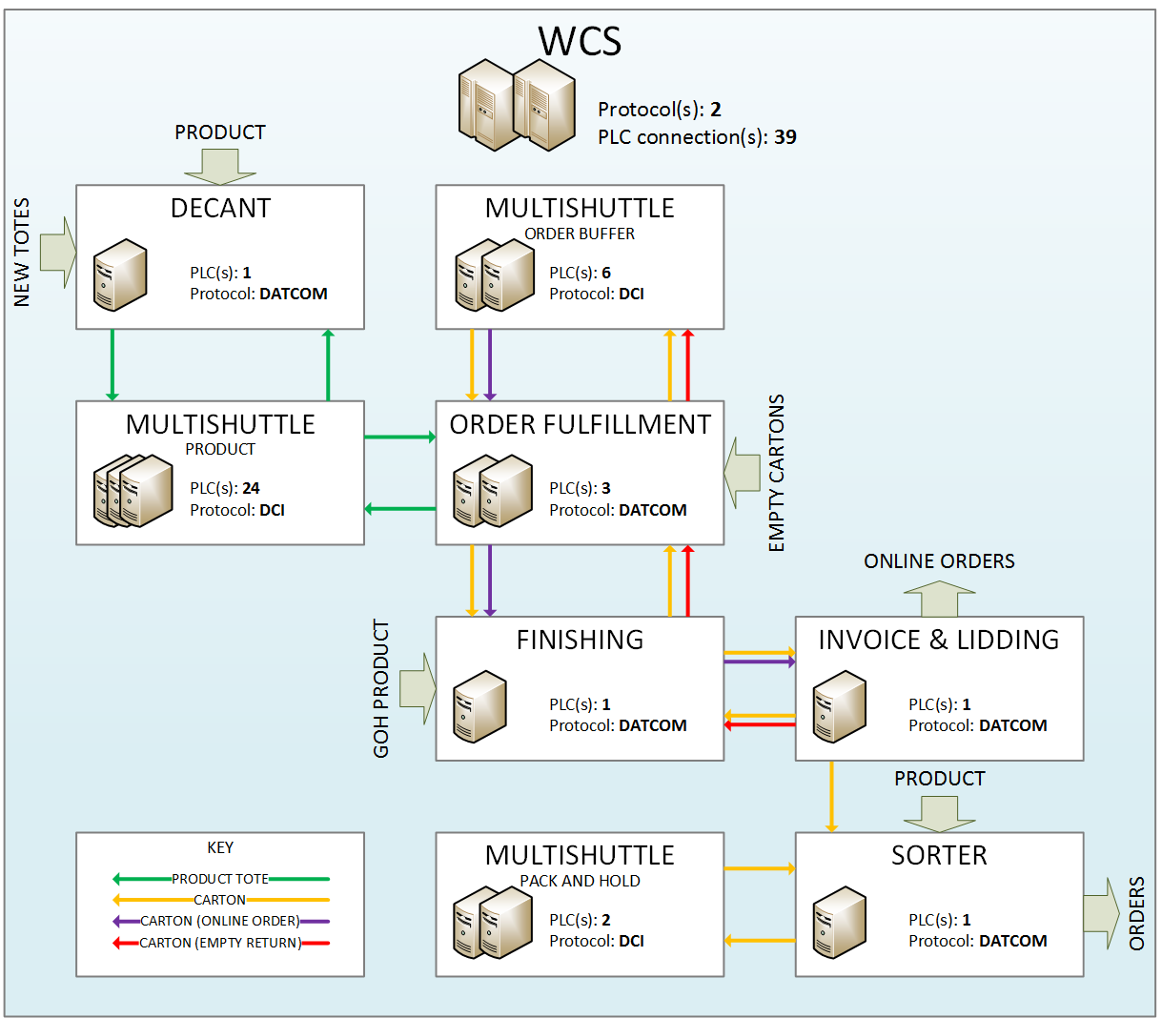

Figure 5 Material flow and messaging protocol overview

### Materials to be Handled

Table 45 outlines the materials to be handled, and their code for the messaging protocol(s) used in the system.

Table 45 Materials to be handled

|  |  |  |
| --- | --- | --- |
| **Carrier** | **DCI** | **DATCOM** |
| Small carton | ‘CA01’ | ‘CA01’ |
| Large carton | ‘CA02’ | ‘CA02’ |
| Small carton – plain lid | ‘CA11’ | ‘CA11’ |
| Large carton – plain lid | ‘CA12’ | ‘CA12’ |
| Small carton – colour lid | ‘CA21’ | ‘CA21’ |
| Large carton – colour lid | ‘CA22’ | ‘CA22’ |
| Product tote | ‘BX01’ | ‘BX01’ |

**NOTE:** In reference to Figure 5, the small carton and large carton materials are used for all applications interchangeably.

### PLC Lookup Table(s)

Some PLC(s) will manage an internal lookup table. The purpose of the table is to reduce message traffic between the PLC and WCS by temporarily storing carrier destinations. A lookup table will only be used for the following functional group(s):

* CC54LOOP
* CC62LOOP
* CC63LOOP

The process for using the lookup table is as follows:

* Tote/Carton arrives and is scanned at a WCS messaging point.
* If the messaging point is managed by a lookup table the PLC checks to see whether an entry exists for the scanned tote/carton.
* If an entry exists the tote/carton is routed at this location based on the destination in the table. No message is sent to the WCS.
* If no entry exists, the tote/carton sends a message to WCS. WCS responds with a mission and the tote/carton is added to the lookup table.
* If the tote/carton is at its destination the entry is removed from the table.

**NOTE:** Lookup table information is not passed between PLCs. If a tote/carton is travelling in an area managed by a lookup table and has a destination in another PLC, once that tote/carton passes to the new PLC an ‘Arrival Telegram’ will be sent at the first messaging point in the new PLC to enable the lookup table to be populated.

## Multishuttle (Order Buffer)

### Controller(s)

Table 46 below lists the PLC(s) in this subsystem, the messaging protocol used for that/those PLC(s), the device IDs expected in the message headers, and the materials to be handled.

Table 46 Multishuttle (Order Buffer) PLC(s)

|  |  |  |  |  |
| --- | --- | --- | --- | --- |
| **PLC** | **Protocol** | **PLC ID** | **Host ID** | **Carrier(s)** |
| *q*E1† | DCI | ‘MS*q*'† | ‘MFC1’ | Small carton, large carton |

†*q* = all integers from 27 to 32 inclusive

### Functional Group(s)

The following functional groups exist within this subsystem. These are used to identify equipment for status-type messages. To see what equipment controls which locations, cross-reference the functional group numbers (FG#) in Table 47 and Table 48.

Table 47 Functional Groups - Multishuttle (Order Buffer)

|  |  |  |  |
| --- | --- | --- | --- |
| **FG#** | **Functional Group Name** | **Description** | |
| 1 | MSAI*ca*LV*yy*SH01*^ | Multishuttle | |
| 2 | MSAI*ca*EL01LO00* | Lift conveyors and carriage– left hand side | |
| 3 | MSAI*ca*ER01LO00* | Lift conveyors and carriage – right hand side | |
| 4 | MSAI*cc*LL*yy*RI10^# | Rack infeed conveyors – left hand side | |
| 5 | MSAI*cb*LR*yy*RI10†^ | Rack infeed conveyors – right hand side | |
| 6 | MSAI*cb*LL*yy*RO10†^ | Rack outfeed conveyors – left hand side | |
| 7 | MSAI*cc*LR*yy*RO10^# | Rack outfeed conveyors – right hand side | |
| 8 | MSAI*cb*CL01DS10† | Drop station 1 conveyors – left hand side | |
| 9 | MSAI*cc*CR01DS10*# | Drop station 1 conveyors – right hand side | |
| 10 | MSAI*cc*CL01PS10*# | Pick station 1 conveyors – left hand side | |
| 11 | MSAI*cb*CR01PS10† | Pick station 1 conveyors – right hand side | |
| 12 | MSAI*cc*CL02PS10*# | Pick station 2 conveyors – left hand side | |
| 13 | MSAI*cb*CR02PS10*† | Pick station 2 conveyors – right hand side | |
| 14 | MSAI*ca*SYSTEM..* | Refer to Table 17 Additional Multishuttle STAT objects for details. |  |
| 15 | MSAI*ca*PROFIBUS* | Whole aisle |
| 16 | MSAI*ca*ASI.....* |  |
| 17 | MSAI*ca*WCS.....* |  |
| 18 | MSAI*ca*ESTOP...* | Whole aisle |
| 19 | MSAI*ca*ML1.....* | Levels 1-4 |
| 20 | MSAI*ca*ML2.....* | Levels 5-8 |
| 21 | MSAI*ca*LIFT.....* |  | |
| 22 | MSAI*ca*EXTESTOP* |  | |
| 23 | MSAI*ca*FIRE....* |  | |
| 24 | MSAI*ca*PSCOMMS.* |  | |
| 25 | MSAI*ca*DSCOMMS.* |  | |
| 26 | MSAI*ca*PROFINET* |  | |

\**ca* = all integers from 27 to 32 inclusive **ONE PER CONTROLLER *q***  
^*yy* = all integers from 01 to 08 inclusive (fixed 2 digit) **ALL PER CONTROLLER *q***  
†*cb* = all integers from 27 to 28 and 31 to 32 inclusive **ONE** **MATCHED TO CONTROLLER *q***  
#*cc* = all integers from 29 to 30 inclusive **MATCHED TO CONTROLLER *q***

### Messaging Point(s)

The following messaging points exist within this subsystem. These are used to identify locations for transport-type messages.

**NOTE:** The following message types can occur at any location therefore may be omitted: TUMI, TUNO, TUEX, TUMC, TUCA, and LORQ.

Table 48 Messaging Points - Multishuttle (Order Buffer)

| **Location(s)** | **FG#** | **Description** | **Destination(s)** | **Send** | **Receive** | **Sequence** |
| --- | --- | --- | --- | --- | --- | --- |
| MSAI*cb*CR01PS10* | 11 | Pick station 1: empty carton buffer, aisles 27, 28, 31, 32 | MSAI*cb*LR*yy*RI10*^ | **TUDR** | TUMI | 1. Send TUDR  2. Receive TUMI  3. Route carrier |
| MSAI*cb*CR02PS10* | 13 | Pick station 2: order buffer, aisles 27, 28, 31, 32 | MSAI*cb*LR*yy*RI10*^ | **TUDR** | TUMI | 1. Send TUDR  2. Receive TUMI  3. Route carrier |
| MSAI*cb*ER01LO00* | 3 | Lift infeed conveyor, aisle 27, 28, 31, 32 | MSAI*cb*LR*yy*RI10*^ | **TUEX** | TUMI | On exception:  1. Send TUEX 2. Get TUMI with modified mission – i.e. different level rack infeed |
| MSAI*cb*LR*yy*RI10*^ | 5 | Rack infeed conveyor, aisles 27, 28, 31, 32 | MSAI*cb*CL01DS10*  MS*cb*1*xxxyydd*11*^†#  MS*cb*2*xxxyydd*11*^†# | **TURP**  **TUDR** | TUMI | If at destination: 1. Send TURP  2. Send TUDR until  3. Receive TUMI  4. Route carrier |
| MSAI*cb*LV*yy*SH01*^ | 1 | Multishuttle, aisles 27, 28, 31, 32 | MS*cb*1*xxxyydd*11*^†#  MS*cb*2*xxxyydd*11*^†#  MSAI*cb*LL*yy*RO10*^ | **TUEX** | TUMI | On exception:  1. Send TUEX 2. Get TUMI with modified mission – i.e. different bin position or rack outfeed |
| MS*cb*1*xxxyydd*11*^†#  MS*cb*2*xxxyydd*11*^†# |  | Bin position, aisles 27, 28, 31, 32 | MSAI*cb*LL*yy*RO10*^  MS*cb*1*xxxyydd*11*^†#  MS*cb*2*xxxyydd*11*^†# | **TURP** | …  TUMI | 1. Send TURP 2. Store as needed 3. Receive TUMI  4. Route carrier |
| MSAI*cb*LL*yy*RO10*^ | 6 | Rack outfeed conveyor, aisles 27, 28, 31, 32 | MSAI*cb*CL01DS10* | **TURP**  **TUDR** | TUMI | If at destination: 1. Send TURP  2. Send TUDR until  3. Receive TUMI  4. Route carrier |
| MSAI*cb*EL01LO00* | 2 | Lift outfeed conveyor, aisle 27, 28, 31, 32 |  | **TUEX** | TUMI | On exception:  1. Send TUEX 2. Get TUMI with modified mission |
| MSAI27CL01DS10  MSAI28CL01DS10 | 8 | Drop station 1, aisles 27, 28 | CC51OBNP1..... | **TURP** |  | 1. Send TURP  2. Leave PLC area  3. New PLC assign destination |
| MSAI31CL01DS10  MSAI32CL01DS10 | 8 | Drop station 1, aisles 31, 32 | CC53OBNP1..... | **TURP** |  | 1. Send TURP  2. Leave PLC area  3. New PLC assign destination |
| MSAI*cc*CL01PS10% | 10 | Pick station 1: empty carton buffer, aisles 29, 30 | MSAI*cc*LL*yy*RI10%^ | **TUDR** | TUMI | 1. Send TUDR  2. Receive TUMI  3. Route carrier |
| MSAI*cc*CL02PS10% | 12 | Pick station 2: order buffer, aisles 29, 30 | MSAI*cc*LL*yy*RI10%^ | **TUDR** | TUMI | 1. Send TUDR  2. Receive TUMI  3. Route carrier |
| MSAI*cc*EL01LO00% | 2 | Lift infeed conveyor, aisle 29, 30 | MSAI*cc*LL*yy*RI10%^ | **TUEX** | TUMI | On exception:  1. Send TUEX 2. Get TUMI with modified mission – i.e. different level rack infeed |
| MSAI*cc*LL*yy*RI10%^ | 4 | Rack infeed conveyor, aisles 29, 30 | MSAI*cc*CR01DS10*  MS*cc*1*xxxyydd*11%^†#  MS*cc*2*xxxyydd*11%^†# | **TURP**  **TUDR** | TUMI | If at destination: 1. Send TURP  2. Send TUDR until  3. Receive TUMI  4. Route carrier |
| MSAI*cc*LV*yy*SH01%^ | 1 | Multishuttle, aisles 29, 30 | MS*cc*1*xxxyydd*11%^†#  MS*cc*2*xxxyydd*11%^†#  MSAI*cc*LR*yy*RO10%^ | **TUEX** | TUMI | On exception:  1. Send TUEX 2. Get TUMI with modified mission – i.e. different bin position or rack outfeed |
| MS*cc*1*xxxyydd*11%^†#  MS*cc*2*xxxyydd*11%^†# |  | Bin position, aisles 29, 30 | MSAI*cc*LR*yy*RO10%^  MS*cc*1*xxxyydd*11%^†#  MS*cc*2*xxxyydd*11%^†# | **TURP** | …  TUMI | 1. Send TURP 2. Store as needed 3. Receive TUMI  4. Route carrier |
| MSAI*cc*LR*yy*RO10%^ | 7 | Rack outfeed conveyor, aisles 29, 30 | MSAI*cc*CR01DS110% | **TURP**  **TUDR** | TUMI | If at destination: 1. Send TURP  2. Send TUDR until  3. Receive TUMI  4. Route carrier |
| MSAI*cc*ER01LO00% | 3 | Lift outfeed conveyor, aisle 27, 28, 31, 32 |  | **TUEX** | TUMI | On exception:  1. Send TUEX 2. Get TUMI with modified mission |
| MSAI29CR01DS10  MSAI30CR01DS10 | 9 | Drop station 1, aisles 29, 30 | CC52OBNP1..... | **TURP** |  | 1. Send TURP  2. Leave PLC area  3. New PLC assign destination |

\**cb* = all integers from 27 to 28 and 31 to 32 inclusive **MATCHED TO CONTROLLER *q***  
%*cc* = all integers from 29 to 30 inclusive **MATCHED TO CONTROLLER *q***  
^*yy* = all integers from 01 to 08 inclusive (fixed 2 digit) **ALL PER CONTROLLER *q***  
†*xxx* = all integers from 001 to 020 inclusive (fixed 3 digit) **ALL PER CONTROLLER *q***  
#*dd* = all integers from 01 to 02 inclusive (fixed 2 digit) **ALL PER CONTROLLER *q***

### Material Flow Description

For general material flow description for a Multishuttle system, refer to Reference Document 3.

The order buffer Multishuttle system serves two purposes: to buffer orders and to buffer empty cartons.

Excess erected empty cartons enter the system through pick station 1 where they may be stored until they are required to start orders. As required, WCS will order the retrieval of empty cartons for use. WCS must keep records of which empty cartons are stored in the Multishuttle system and where they are located. Retrieved empty cartons are dropped at drop station 1 where they leave the system.

Non-empty order cartons enter the system through pick station 2 where they may be stored until they are required to complete orders or go to finishing. As required, WCS will order the retrieval of order cartons for completion/finishing. WCS must keep records of which order cartons are stored in the Multishuttle system and where they are located. Retrieved order cartons are dropped at drop station 1 where they leave the system.

## Order Fulfilment

### Controller(s)

Table 49 below lists the PLC(s) in this subsystem, the messaging protocol used for that/those PLC(s), the device IDs expected in the message headers, and the materials to be handled.

Table 49 Order Fulfilment PLC(s)

|  |  |  |  |  |
| --- | --- | --- | --- | --- |
| **PLC** | **Protocol** | **PLC ID** | **Host ID** | **Carrier(s)** |
| CC51 | DATCOM | ‘51’ | ‘01’ | Small carton, large carton, product tote |
| CC52 | DATCOM | ‘52’ | ‘01 | Small carton, large carton, product tote |
| CC53 | DATCOM | ‘53’ | ‘01’ | Small carton, large carton, product tote |

### Functional Group(s)

The following functional groups exist within this subsystem. These are used to identify equipment for status-type messages. To see what equipment controls which locations, cross-reference the functional group numbers (FG#) in Table 50 and Table 52.

Table 50 Functional Groups – Order Fulfilment

|  |  |  |
| --- | --- | --- |
| **FG#** | **Functional Group Name** | **Description** |
| 1 | CC5*q*CBUFFIN* | Carton erector and verification |
| 2 | CC5*q*OBUFFIN* | Order finishing loop in to order buffer PS 2 |
| 3 | CC5*q*BUFF* | Main line at carton buffer area |
| 4 | CC5*q*OBUFFOUT* | From buffer main line to finishing loop |
| 5 | CC5*q*RP*aa*IN*^ | From RapidPick area to RapidPick station |
| 6 | RP*aa*^ | RapidPick station |
| 7 | CC53QA | Quality assurance station |

\**q* = all integers from 1 to 3 inclusive **ONE PER CONTROLLER**  
^*aa* = all integers from 01 to 24 inclusive (fixed 2 digit) **EIGHT MATCHED TO CONTROLLER**  
†*ca* = all integers from 27 to 32 inclusive **TWO MATCHED TO CONTROLLER**

The table below describes which PLC controls which order buffer and product Multishuttle aisles.

Table 51 Order Fulfilment functional group match table

|  |  |  |  |
| --- | --- | --- | --- |
| **PLC** | **q** | **aa** | **ca** |
| CC51 | 1 | 01, 02, 03, 04, 05, 06, 07, 08 | 27, 28 |
| CC52 | 2 | 09, 10, 11, 12, 13, 14, 15, 16 | 29, 30 |
| CC53 | 3 | 17, 18, 19, 20, 21, 22, 23, 24 | 31, 32 |

### Messaging Point(s)

The following messaging points exist within this subsystem. These are used to identify locations for transport-type messages.

**NOTE:** The following message types can occur at any location therefore may be omitted: 01, 02, 05 and 06.

Table 52 Messaging Points – Order Fulfilment

| **Location(s)** | **FG#** | **Description** | **Destination(s)** | **Send** | **Receive** | **Sequence** |
| --- | --- | --- | --- | --- | --- | --- |
| CC5*q*CARTONA1* | 1 | Automatic carton erector | CC5*q*ECINP1* | **02** | …  01 | 1. Send Arrival Telegram (02)  2. Get Transport Order (01)  3. Release carrier |
| **02**  **06** | …  01 | 1. Send Arrival Telegram (02)  2. Box manually removed  3. Get Transport Order (01)  4. Send Exception Telegram (06) with status ‘MD’ (manually deleted) |
| CC5*q*LPAA1 | 1 | Label print applicator |  | **02** |  | 1. Send Arrival Telegram (02)  2. WCS send labels to printers |
| CC51ECINP1 | 1 | Empty carton validation and induct | MSAI27CR01PS10  MSAI28CR01PS10  CC51OBNP1.....  CC53ECFA0 | **02** | 01 | 1. Send Arrival Telegram (02)  2. Get Transport Order (01)  3. Route carrier  If to pick station:  4. Leave PLC area  WCS is to mission carton to ECF if the carton data send in 02 does not match what WCS expects. |
| CC52ECINP1 | MSAI29CL01PS10  MSAI30CL01PS10  CC52OBNP1.....  CC52ECFA0 |
| CC53ECINP1 | MSAI31CR01PS10  MSAI32CR01PS10  CC53OBNP1.....  CC53ECFA0 |
| CC5*q*ECFA0* | 1 | Empty carton fail line |  | **02** |  | 1. Failed carton manually removed from conveyor  2. Send Arrival Telegram (02) |
| CC51AI27NP1 | 3 | Multishuttle aisle notification point | CC51OBNP2  CC51AI28NP1 | **02** | 01 | 1. Send Arrival Telegram (02)  2. Get Transport Order (01)  3. Route carrier |
| CC51AI28NP1 | CC51OBNP2 |
| CC52AI29NP1 | CC52OBNP2  CC52AI30NP1 |
| CC52AI30NP1 | CC52OBNP2 | **06** | 05 | If path full/in fault:  1. Send Exception Telegram (06) with status ‘08’ (blocked)  2. Get Mission Modify (05) |
| CC53AI31NP1 | CC53OBNP2  CC53AI32NP1 |
| CC53AI32NP1 | CC53OBNP2 |
| CC51AI28NP2 | 2 | Order carton returning to buffer | MSAI27CR02PS10  MSAI28CR02PS10 | **02** | 01 | 1. Send Arrival Telegram (02)  2. Get Transport Order (01)  3. Leave PLC area |
| CC52AI30NP2 | MSAI29CL02PS10  MSAI30CL02PS10 |
| CC53AI32NP2 | MSAI31CR02PS10  MSAI32CR02PS10  CC53QAA1 |
| CC5*q*OBNP1.....* | 3 | Leaving order buffer area to loop or GTP | CC5*q*LIP*cb*\*†  PUT*aa*A1^ | **02** | 01 | 1. Send Arrival Telegram (02)  2. Get Transport Order (01)  3. Route carrier |
| CC5*q*PUT*aa*NP1*^ | 5 | RapidPick accumulation put lane |  | **02** |  | If to be diverted: 1. Divert carrier into put lane  2. Send Arrival Telegram (02) |
| PUT*aa*A1^ | **06** | 05 | If path full/in fault:  1. Send Exception Telegram (06) with status ‘08’ (blocked)  2. Get Mission Modify (05) – other station |
| PUT*aa*A1^ | 6 | RapidPick put position (carton) | CC61DOCLIDNP1  CC54GOHNP1  CC53AI32NP2  CC52AI30NP2  CC51AI28NP2 | **02** | …  01 | 1. Send Arrival Telegram (02)  2. Complete put  3. Get Transport Order (01)  4. Release carrier  5. Leave PLC area |
| PICK*aa*A1...... ^ | 6 | RapidPick pick position (tote) | MSAI*aa*CL02PS10 | **02** | …  01 | 1. Send Arrival Telegram (02)  2. Complete pick  3. Get Transport Order (01) |
| PICK*aa*NP1^ | 6 | Tote over height notification point | MSAI*aa*CL02PS10 | **06** | 05 | If tote over height:  1. Send Exception Telegram (06) with status ‘08’ (blocked)  2. Get Mission Modify (05) |
| CC53QANP1 | 2 | QA notification point | CC53QAA1 | **06** | 05 | If path full/in fault:  1. Send Exception Telegram (06) with status ‘08’ (blocked)  2. Get Mission Modify (05) |
| CC53QAA1 | 7 | QA station off finishing loop | CC53LIP32 | **02** | …  01 | 1. Send Arrival Telegram (02)  2. Perform QA  3. Get Transport Order (01)  4. Route carrier |

\**q* = all integers from 1 to 3 inclusive **ONE PER CONTROLLER**  
^*aa* = all integers from 01 to 24 inclusive (fixed 2 digit) **EIGHT MATCHED TO CONTROLLER**  
†*cb* = 28, 30, 32 **ONE MATCHED TO CONTROLLER**

### Material Flow Description

#### Carton induction

Each automatic carton erector is capable of making large and small cartons. There is a minimum number of cartons which must be released of one size before the WCS will receive at the release point a carton of the other size.

If a carton is available the PLC shall send an ‘Arrival Telegram’ from the release location, ‘CC5*q*CARTONA1*’*. The ‘Carrier Size’ field of this telegram shall indicate the carton size currently sitting at the release point. Table 53 below describes the different values of the ‘Carrier Size’ field and what they mean.

Table 53 Carton sizes available from carton erector

|  |  |
| --- | --- |
| **Carrier Size** | **Meaning** |
| CA00 | Small carton |
| CA01 | Large carton |

**NOTE:** When a carton size is reported as unavailable by an equipment status message, there may be one or more cartons of that size in the carton erector machine still being erected.

If the WCS requires a carton to be released it shall wait for an arrival from location ‘CC5*q*CARTONA1*’* and send a ‘Transport Order’ to ‘CC5*q*ECINP1*’* (Empty Carton Induct). The ‘Carrier Size’ field of this telegram shall tell the PLC which carton size should be made by the carton erector. WCS should not request a carton size which is unavailable. If it does a size change will not occur.

Table 54 below describes the different values of the ‘Carrier Size’ field and what they mean.

Table 54 Carton size to be made by carton erector

|  |  |
| --- | --- |
| **Carrier Size** | **Meaning** |
| CA01 | Carton erector to make small cartons. |
| CA10 | Carton erector to make large cartons. |

If the carton size specified by WCS in the 'Transport Order' (01) is different to the size of the previous ‘Transport Order’, the PLC will command the carton erector to change sizes. In the event that both sizes become unavailable and all cartons in the buffer have run out, independent of WCS, the PLC may ask the carton erector to make the size which first becomes available, or the last previous size if both become available instantaneously, or some other option. When the first carton arrives at ‘CC5*q*CARTONA1’, WCS may then regain control of the size like normal through its 'Transport Order' (01) response.

If the WCS does not respond to an arrival no carton will be released.

A released carton shall send an 'Arrival Telegram' (02) just prior to the label print applicator (LPA) at CC5*q*LPAA1. On receipt of this message the WCS shall send an identical label to each printer.

After labelling, the carton will pass through a verification point. The PLC shall scan each label, determine the carton height (which determines its size) and send an ‘Arrival Telegram’ with current location ‘CC5*q*ECINP1’ to the WCS containing this information. That is, here the ‘Carrier Size’ field will correspond to the actual carton size, the ‘Barcode1’ field will correspond to the label on the left hand side of the box when looking in direction of travel & the ‘Barcode2’ field will correspond to the label on the right hand side.

If the arrival is for an expected carton of the correct size and the barcode labels match the WCS shall mission the carton to a downstream location, i.e. an order buffer Multishuttle pick station, or to ‘CC5*q*OBNP1’. If the carton is either unexpected, the labels do not match, or the carton size is not the size requested by WCS (after a configurable time and/or unit changeover delay) then the following actions shall occur:

**WCS**

* The WCS shall mission the carton to ‘CC5*q*ECFA0’ (Empty Carton Fail).
* The WCS shall purge the labeller buffers.

**PLC**

* The PLC will visually annunciate the failure of the verified carton using a local lamp.
* -the PLC shall suspend generation of ’Arrival Telegrams’ at ‘CC5*q*CARTONA1*’* until the failed carton is lifted from the conveyor.

Upon receipt of the ‘Transport Order’ to ‘CC5*q*ECFA0’ the PLC shall respond by sending an arrival at ‘CC5*q*ECFA0’ when the carton has been physically lifted off the conveyor.

**NOTE:** Multiple cartons can be released and not yet labeled or verified. This means multiple labels can be in the labeler print buffer at any point in time.

##### Induction Timeout

The WCS shall implement an induction timer. This timer shall only increment whilst equipment group ‘CC5*q*CBUFFIN’ state is running (See 4.2.11.6.4).

Upon sending a release command to the PLC the WCS shall commence an induction timer. If the released carton is not verified within a configurable period of a release command the labeler queue shall be purged and all cartons released and yet to be verified shall be deleted and re-released.

##### Exceptions

**Loss of an LPA arrival message:**

The PLC shall only send a message once for a particular carton. In the unlikely instance that this message is not received by the WCS the following errors will occur:

1. The WCS will not load the label file into the printers.
2. The released carton will arrive at the verification point having not been labeled. The WCS shall fail verification, delete the carton and re-release the carton.

##### Empty Carton Buffer

If an empty carton arrives at ‘CC5*q*ECINP1’ and has been verified but is not required immediately or a carton of the different size is needed first, it may be routed to the order buffer Multishuttle. The destination is the pick station of either aisle (to be managed and determined by WCS). The carton then leaves the Order Fulfilment subsystem and enters the Multishuttle (Order Buffer) subsystem.

#### Carton material flow

If an empty carton arrives at ‘CC5*q*ECINP1’ and has been verified, it may be routed directly to a RapidPick station. Alternatively, a carton could be coming via the drop station of an order buffer Multishuttle.

Cartons leaving the induction/buffer area are missioned to ‘CC5*q*OBNP1.....’. When a carton arrives at this destination the PLC sends an ‘Arrival Telegram’ (02) and WCS responds with a ‘Transport Order’ (01) to one of the RapidPick put locations ‘PUT*aa*A1’ or to the finishing loop, described in 5.3.4.2.1.

All cartons which are diverted successfully into a RapidPick station’s put accumulation line will trigger an ‘Arrival Telegram’ (Type 02) at ‘CC5*q*PUT*aa*B1’. This will serve to inform the WCS of the current location of the tote and enable queues to be managed accordingly.

Cartons which are unsuccessful at diverting into the put accumulation line due to a lane full or hardware fault will trigger an ‘Exception Telegram’ (Type 06) at ‘CC5*q*PUT*aa*B1’. The carton will have its status changed to ‘08’ = Blocked. The carton shall wait for a ‘Mission Modify’ telegram (Type 05) to be received with a new destination. The modify mission telegram can have the same destination or a downstream put accumulation line.

Prior to cartons arriving at the put location they will be scanned to confirm the carton ID. If the tracked carton ID does not match the scanned ID the carton ID will be modified to the scanned ID. If the carton ID is a no-read the tracked ID will be used.

Upon lifting the carton into the put station position ‘PUT*aa*A1’ the PLC shall send an ‘Arrival Telegram’ (type 02). If the both the tracked carton barcode and scanned carton barcode are a no read the ‘Arrival Telegram’ will contain a ‘?’ padded with ASCII space characters in the barcode field.

When picking into this carton is complete the WCS shall send a ‘Transport Order’ (type 01) to a location downstream in the Finishing subsystem and leave this PLC. The carton will move away and the next carton in the queue will be raised into position.

Should the carton be manually removed from the pick station the PLC shall send an Exception Telegram (type 06) with status ‘MD’. The WCS shall delete this carton from the pick station, set it to missing and be ready to accept an ‘Arrival Telegram’ for the next carton lifted into position.

##### Direct to Finishing

When a carton arrives at ‘CC5*q*OBNP1.....’ and the PLC sends an ‘Arrival Telegram’ (02), WCS may also send a ‘Transport Order’ (01) to ‘CC5*q*LIP*cb*’ to go direct on to the finishing loop.

##### Return from Finishing

A carton may return to the Multishuttle (Order Buffer) from the Finishing loop, via a small section of conveyor controlled by Order Fulfilment. The carton diverts off the Finishing loop and arrives at CC51AI28NP2, CC52AI30NP2, or CC53AI32NP2, depending on which buffer system WCS has directed it to. Upon arrival, the PLC sends an ‘Arrival Telegram’ (02), and WCS responds with a ‘Transport Order’ (01) saying which aisle pick station to send the carton to.

#### Product tote material flow

Product totes enter the subsystem via a Multishuttle level 2 drop station.

Product totes are crossed over the empty carton main line to the RapidPick pick accumulation line notification point (‘CC5*q*PICK*aa*NP1’). By cross over, it means the tote transfers in via the belt and out via the belt, crossing over the rollers.

Upon successful cross-over the PLC shall send an ‘Arrival Telegram’ (type 02) with location (‘CC5*q*PICK*aa*NP1’). The WCS shall use this telegram to enter the tote into a pick station queue. This queue shall track totes between locations ‘CC5*q*PICK*aa*NP1’ and ‘PICK*aa*A1......’.

The WCS shall maintain the order that totes are in this queue. If the order in which totes have arrived at location ‘PICK*aa*A1......’ does not match the order in which they were entered into the queue at ‘CC5*q*PICK*aa*NP1’, then each tote which did not arrive shall be deleted from the queue. This shall prevent the physical quantity and identity of totes in the queue differing from the actual.

An example of where this logic would remove a tote from the queue would include when a tote no reads at ‘PICK*aa*A1......’. The subsequent tote should be read by the scanner and would not match the expected (as this would be the no-read tote). The no-read tote would be deleted from the WCS queue and set to missing.

Upon lifting the tote into the pick station position ‘PICK*aa*A1......’ the PLC shall send an ‘Arrival Telegram’ (Type 02). If the tracked carton barcode was a no read the ‘Arrival Telegram’ will contain a ‘?’ padded with ASCII space characters in the barcode field.

When picking from this tote is complete the WCS shall send a ‘Transport Order’ (type 01) to ‘MSAI*aa*CL02PS10’, i.e. the Multishuttle level 2 pick station.

Should the tote be manually removed from the pick station the PLC shall send an Exception Telegram (type 06) with status ‘MD’. The WCS shall delete this tote from the pick station, set it to missing and be ready to accept an ‘Arrival Telegram’ for the next tote lifted into position.

##### Over height Totes

If a tote exiting the RapidPick station is sensed as over height, it will send an Exception Telegram (type 06) with status ‘08’ (blocked) at ‘PICKaaNP1’. Over height totes shall be missioned to ‘CC63QA2A1’ via intermediate messaging locations in the corresponding multishuttle system. Over height totes shall only be handled by the multishuttle on level 12 to prevent clashes with overhead conveyors.

#### QA station

CC53 has a QA station which is used for cartons on the Finishing loop (CC54). Any carton arriving at ‘CC53AI32NP2’ which is not destined for 'MSAI31CR02PS10’ or ‘MSAI32CR02PS10’ should go to QA ('CC53QAA1’). If and when the carton is ready to go back onto the loop, WCS shall send a 'Transport Order' (01) with destination ‘CC53LIP32’.

## Multishuttle (Product)

### Controller(s)

Table 55 below lists the PLC(s) in this subsystem, the messaging protocol used for that/those PLC(s), the device IDs expected in the message headers, and the materials to be handled.

Table 55 Multishuttle (Product) PLC(s)

|  |  |  |  |  |
| --- | --- | --- | --- | --- |
| **PLC** | **Protocol** | **PLC ID** | **Host ID** | **Carrier(s)** |
| *n*E1* | DCI | ‘MS*n*'* | ‘MFC1’ | Product tote |

\**n* = all integers from 01 to 24 inclusive (fixed 2 digits)

### Functional Group(s)

The following functional groups exist within this subsystem. These are used to identify equipment for status-type messages. To see what equipment controls which locations, cross-reference the functional group numbers (FG#) in Table 56 and Table 57.

Table 56 Functional Groups - Multishuttle (Product)

|  |  |  |  |
| --- | --- | --- | --- |
| **FG#** | **Functional Group Name** | **Description** | |
| 1 | MSAI*aa*LV*yy*SH01*^ | Multishuttle | |
| 2 | MSAI*aa*EL01LO00* | Lift conveyors and carriage– left hand side | |
| 3 | MSAI*aa*ER01LO00* | Lift conveyors and carriage – right hand side | |
| 4 | MSAI*aa*LL*yy*RI10*^ | Rack infeed conveyors – left hand side | |
| 5 | MSAI*aa*LR*yy*RO10*^ | Rack outfeed conveyors – right hand side | |
| 6 | MSAI*aa*CR01DS10* | Drop station 1 conveyors – right hand side | |
| 7 | MSAI*aa*CR02DS10* | Drop station 2 conveyors – right hand side | |
| 8 | MSAI*aa*CL01PS10* | Pick station 1 conveyors – left hand side | |
| 9 | MSAI*aa*CL02PS10* | Pick station 2 conveyors – left hand side | |
| 10 | MSAI*aa*SYSTEM..* | Refer to Table 17 Additional Multishuttle STAT objects for details. |  |
| 11 | MSAI*aa*PROFIBUS* | Whole aisle |
| 12 | MSAI*aa*ASI.....* |  |
| 13 | MSAI*aa*WCS.....* |  |
| 14 | MSAI*aa*ESTOP...* | Whole aisle |
| 15 | MSAI*aa*ML1.....* | Levels 1-4 |
| 16 | MSAI*aa*ML2.....* | Levels 5-8 |
| 17 | MSAI*aa*ML3.....* | Levels 9-11 |
| 18 | MSAI*aa*LIFT.....* |  | |
| 19 | MSAI*aa*EXTESTOP* |  | |
| 20 | MSAI*aa*FIRE....* |  | |
| 21 | MSAI*aa*PSCOMMS.* |  | |
| 22 | MSAI*aa*DSCOMMS.* |  | |
| 23 | MSAI*aa*PROFINET* |  | |

\**aa* = all integers from 01 to 24 inclusive (fixed 2 digit) **ONE PER CONTROLLER *n***  
^*yy* = all integers from 01 to 11 inclusive (fixed 2 digit) **ALL PER CONTROLLER *n***

### Messaging Point(s)

The following messaging points exist within this subsystem. These are used to identify locations for transport-type messages.

**NOTE:** The following message types can occur at any location therefore may be omitted: TUMI, TUNO, TUEX, TUMC, TUCA, and LORQ.

Table 57 Messaging Points - Multishuttle (Product)

| **Location(s)** | **FG#** | **Description** | **Destination(s)** | **Send** | **Receive** | **Sequence** |
| --- | --- | --- | --- | --- | --- | --- |
| MSAI*aa*CL01PS10* | 8 | Pick station 1: decanted totes | MSAI*aa*LL*yy*RI10*^ | **TUDR** | TUMI | 1. Send TUDR  2. Receive TUMI  3. Route carrier |
| MSAI*aa*CR02PS10* | 9 | Pick station 2: product totes | MSAI*aa*LL*yy*RI10*^ | **TUDR** | TUMI | 1. Send TUDR  2. Receive TUMI  3. Route carrier |
| MSAI*aa*EL01LO00* | 2 | Lift infeed conveyor | MSAI*aa*LL*yy*RI10*^ | **TUEX** | TUMI | On exception:  1. Send TUEX 2. Get TUMI with modified mission – i.e. different level rack infeed |
| MSAI*aa*LL*yy*RI10*^ | 4 | Rack infeed conveyor | MSAI*aa*CR01DS10*  MSAI*aa*CR02DS10*  MS*aa*1*xxxyydd*11*^†#  MS*aa*2*xxxyydd*11*^†#  MS*aa*1*zzzyy*IA11*^†  MSaa2zzzyyIA11*^† | **TURP**  **TUDR** | TUMI | If at destination: 1. Send TURP  2. Send TUDR until  3. Receive TUMI  4. Route carrier |
| MSAI*aa*LV*yy*SH01*^ | 1 | Multishuttle | MS*aa*1*xxxyydd*11*^†#  MS*aa*2*xxxyydd*11*^†#  MS*aa*1*zzzyy*IA11*^†  MSaa2zzzyyIA11*^†  MSAI*aa*LR*yy*RO10*^ | **TUEX** | TUMI | On exception:  1. Send TUEX 2. Get TUMI with modified mission – i.e. different bin position or rack outfeed |
| MS*aa*1*xxxyydd*11*^†#  MS*aa*2*xxxyydd*11*^†# |  | Bin position | MSAI*aa*LR*yy*RO10*^  MS*aa*1*xxxyydd*11*^†#  MS*aa*2*xxxyydd*11*^†#  MS*aa*1*zzzyy*IA11*^†  MSaa2zzzyyIA11*^† | **TURP** | …  TUMI | 1. Send TURP 2. Store as needed 3. Receive TUMI  4. Route carrier |
| MS*aa*1*zzzyy*IA11*^†  MSaa2zzzyyIA11*^† |  | Inter-aisle transfer |  | **TURP** |  | Outgoing:  1. Send TURP  2. Mission given in new PLC area |
| MSAI*aa*LR*yy*RO10*^  MS*aa*1*xxxyydd*11*^†#  MS*aa*2*xxxyydd*11*^†#  MS*aa*1*zzzyy*IA11*^†  MSaa2zzzyyIA11*^† |  | TUMI | Incoming: 1. Report given in old PLC area  2. Receive TUMI  3. Route carrier |
| MSAI*aa*LR*yy*RO10*^ | 5 | Rack outfeed conveyor | MSAI*aa*CR01DS10*  MSAI*aa*CR02DS10* | **TURP**  **TUDR** | TUMI | If at destination: 1. Send TURP  2. Send TUDR until  3. Receive TUMI  4. Route carrier |
| MSAI*aa*ER01LO00* | 3 | Lift outfeed conveyor |  | **TUEX** | TUMI | On exception:  1. Send TUEX 2. Get TUMI with modified mission |
| MSAI*aa*CR01DS10* | 6 | Drop station 1: empty totes | CC63QA1NP1.... | **TURP** |  | 1. Send TURP  2. Leave PLC area  3. New PLC assign destination |
| MSAI*aa*CR02DS10* | 7 | Drop station 2: product totes | PICK*aa*A1......* | **TURP** |  | 1. Send TURP  2. Leave PLC area  3. New PLC assign destination |

\**aa* = all integers from 01 to 24 inclusive (fixed 2 digit) **ONE PER CONTROLLER *n***  
^*yy* = all integers from 01 to 11 inclusive (fixed 2 digit) **ALL PER CONTROLLER *n***  
†*xxx* = all integers from 005 to 129 inclusive (fixed 3 digit) **ALL PER CONTROLLER *n***  
%*zzz* = all integers from 001 to 004 inclusive (fixed 3 digit) **ALL PER CONTROLLER *n***  
#*dd* = all integers from 01 to 02 inclusive (fixed 2 digit) **ALL PER CONTROLLER *n***

### Material Flow Description

For general material flow description for a Multishuttle system, refer to Reference Document 3.

The order fulfilment Multishuttle system serves two purposes: to provide product for orders and for replenishment/consolidation of product.

A tote containing product may be stored within the rack until it is required for an order. As required, WCS will order the retrieval of product totes for use. WCS must keep records of which totes are stored in the Multishuttle system and where they are located. Retrieved totes are missioned to the rack out conveyor first to allow for sequencing, then dropped at drop station 2 where they leave the system. Once the tote’s work has been done, it re-enters the system through pick station 2.

If the tote is not empty, it will be missioned to a bin location and stored within the aisle for use again. If the tote is now empty or close to empty, it will be missioned to drop station 1 for replenishment and/or consolidation where it leaves the system. In all cases, the tote is first missioned to a rack infeed conveyor.

Once the tote has been replenished with product, it re-enters the system through pick station 1.

A stored tote may also undergo an inter-aisle transfer. This facilitates the movement of totes between aisles for housekeeping or order fulfilment. A shuttle moves a tote to one of four positions in the first bay of the rack. WCS then orders the neighbouring shuttle in the next aisle to pick it up and the tote leaves the system (aisle).

#### Permanently unavailable bin positions

For some aisles, there exists some bin positions which are permanently unavailable due to the presence of building columns. WCS should never mission a shuttle to make a drop at one of these locations. These locations are:

X-locations: 5, 6, 51, 52, 98 Sides: 2

Aisles: 3, 6, 9, 12, 15, 18, 21, 24 Depths: 1, 2

## Finishing

### Controller(s)

Table 58 below lists the PLC(s) in this subsystem, the messaging protocol used for that/those PLC(s), the device IDs expected in the message headers, and the materials to be handled.

Table 58 Finishing PLC(s)

|  |  |  |  |  |
| --- | --- | --- | --- | --- |
| **PLC** | **Protocol** | **PLC ID** | **Host ID** | **Carrier(s)** |
| CC54 | DATCOM | ‘54’ | ‘01’ | Small carton, large carton |

### Functional Group(s)

The following functional groups exist within this subsystem. These are used to identify equipment for status-type messages. To see what equipment controls which locations, cross-reference the functional group numbers (FG#) in Table 59 and Table 60.

Table 59 Functional Groups – Finishing

|  |  |  |
| --- | --- | --- |
| **FG#** | **Functional Group Name** | **Description** |
| 1 | CC54LOOP | Main loop (level 2) |
| 2 | CC54FINISHLINE | From finishing loop to documentation & lidding |
| 3 | CC54RECYCLE | Empty carton return line (from online orders) |
| 4 | CC54GOH | Garment on hanger and document inserter line |

### Messaging Point(s)

The following messaging points exist within this subsystem. These are used to identify locations for transport-type messages.

**NOTE:** The following message types can occur at any location therefore may be omitted: 01, 02, 05 and 06.

Table 60 Messaging Points – Finishing

| **Location(s)** | **FG#** | **Description** | **Destination(s)** | **Send** | **Receive** | **Sequence** |
| --- | --- | --- | --- | --- | --- | --- |
| CC54LOOPNP1  CC54OB3NP1  CC54OB2NP1  CC54OB1NP1 | 1 | Notification points on the loop | CC54GOHB1  CC54DOC1A1  CC61DOCLIDNP1  CC53QAA1  CC53AI32NP2  CC52AI30NP2  CC51AI28NP2 | **02\*\*** | 01 | If barcode read and not in table:  1. Send Arrival Telegram (02)  2. Get Transport Order (01)  3. Route carrier |
| **06\*\*** | 05 | If path full/in fault:  1. Send Exception Telegram (06) with status ‘08’ (blocked)  2. Get Mission Modify (05) – different aisle |
| CC54GOHNP1 | 2 | Notification point for garment on hanger product(s) | CC54GOHB1  CC54DOC1A1  CC61DOCLIDNP1 | **02** | 01 | 1. Send Arrival Telegram (02)  2. Delete carrier from queue/table  3. Route carrier |
| CC54GOHNP2 | 4 | Second notification point for garment on hanger product(s) | CC54GOHB1  CC54DOC1A1  CC61DOCLIDNP1 | **02** | 01 | 1. Send Arrival Telegram (02)  2. Get 'Transport Order' (01)  3. Route carrier |
| CC54GOHB1 | 4 | Garment on Hanger | CC54DOC1A1  CC61DOCLIDNP1 | **02** |  | 1. Send Arrival Telegram (02)  2. Carton manually removed from conveyor and processed  3. Carton pushed back onto conveyor |
| CC54DOC1A1 | 4 | Document Inserters | CC61DOCLIDNP1 | **02** | 01 | If document insertion success:  1. Send Arrival Telegram (02)  2. Get Transport Order (01)  3. Route carrier |
|  |  |  |  | **06** | 01 | If document insertion error:  1. Send Exception Telegram (06) with status ‘00’  2. Get Transport Order (01)  3. Route carrier |

**\*\*NOTE:**  Arrival (02) message sent when either:

1. Carton diverts at this location (destination outside of loop) ,
2. Destination is this location (recirculation).
3. Tote destination not in PLC lookup table (‘Destination field will be blank),

For a) & b) the WCS should check the ‘Destination’ field to determine if the tote was diverted or recirculated.

Blockade message (06) sent when carton required to divert at this location but path is blocked.

### Material Flow Description

#### Finishing loop

Once a carton has been given a destination by the WCS at a notification point, no more messaging for this carton shall take place until either the carton is successfully diverted off the conveyor loop en route to its destination or the destination is unavailable (Exception Message (06)). The PLC will manage the routing by a PLC Lookup Table(s).

When feeding in a carton onto the conveyor loop, the WCS shall add the tote ID to a queue it maintains for cartons on the loop. When the carton is added to the queue, a timer shall monitor how long that carton ID has been on the loop. The timer shall only increment when the loop conveyors are running. This is indicated to the WCS by an Equipment Status message sent by the PLC. See section 4.2.11.6.2. The timer for a carton shall be reset every time a blockade message is sent on the loop for that carton.

A carton shall be removed from the queue in the following circumstances:

1. It is diverted off the conveyor loop into downstream finishing and an ‘Arrival Telegram’ is sent at ‘CC54LOOPNP1’ with destination .
2. It is diverted off the conveyor loop towards a Multishuttle aisle and an ‘Arrival Telegram’ is sent at a level 2 aisle notification point (‘CC5*q*AI*cb*NP2’).
3. The timer monitoring the length of time a carton has been on the loop exceeds a configurable timeout value. The likely cause of this is that the carton has either been lifted off the conveyor by hand or the carton has no-read and been sent to the QA point ‘CC53QAA1’.

##### Over height cartons

Carton height will be checked for all cartons passing messaging point ‘CC54LOOPNP1’. Height checking is to ensure totes entering the multi-shuttle system do not interfere with the rack due to an over height condition. In addition, over height cartons should not be sent to the lidding machines.

If a tote is detected by the PLC as over height, the tote will have its status changed to ‘Blocked’ (State = ‘08’) and an ‘Exception Telegram’ (Type 06) shall be sent to the WCS with the over height bit set in the profile status. The ‘Exception Telegram’ will have a current location of ‘CC54LOOPNP1’. The tote shall wait for a ‘Mission Modify’ telegram (Type 05) to be received with a new destination. The ‘Modify Mission’ telegram shall have a destination of the QA Point ‘CC53QAA1’.

#### Garment On Hanger (GOH) and E-Commerce Document Inserter

If an order requires a Garment On Hanger (GOH) product or document inserted, WCS is to mission the carton to ‘CC54GOHNP1’. Upon arrival the PLC will send an ‘Arrival Telegram’. The carton is removed from loop look up tables/queues.

From ‘CC54GOHNP1’ the carton can be routed to the GOH area (‘CC54GOHB1’), or to one of two automatic document inserters (‘CC54DOC1’). GOH cartons are manually pushed back onto the conveyor between ‘CC54GOHNP1’ and ‘CC54GOHNP2’.

After the GOH picking or document inserting is complete, the carton merges onto the ‘FINISHLINE’ group of conveyors. The carton then leaves the PLC. The first messaging point the carton encounters is ‘CC61DOCLIDNP1’ where the carton is scanned and the ID is sent in an ‘Arrival Telegram’ (02) with a blank destination to which WCS responds with a ‘Transport Order’ (01).

##### Document Insertion

The WCS is responsible for placing a file into a shared directory for each carton that requires a document. Both document insertion machines will access this shared directory. The file must be in the directory immediately after the carton passes the notification point ‘CC54GOHNP2’.

WCS shall mission cartons requiring a document to location ‘CC54DOC1A1’. The PLC will be responsible for selecting the most appropriate document inserter and transmitting the barcode of the carton to the applicable machine to enable the document to be printed and inserted.

The PLC will send an ‘Arrival Message’ (02) at location ‘CC54DOC1A1’ for all cartons which have had a document successfully inserted. The PLC will send an ‘Exception Telegram’ (06) for cartons that have NOT had a document inserted or there was some other type of error. In either case, the WCS shall send a ‘Transport Order’ to a downstream location.

NOTE If the WCS routes a carton to a document inserter and the carton instead arrives at a downstream location without an expected arrival at ‘CC54DOC1A1’ then the WCS must assume a document was not inserted and send it to QA.

#### QA

There is a QA station off the loop which is a part of CC53. Cartons on the loop can be directed to this QA station with the destination ‘CC53QAA1’. Cartons directed to QA will be diverted off the loop at ‘CC54OB3NP1’ and then will re-enter the loop via ‘CC53LIP32’.

The carton will leave the PLC look-up table when it arrives at ‘CC53AI32NP2’ like other cartons. It will be added again to the look-up table if and when it re-enters the loop, at ‘CC54OB2NP1’ where it will be first scanned.

## Documentation & Lidding

### Controller(s)

Table 61 below lists the PLC(s) in this subsystem, the messaging protocol used for that/those PLC(s), the device IDs expected in the message headers, and the materials to be handled.

Table 61 Online Order PLC(s)

|  |  |  |  |  |
| --- | --- | --- | --- | --- |
| **PLC** | **Protocol** | **PLC ID** | **Host ID** | **Carrier(s)** |
| CC61 | DATCOM | ‘61’ | ‘01’ | Small carton, large carton, small carton – plain lid, large carton – plain lid, small carton – colour lid, large carton – colour lid |

### Functional Group(s)

The following functional groups exist within this subsystem. These are used to identify equipment for status-type messages. To see what equipment controls which locations, cross-reference the functional group numbers (FG#) in Table 62 and Table 63

Table 62 Functional Groups – Documentation & Lidding

|  |  |  |
| --- | --- | --- |
| **FG#** | **Functional Group Name** | **Description** |
| 1 | CC61COMMON | Common line feeding into CC61 |
| 2 | CC61DOCLID | Documentation & lidding main line |
| 3 | CC61DOC1 | Document inserter line 1 |
| 4 | *CC61DOC2* | *Document inserter line 2 (future)* |
| 5 | CC61QA | Quality assurance station |
| 6 | CC61LID1 | Auto lidding line 1 |
| 7 | CC61LID2 | Auto lidding line 2 |
| 8 | CC61LID3 | Auto lidding line 3 |
| *9* | *CC61LID4* | *Auto lidding line 4 (future)* |
| 10 | CC61ONLINE | Online order line |
| 11 | CC61RECYCLE | Empty carton return line |
| 12 | CC61LPA1 | Label print applicator line 1 |
| 13 | CC61LPA2 | Label print applicator line 2 |

### Messaging Point(s)

The following messaging points exist within this subsystem. These are used to identify locations for transport-type messages.

**NOTE:** The following message types can occur at any location therefore may be omitted: 01, 02, 05 and 06.

Table 63 Messaging Points – Documentation & Lidding

| **Location(s)** | **FG#** | **Description** | **Destination(s)** | **Send** | **Receive** | **Sequence** |
| --- | --- | --- | --- | --- | --- | --- |
| CC61DOCLIDNP1 | 1 | From finishing line, separation of online orders to those not | CC61DOC1A1  *CC61DOC2A1 (future)*  CC61QAA1  CC61LID1A1  CC61LID2A1  CC61LID3A1 | **02** | 01 | 1. Send Arrival Telegram (02)  2. Get Transport Order (01)  3. Route carrier |
| CC61DOCNP1 | 2 | Document inserter notification point | CC61DOC1A1  *CC61DOC2A1 (future)*  CC61QANP1 | **02** | 01 | 1. Send Arrival Telegram (02)  2. Get Transport Order (01)  3. Route carrier |
| **06** | 05 | If path full/in fault:  1. Send Exception Telegram (06) with status ‘08’ (blocked)  2. Get Mission Modify (05) |
| CC61DOC1A1 | 3 | Document inserter active | CC61QANP1 | **02** | …  01 | If document insertion success:  1. Send Arrival Telegram (02)  2. Get Transport Order (01)  3. Route carrier |
| *CC61DOC2A1 (future)* | *4* |
| **06** | 01 | If document insertion error:  1. Send Exception Telegram (06) with status ‘00’  2. Get Transport Order (01)  3. Route carrier |
| CC61QANP1 | 2 | QA/Manual documentation notification point | CC61QAA1  CC61LID1A1  CC61LID2A1  CC61LID3A1 | **02** | 01 | 1. Send Arrival Telegram (02)  2. Get Transport Order (01)  3. Route carrier |
| CC61QAA1 | 5 | QA/Manual documentation active | CC61LID1A1  CC61LID2A1  CC61LID3A1 | **02** | …  01 | 1. Send Arrival Telegram (02)  2. Perform QA  3. Get Transport Order (01)  4. Route carrier |
| CC61LIDNP1 | 2 | Lidder notification point 1 | CC61LID3A1  *CC61LID4A1 (future)*  CC61LID1A1  CC61LID2A1 | **02** | 01 | 1. Send Arrival Telegram (02)  2. Get Transport Order (01)  3. Route carrier |
| **06** | 05 | If path full/in fault:  1. Send Exception Telegram (06) with status ‘08’ (blocked)  2. Get Mission Modify (05) |
| CC61LIDNP2 | 2 | Lidder notification point 2 | CC61LID1A1  CC61LID2A1  CC61LPA1A1  CC61LPA2A1  CC62SORTNP1 | **02** | 01 | 1. Send Arrival Telegram (02)  2. Get Transport Order (01)  3. Route carrier |
| **06** | 05 | If path full/in fault:  1. Send Exception Telegram (06) with status ‘08’ (blocked)  2. Get Mission Modify (05) |
| CC61LID1A1 | 6 | Lidder active point | CC61LPA1A1  CC61LPA2A1 | **02** | …  01 | 1. Send Arrival Telegram (02)  2. Cut and lid  3. Get Transport Order (01)  4. Route carrier |
| CC61LID2A1 | 7 |
| CC61LID3A1 | 8 |
| *CC61LID4A1 (future)* | *9* |
| CC61LPANP1 | 2 | LPA notification point | CC61LPA1A1  CC61LPA2A1 | **02** | 01 | 1. Send Arrival Telegram (02)  2. Get Transport Order (01)  3. Route carrier |
| **06** | 05 | If path full/in fault:  1. Send Exception Telegram (06) with status ‘08’ (blocked)  2. Get Mission Modify (05) |
| CC61LPA1A1 | 12 | Mandatory label LPA active point | CC61LPA1A2  CC62SORTNP1 | **02** | …  01 | 1. Send Arrival Telegram (02)  2. Apply label  3. Get Transport Order (01)  4. Route carrier |
| CC61LPA2A1 | 13 | CC61LPA2A2  CC62SORTNP1 |
| CC61LPA1A2 | 12 | Optional label LPA active point | CC62SORTNP1 | **02** | …  01 | If at destination:  1. Send Arrival Telegram (02)  2. Apply label  3. Get Transport Order (01)  4. Route carrier |
| CC61LPA2A2 | 13 |
| CC61ONLINENP | 10 | Notification point for online order packing stations | CC61LANEz# | **02** | 01 | 1. Send Arrival Telegram (02)  2. Get Transport Order (01)  3. Route carrier |
| CC61LNEy/y+1NP^ | 10 | Lane notification points | CC61LANEz#  (downstream lanes only)  CC61ONLINENP | **06** | 05 | If path full/in fault:  1. Send Exception Telegram (06) with status ‘08’ (blocked)  2. Get Mission Modify (05) |
| CC61LANEz# | 10 | Sort Lanes |  | **02** |  | 1. Send Arrival Telegram (02) |
| CC61WEB2DLNP1 | 11 | Online order to be sent to doc/lidding, possibly QA | CC54LIPECR  CC61DOCNP1  CC54OB3NP1 | **02** | 01 | 1. Send Arrival Telegram (02)  2. Get Transport Order (01)  3. Route carrier/ leave PLC area |

^*y* = all integers from 1 to 18 inclusive

#z = all integers from 1 to 35 inclusive (odd numbers only, even numbers FUTURE)

### Material Flow Description

Cartons arriving in this PLC area shall send an ‘Arrival Telegram’ (Type 02) at ‘CC61DOCLIDNP1’. Cartons which are for online orders shall receive a ‘Transport Order’ (01) with a destination of ‘CC61ONLINENP’. All other cartons shall receive a destination of either a document inserter, QA notification point or QA point.

#### Automatic document insertion

Cartons for document insertion shall be directly routed to the document inserter from ‘CC61DOCLIDNP1’.

The WCS is responsible for placing a file into a shared directory for each carton that requires a document. Both document insertion machines (current + future) will access this shared directory. The file must be in the directory before the carton arrives at notification point ‘CC61DOCNP1’.

WCS shall mission cartons requiring a document to location ‘CC61DOC1A1’. The PLC will be responsible for selecting the most appropriate document inserter, ‘CC61DOC1A1’ or future ‘CC61DOC2A1’ and transmitting the barcode of the carton to the applicable machine to enable the document to be printed and inserted.

The PLC will send an ‘Arrival Telegram’ (02) at location ‘CC61DOC1A1’ (or future ‘CC61DOC2A1’) for all cartons which have had a document successfully inserted. The PLC will send an ‘Exception Telegram’ (06) for cartons that have NOT had a document inserted or there was some other type of error. In either case, the WCS shall send a ‘Transport Order’ to a downstream location.

NOTE If the WCS routes a carton to a document inserter and the carton instead arrives at a downstream location without an expected arrival at ‘CC61DOC1A1’ (or future ‘CC61DOC2A1’) then the WCS must assume a document was not inserted and send it to QA.

#### QA/Manual document insertion

All cartons which pass through or bypass the document inserter lines will be directed to ‘CC61QANP1’. Cartons will pass through a SWAP station just before arriving at the location. The carton will send an 'Arrival Telegram' (02) at the location and WCS shall respond with a 'Transport Order' (01) to the QA point (‘CC61QAA1’) or to a lidding machine (CC61LID1A, CC61LID2A1, CC61LID3A1, CC61LID4A1 (future)).

The carton should be directed to QA if one of the following faults occur:

1. The carton is outside its allowable weight range
2. The carton’s barcodes mismatch or are not read
3. The detected carton size does not match the expected size
4. There was an error during the automatic document insertion
5. The carton is out of place and should not go any further

**NOTE:** The QA line may also be used for manual document insertion. This is yet to be confirmed.

#### Lidding

All completed cartons require a lid be applied by an automatic lidding machine before being sent to the sorter or Multishuttle. The WCS is responsible for routing applicable cartons to the appropriate lidder based on the carton size.

There are at present three lidding machines, with possibly a fourth in the future. One machine will be dedicated to lid small boxes, one machine dedicated to lid large boxes, and the third has the capability to do both, though only one at a time. A changeover time must be had before the other size can be lidded.

Which lidding machines (by number) lid which size box(es) is TBD.

Cartons shall be routed to the lidder from either ‘CC61QANP1’ or CC61QAA1’.

**NOTE:** WCS is to specify which type of lid (coloured or normal) for each carton going to LID3 or LID4 in the carrier size field. See Table 45 for details.

If the WCS does not respond the PLC shall resend the ‘Arrival Telegram’ at 2.5 second intervals. This removes the need to send messages at this location during remap.

If the destination is ‘CC61LID3A1’ the PLC will respond with one of two messages:

* If the carton was successfully diverted into this lidding machine an arrival (type 02) at ‘CC61LID3A1’ will be sent. In this case receipt of this message by the WCS shall indicate a lid has been applied.
* If the lidder is not available (due to accumulation or due to fault) an ‘Exception Telegram’ (06) will be sent with status of ‘08’ (blocked). The WCS shall respond in one of two ways.
  + If the lidder is still in service it shall resend the ‘Transport Order’.
  + If the lidder has been placed “Long-term Out of Service” (LOS) it shall respond with a ‘Modify Mission’ (05) to the downstream lidder which is lidding cartons of the same size, if there is one. If there is none, the line must stop. There is no way for cartons to go off the line and recirculate back.

Cartons which pass through lidder 3 (& lidder 4 in future) will generate an ‘Arrival Telegram’ at ‘CC61LIDNP2’. The WCS shall send a ‘Transport Order’ (01) for these cartons to the first sorter notification point ‘CC62SORTNP1’.

If the WCS does not respond the PLC shall resend the ‘Arrival Telegram’ at 2.5 second intervals. This removes the need to send messages at this location during remap.

If the destination is ‘CC61LID1A1’ or ‘CC61LID2A1’ the PLC will respond with one of two messages:

* If the carton was successfully diverted into this lidding machine an arrival (type 02) will be sent. In this case receipt of this message by the WCS shall indicate a lid has been applied.
* If the lidder is not available (due to accumulation or due to fault) an ‘Exception Telegram’ (06) will be sent with status of ‘08’ (blocked). The WCS shall respond in one of two ways.
  + If the lidder is still in service it shall resend the ‘Transport Order’.
  + If the lidder has been placed “Long-term Out of Service” (LOS) the line must stop. There is no way for cartons to go off the line and recirculate back.

**NOTE:** It shall be possible to place more than one lidder “Long Term Out of Service” (LOS) at a time. If a lidder is placed out of service, the WCS shall not route cartons to that machine.

#### Online orders

Cartons which are for online orders shall receive a ‘Transport Order’ (01) with destination ‘CC61ONLINENP’ in response to an ‘Arrival Telegram’ (02) at ‘CC61DOCLIDNP1’. The PLC will then route the carton to the online order packing station area.

Prior to the first lane in the online order packing station area the PLC will send an ‘Arrival Telegram (02) at ‘CC61ONLINENP’. The WCS shall respond with a packing station sort lane (1-35 (odd numbers only, even numbers future lanes)). Choice of lane by the WCS shall consider whether the lane is in operation.

When a carton is successfully diverted to an online order packing station lane an ‘Arrival Telegram' (02) shall be sent

If the packing station lane is full or in fault the PLC shall send an ‘Exception Telegram’ (06) with status (08) ‘blocked’. The WCS shall respond with a ‘Modify Mission’ (05) to an alternative downstream lane or recirculate the carton back to ‘CC61ONLINENP’.

Once the order has been repacked, the empty carton will be placed on the empty carton return takeaway line. The PLC will scan the carton at ‘CC61WEB2DLNP1’ and send an ‘Arrival Telegram’ (02) with the barcode. The WCS must identify this as an empty carton and respond with a destination of ‘CC54OB3NP1’.

##### Online Orders in Cartons

There may exist exception cases where an online order may not fit in any of the satchel sizes provided, the carton/products within do not match what is described in the terminal, any other reason the carton needs to be sent to QA, or any other reason the order cannot be repacked and sorted as a satchel.

In any of these scenarios, WCS must instruct the operator to put the order on the empty carton takeaway conveyors, or vice versa. Then, in response to the ‘Arrival Telegram’ (02) at ‘CC61WEB2DLNP1’, WCS shall respond with a 'Transport Order' (01) with destination ‘CC61DOCNP1’ to join the documentation and lidding line.

## Sorter

### Controller(s)

Table 64 below lists the PLC(s) in this subsystem, the messaging protocol used for that/those PLC(s), the device IDs expected in the message headers, and the materials to be handled.

Table 64 Sorter PLC(s)

|  |  |  |  |  |
| --- | --- | --- | --- | --- |
| **PLC** | **Protocol** | **PLC ID** | **Host ID** | **Carrier(s)** |
| CC62 | DATCOM | ‘62’ | ‘01’ | Small carton, large carton, small carton – plain lid, large carton – plain lid, small carton – colour lid, large carton – colour lid |

### Functional Group(s)

The following functional groups exist within this subsystem. These are used to identify equipment for status-type messages. To see what equipment controls which locations, cross-reference the functional group numbers (FG#) in Table 65 and Table 66

Table 65 Functional Groups – Sorter

|  |  |  |
| --- | --- | --- |
| **FG#** | **Functional Group Name** | **Description** |
| 1 | CC62TOSORT | Main line to sorter |
| 2 | CC62DBIN | Conveyors to despatch buffer Multishuttle |
| 3 | CC62LOOP | Sorter loop |
| 4 | CC62LANE*s* | Sort lane *s*, 1-9 (indicate full status only) |
| 5 | CC62REJECT | Reject/overshoot sort lane |

\**s* = all integers from 1 to 9 inclusive

### Messaging Point(s)

The following messaging points exist within this subsystem. These are used to identify locations for transport-type messages.

**NOTE:** The following message types can occur at any location therefore may be omitted: 01, 02, 05 and 06.

Table 66 Messaging Points – Sorter

| **Location(s)** | **FG#** | **Description** | **Destination(s)** | **Send** | **Recv** | **Sequence** |
| --- | --- | --- | --- | --- | --- | --- |
| CC62SORTNP1 | 1 | Entering to sorter PLC | CC62DBNP1  CC62SORTERIP | **02** | 01 | 1. Send Arrival Telegram (02)  2. Get Transport Order (01)  3. Route carrier |
| CC62DBNP1 | 2 | Order carton entering despatch buffer Multishuttle | MSAI25CL01PS10  MSAI26CL01PS10 | **02** | 01 | 1. Send Arrival Telegram (02)  2. Get Transport Order (01)  3. Leave PLC area |
| **06** | 05 | If path full/in fault:  1. Send Exception Telegram (06) with status ‘08’ (blocked)  2. Get Mission Modify (05) |
| CC62SORTERIP | 3 | Sorter induction point | CC62LANE*s*  CC62RECIRC | **02** | 01 | 1. Send Arrival Telegram (02)  2. Get Transport Order (01)  3. Route carrier |
| CC62RECIRC | 3 | Sorter Recirculation |  | **02** |  | Carton will automatically route to ‘CC62SORTERIP’ |
| CC62LANE*s*B1 | 4 | Buffer point for sort lanes |  | **02** |  | 1. Send Arrival Telegram (02)  2. Carton manually removed from conveyor |
| CC62REJECTB1 | 5 | Sorter lane for rejects, no reads, non-sorts, etc. |  | **02** |  | 1. Send Arrival Telegram (02)  2. Carton manually removed from conveyor |

\**s* = all integers from 1 to 9 inclusive

### Material Flow Description

#### Despatch buffer

Cartons which are to be stored and in the despatch buffer Multishuttle are to be given the destination ‘CC62DBNP1’ when first coming into the PLC area (‘CC62SORTNP1’).

All cartons which are diverted successfully towards the Multishuttle buffer will trigger an ‘Arrival Telegram’ (Type 02) with current location ‘CC62SORTNP1’ and destination ‘CC62DBNP1’.This will serve to inform the WCS of the current location of the carton.

Cartons that are unsuccessful at diverting towards the Multishuttle buffer due to a hardware fault will trigger an ‘Exception Telegram’ (Type 06) at notification point ‘CC62SORTNP1’. The status of the tote will have its status changed to ‘08’ = Blocked. These cartons will automatically be routed to messaging point ‘CC62SORTERIP’ where the WCS shall be route them to ‘CC62REJECTB1’.

When a diverted carton arrives at ‘CC62DBNP1’ (just prior to the divert to aisle 25), the PLC will send an ‘Arrival Telegram’ (02) and WCS shall respond with a ‘Transport Order’ (01) with a destination of the aisle 25 or 26 pick station.

Cartons coming from the drop station are missioned directly to ‘CC62SORTERIP’.

#### Sorter

Cartons arriving at the despatch sorter shall send an ‘Arrival Telegram’ (02) at location ‘CC62SORTERIP’. Cartons are weighed and dimensioned just prior and this information is included in the ‘Arrival telegram’.

The WCS shall respond with a ‘Transport Order’ (01) to a destination sort lane or the recirculation if it the carton should be recirculated. If the WCS does not respond within an acceptable time frame the carton will automatically be sorted to the recirculation lane ‘CC62RECIRC’.

If the carton could not be diverted down the selected sort lane due to a lane full or hardware fault the PLC will automatically route the carton to the sorter recirculation lane ‘CC62RECIRC’. An ‘Arrival Telegram’ shall be sent to the WCS with current location = ‘CC62RECIRC’ and destination of the selected lane from the WCS.

If a carton is lost on the sorter an arrival telegram will be sent at location ‘CC62RECIRC’ (the most likely location the carton has arrived). The ‘special data’ field of the arrival telegram will contain a PLC error code.

## Multishuttle (Despatch Buffer)

### Controller(s)

Table 67 below lists the PLC(s) in this subsystem, the messaging protocol used for that/those PLC(s), the device IDs expected in the message headers, and the materials to be handled.

Table 67 Multishuttle (Despatch Buffer) PLC(s)

|  |  |  |  |  |
| --- | --- | --- | --- | --- |
| **PLC** | **Protocol** | **PLC ID** | **Host ID** | **Carrier(s)** |
| *m*E1^ | DCI | ‘MS*m*'^ | ‘MFC1’ | Small carton, large carton, small carton – plain lid, large carton – plain lid, small carton – colour lid, large carton – colour lid |

^*m* = all integers from 25 to 26 inclusive

### Functional Group(s)

The following functional groups exist within this subsystem. These are used to identify equipment for status-type messages. To see what equipment controls which locations, cross-reference the functional group numbers (FG#) in Table 68 and Table 69.

Table 68 Functional Groups - Multishuttle (Despatch Buffer)

|  |  |  |  |
| --- | --- | --- | --- |
| **FG#** | **Functional Group Name** | **Description** | |
| 1 | MSAI*bb*LV*yy*SH01*^ | Multishuttle | |
| 2 | MSAI*bb*EL01LO00* | Lift conveyors and carriage– left hand side | |
| 3 | MSAI*bb*ER01LO00* | Lift conveyors and carriage – right hand side | |
| 4 | MSAI*bb*LL*yy*RI10*^ | Rack infeed conveyors – left hand side | |
| 5 | MSAI*bb*LR*yy*RO10*^ | Rack outfeed conveyors – right hand side | |
| 6 | MSAI*bb*CR01DS10* | Drop station 1 conveyors – right hand side | |
| 7 | MSAI*bb*CL01PS10* | Pick station 1 conveyors – left hand side | |
| 8 | MSAI*bb*SYSTEM..* | Refer to Table 17 Additional Multishuttle STAT objects for details. |  |
| 9 | MSAI*bb*PROFIBUS* | Whole aisle |
| 10 | MSAI*bb*ASI.....* |  |
| 11 | MSAI*bb*WCS.....* |  |
| 12 | MSAI*bb*ESTOP...* | Whole aisle |
| 13 | MSAI*bb*ML1.....* | Levels 1-4 |
| 14 | MSAI*bb*ML2.....* | Levels 5-9 |
| 15 | MSAI*bb*ML3.....* | Levels 10-13 |
| 16 | MSAI*bb*LIFT.....* |  | |
| 17 | MSAI*bb*EXTESTOP* |  | |
| 18 | MSAI*bb*FIRE....* |  | |
| 19 | MSAI*bb*PSCOMMS.* |  | |
| 20 | MSAI*bb*DSCOMMS.* |  | |
| 21 | MSAI*bb*PROFINET* |  | |

\**bb* = all integers from 25 to 26 inclusive **ONE PER CONTROLLER *m***  
^*yy* = all integers from 01 to 13 inclusive (fixed 2 digit) **ALL PER CONTROLLER *m***

### Messaging Point(s)

The following messaging points exist within this subsystem. These are used to identify locations for transport-type messages.

**NOTE:** The following message types can occur at any location therefore may be omitted: TUMI, TUNO, TUEX, TUMC, TUCA, and LORQ.

Table 69 Messaging Points - Multishuttle (Despatch Buffer)

| **Location(s)** | **FG#** | **Description** | **Destination(s)** | **Send** | **Receive** | **Sequence** |
| --- | --- | --- | --- | --- | --- | --- |
| MSAI*bb*CL01PS10* | 7 | Pick station 1 | MSAI*bb*LL*yy*RI10*^ | **TUDR** | TUMI | 1. Send TUDR  2. Receive TUMI  3. Route carrier |
| MSAI*bb*EL01LO00* | 2 | Lift infeed conveyor | MSAI*bb*LL*yy*RI10*^ | **TUEX** | TUMI | On exception:  1. Send TUEX 2. Get TUMI with modified mission – i.e. different level rack infeed |
| MSAI*bb*LL*yy*RI10*^ | 4 | Rack infeed conveyor | MSAI*bb*CR01DS10*  MS*bb*1*xxxyydd*11*^†#  MS*bb*2*xxxyydd*11*^†# | **TURP**  **TUDR** | TUMI | If at destination: 1. Send TURP  2. Send TUDR until  3. Receive TUMI  4. Route carrier |
| MSAI*bb*LV*yy*SH01*^ | 1 | Multishuttle | MS*bb*1*xxxyydd*11*^†#  MS*bb*2*xxxyydd*11*^†#  MSAI*bb*LR*yy*RO10*^ | **TUEX** | TUMI | On exception:  1. Send TUEX 2. Get TUMI with modified mission – i.e. different bin position or rack outfeed |
| MS*bb*1*xxxyydd*11*^†#  MS*bb*2*xxxyydd*11*^†# |  | Bin position | MSAI*bb*LR*yy*RO10*^  MS*bb*1*xxxyydd*11*^†#  MS*bb*2*xxxyydd*11*^†# | **TURP** | …  TUMI | 1. Send TURP 2. Store as needed 3. Receive TUMI  4. Route carrier |
| MSAI*bb*LR*yy*RO10*^ | 5 | Rack outfeed conveyor | MSAI*bb*CR01DS10* | **TURP**  **TUDR** | TUMI | If at destination: 1. Send TURP  2. Send TUDR until  3. Receive TUMI  4. Route carrier |
| MSAI*bb*ER01LO00* | 3 | Lift outfeed conveyor |  | **TUEX** | TUMI | On exception:  1. Send TUEX 2. Get TUMI with modified mission |
| MSAI*bb*CR01DS10* | 6 | Drop station 1 | CC62SORTNP2... | **TURP** |  | 1. Send TURP  2. Leave PLC area  3. New PLC assign destination |

\**bb* = all integers from 25 to 26 inclusive **ONE PER CONTROLLER *m***  
^*yy* = all integers from 01 to 13 inclusive (fixed 2 digit) **ALL PER CONTROLLER *m***  
†*xxx* = all integers from 001 to 130 inclusive (fixed 3 digit) **ALL PER CONTROLLER *m***  
#*dd* = all integers from 01 to 03 inclusive (fixed 2 digit) **ALL PER CONTROLLER *m***

### Material Flow Description

For general material flow description for a Multishuttle system, refer to Reference Document 3.

The despatch buffer Multishuttle system serves one purpose: to hold completed orders awaiting despatch.

Order cartons which are not ready for despatch may enter the system through pick station 1 where they may be stored until they are able to be further processed. As required, WCS will order the retrieval of cartons for despatch. WCS must keep records of which cartons are stored in the Multishuttle system and where they are located. Retrieved cartons are missioned to the rack out conveyor first, then dropped at drop station 1 where they leave the system.

#### Permanently unavailable bin positions

For some aisles, there exists some bin positions which are permanently unavailable due to the presence of building columns. WCS should never mission a shuttle to make a drop one of these locations. These locations are:

X-locations: 5, 6, 51, 52, 98 Sides: 2

Aisles: 26 Depths: 1, 2, 3

## Decant

### Controller(s)

Table 70 below lists the PLC(s) in this subsystem, the messaging protocol used for that/those PLC(s), the device IDs expected in the message headers, and the materials to be handled.

Table 70 Decant PLC(s)

|  |  |  |  |  |
| --- | --- | --- | --- | --- |
| **PLC** | **Protocol** | **PLC ID** | **Host ID** | **Carrier(s)** |
| CC63 | DATCOM | ‘63’ | ‘01’ | Product tote |

### Functional Group(s)

The following functional groups exist within this subsystem. These are used to identify equipment for status-type messages. To see what equipment controls which locations, cross-reference the functional group numbers (FG#) in Table 71, Table 65 and Table 72.

Table 71 Functional Groups – Decant

|  |  |  |
| --- | --- | --- |
| **FG#** | **Functional Group Name** | **Description** |
| 1 | CC63ETL | Empty tote line incl. Multishuttle outfeeds |
| 2 | CC63LOOP | From decanted tote line to Multishuttle aisles loop |
| 3 | CC63QA1 | Western QA (typically for existing product totes) |
| 4 | CC63QA2 | Eastern QA (typically for bad decanted totes) |

### Messaging Point(s)

The following messaging points exist within this subsystem. These are used to identify locations for transport-type messages.

**NOTE:** The following message types can occur at any location therefore may be omitted: 01, 02, 05 and 06.

Table 72 Messaging Points – Decant

| **Location(s)** | **FG#** | **Description** | **Destination(s)** | **Send** | **Receive** | **Sequence** |
| --- | --- | --- | --- | --- | --- | --- |
| CC63ETLNP1 | 1 | Empty tote line notification point | CC63ETL  CC63QA1A1  CC63QA2A1  CC63QA1NP1 | **02** | 01 | 1. Send ‘Arrival Telegram’ (02) or if path in fault send blockade message (06) with status (08).  2. Get modify mission (05)  3. Route carrier  **NOTE:** Arrival (02) message only sent when tote destination not in PLC lookup table (‘Destination field will be blank).  Blockade message (06) sent when tote required to divert at this location but path is blocked. |
| CC63ETL | 1 | Empty tote line |  | **02** |  | 1. Send Arrival Telegram (02)  2. Carton manually removed from conveyor |
| CC63QA2NP1 | 3 | Western QA station notification point | CC63QA1A1  CC63QA2A1  CC63QA1NP1 | **02** | 01 | 1. Send ‘Arrival Telegram’ (02) or if path in fault send blockade message (06) with status (08).  2. Get modify mission (05)  3. Route carrier  **NOTE:** Arrival (02) message only sent when tote destination not in PLC lookup table (‘Destination field will be blank).  Blockade message (06) sent when tote required to divert at this location but path is blocked. |
| CC63QA2A1 | 3 | Western QA station | CC63QA1NP1 | **02** | …  01 | 1. Send Arrival Telegram (02)  2. Perform QA  3. Get Transport Order (01)  4. Route carrier |
| CC63QA1NP1 | 3 | Eastern QA station notification point | CC63QA1A1  MSAI*aa*CL01PS10* | **02** | 01 | 1. Send ‘Arrival Telegram’ (02)  2. Get transport order (01).  3. Route carrier  **NOTE:** Arrival (02) message only sent when the tote destination is not in PLC lookup table (‘Destination field will be blank).  If the WCS does not respond a new ‘Arrival Telegram’ will be sent every 5 seconds. |
| CC63QA1A1 | 4 | Eastern QA station | CC63QA1NP1 | **02** | …  01 | 1. Send Arrival Telegram (02)  2. Perform QA  3. Get Transport Order (01)  4. Route carrier |
| CC63ANP*aa* | 2 | Aisle Notification Point | MSAI*aa*CL01PS10*  CC63QA1NP1 | **02**  **06** | 05 | 1. Send ‘Arrival Telegram’ (02) or if path full/in fault send blockade message (06) with status (08).  2. Get modify mission (05).  3. Route carrier  **NOTE:** Arrival (02) message sent when either:  a) Tote diverts at this location  (destination of pick station),  b) Destination is this location  (recirculation).  c) Tote destination not in PLC lookup table (‘Destination field will be blank),  For a) & b) the WCS should check the ‘Destination’ field to determine if the tote was diverted or recirculated.  Blockade message (06) sent when tote required to divert at this location but path is blocked. |
|  |  |  |  |  |  |  |

\**aa* = all integers from 01 to 24 inclusive (fixed 2 digit)

### Material Flow Description

#### Empty Tote Line (CC63ETL)

Under PLC control, totes leave the multishuttle drop station to the destination ‘CC63ETLNP1’. Totes are scanned and an 'Arrival Telegram' (02) is sent. WCS shall respond with a destination – for good empty totes, the empty tote line (‘CC63ETL’) or for all else to a downstream location as per the table above.

On entering the empty tote line an 'Arrival Telegram' (02) is sent at ‘CC63ETL’.

#### Western QA (CC63QA2A1)

At ‘CC63QA2NP1’, totes may be diverted to the QA location ‘CC63QA2A1’. When the tote is ready to be pushed back onto the line by the operator, WCS sends the PLC a 'Transport Order' (01) with the a new downstream destination as per the table above.

#### Decanting into new product totes

The WCS directs operators to replenish (refill) totes in the decant area. Totes are manually placed onto the decant conveyor.

The first location the WCS is notified of a replenishment tote on the conveyor system is when an ‘Arrival Telegram’ is sent by the PLC at location ‘CC63QA1NP1’.

#### Eastern QA (CC63QA1A1)

Immediately prior to ‘CC63QA1NP1’ the tote shall pass through a tote checking station. This station comprises weight and height checking. In addition, a set of barcode scanners read the labels on each side of the tote.

Once all data has been captured the conveyor PLC will send an ‘Arrival Telegram’ (Type 02). This telegram will contain both barcodes, weight and height information.

Upon receipt of the ‘Arrival Telegram’ the WCS shall determine a destination. The tote will wait at ‘CC63QA1NP1’ until the PLC receives a ‘Transport Order’ (Type 01), which contains the selected destination.

In the event the WCS does not respond to the ‘Arrival Telegram’, the PLC shall resend the telegram at a 5 second interval until a response is received. This functionality is provided in place of sending data during remap.

The WCS shall be responsible for diverting the tote to QA in case of barcode

mismatch, barcode no-read, height and weight errors.

##### Barcode No Reads

In the event that either barcode could not be read, the corresponding ‘Barcode’ field within the ‘Arrival Telegram’ shall contain ‘?’ padded with ASCII space characters. The appropriate bit in the ‘profile field’ will also be set by the conveyor system.

When sending a ‘Transport Order’ for the tote, the WCS shall echo the ‘Barcode’ fields as sent by the PLC.

##### Barcode Mismatch

In the event that the barcodes on either side of the tote do not match, the

barcode mismatch bit of the ‘profile field’ will be set.

#### Empty Tote Conveyor

The WCS shall route empty totes to the empty tote conveyor based on fill level. The PLC shall send a special equipment status message for the empty tote line based on change of state of fill level. This equipment status message will be in addition to the equipment status message sent for function group faults.

The PLC shall provide the following fill levels to the WCS:

- Empty (0 to 12 empty tote places occupied, minimum of 36 free available, maximum of 48)

- 1/6 Full (13 to 24 empty tote places occupied, minimum of 24 free available, maximum of 35)

-1/3 Full (25 to 30 empty tote places occupied, minimum of 18 free available, maximum of 23)

- 1/2 Full (31 to 36 empty tote places occupied, minimum of 12 free available, maximum of 17)

- 2/3 Full (37 to 42 empty tote places occupied, minimum of 6 free available, maximum of 11)

- 5/6 Full (43 to 47 empty tote places occupied, minimum of 1 free available, maximum of 5)

- Full (All 48 empty tote places occupied, 0 free available)

The PLC shall also advise the fill level during Re-map.

# Conveyor Layout & Messaging Points

The following diagrams depict the layout of the conveyor system.

.

## System Overview

TBC

## Multishuttle (Order Buffer)

### Aisles 27-28, 31-32

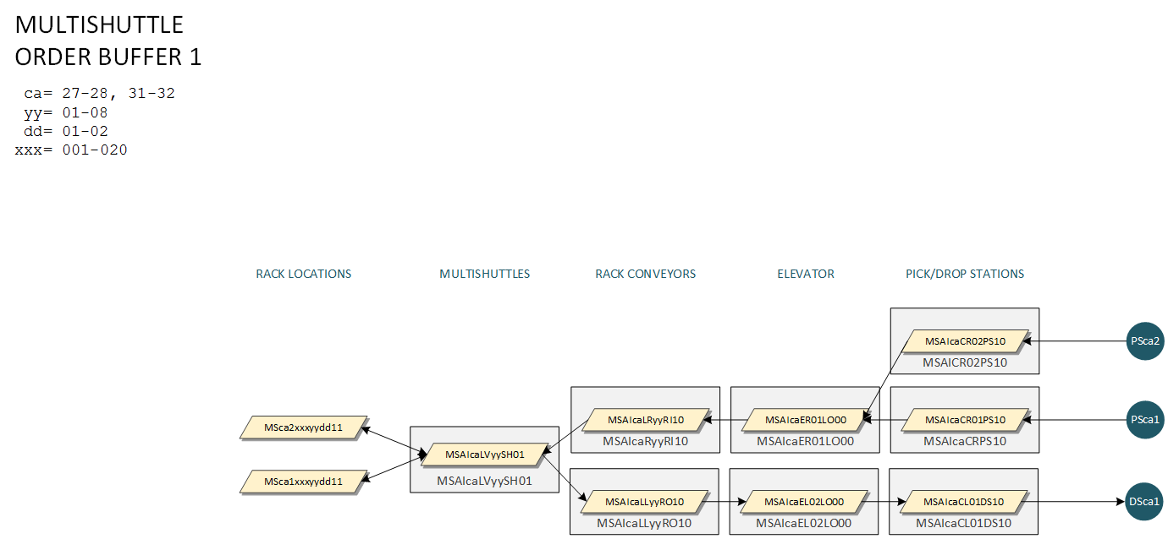

### Aisles 29-30

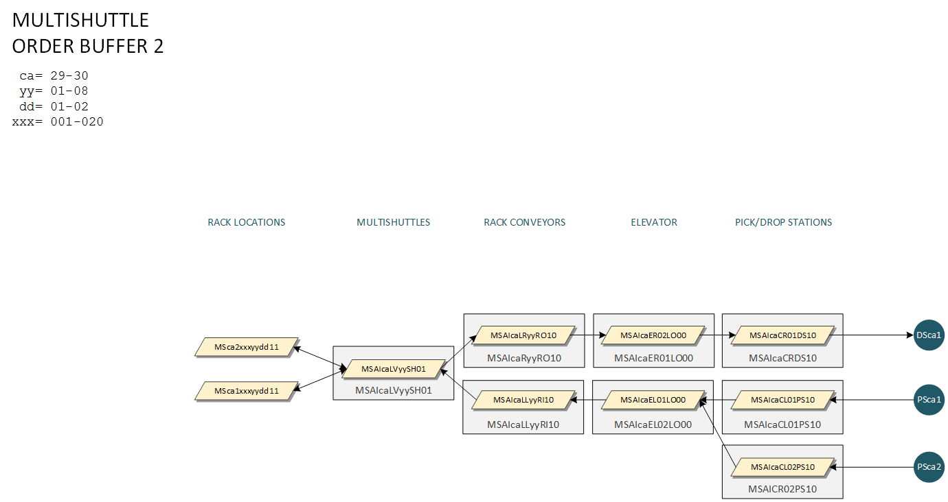

## Order Fulfilment

### Carton Induction

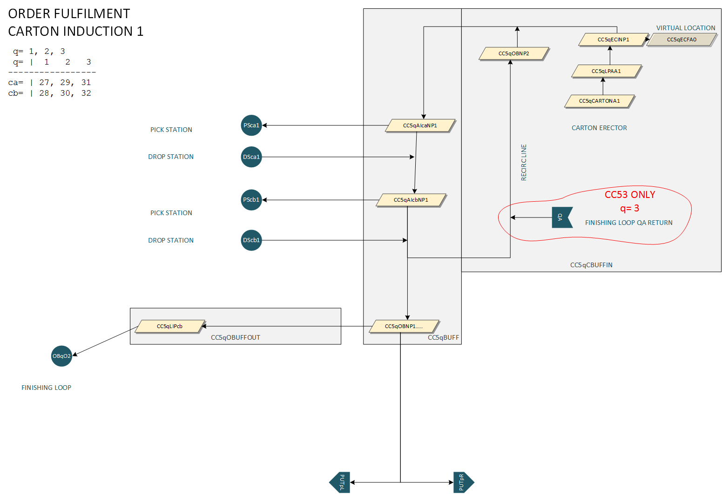

### Inbound 1

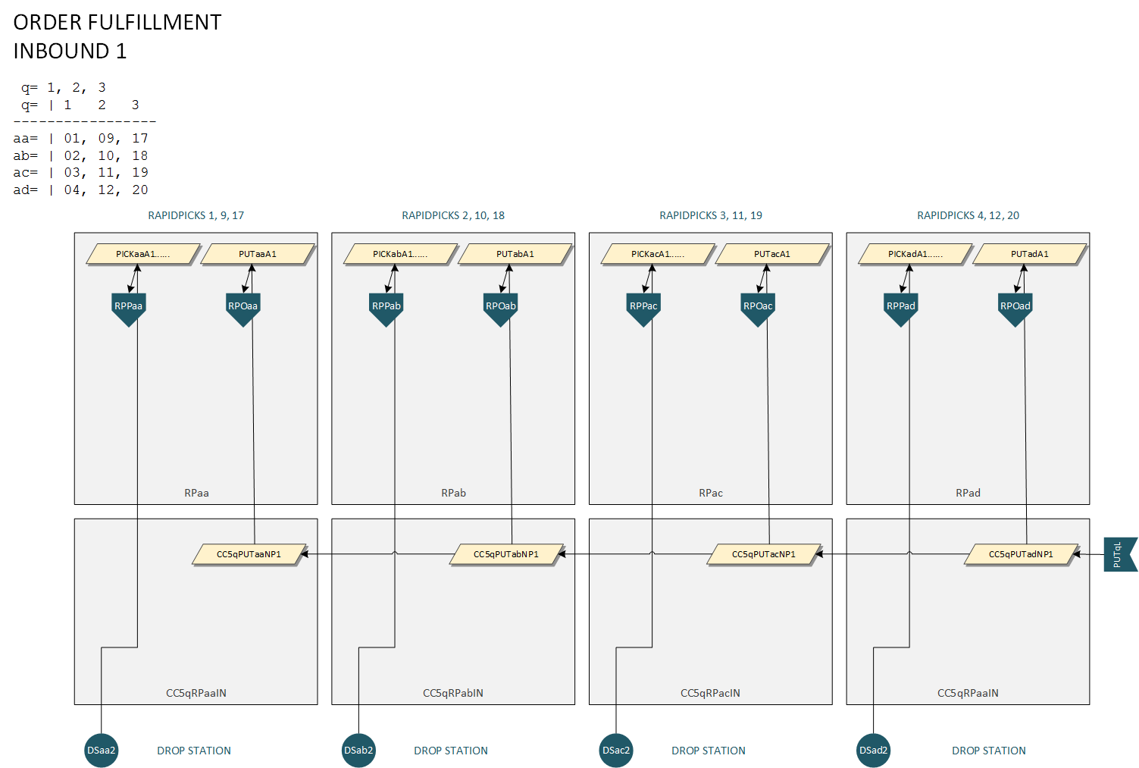

### Inbound 2

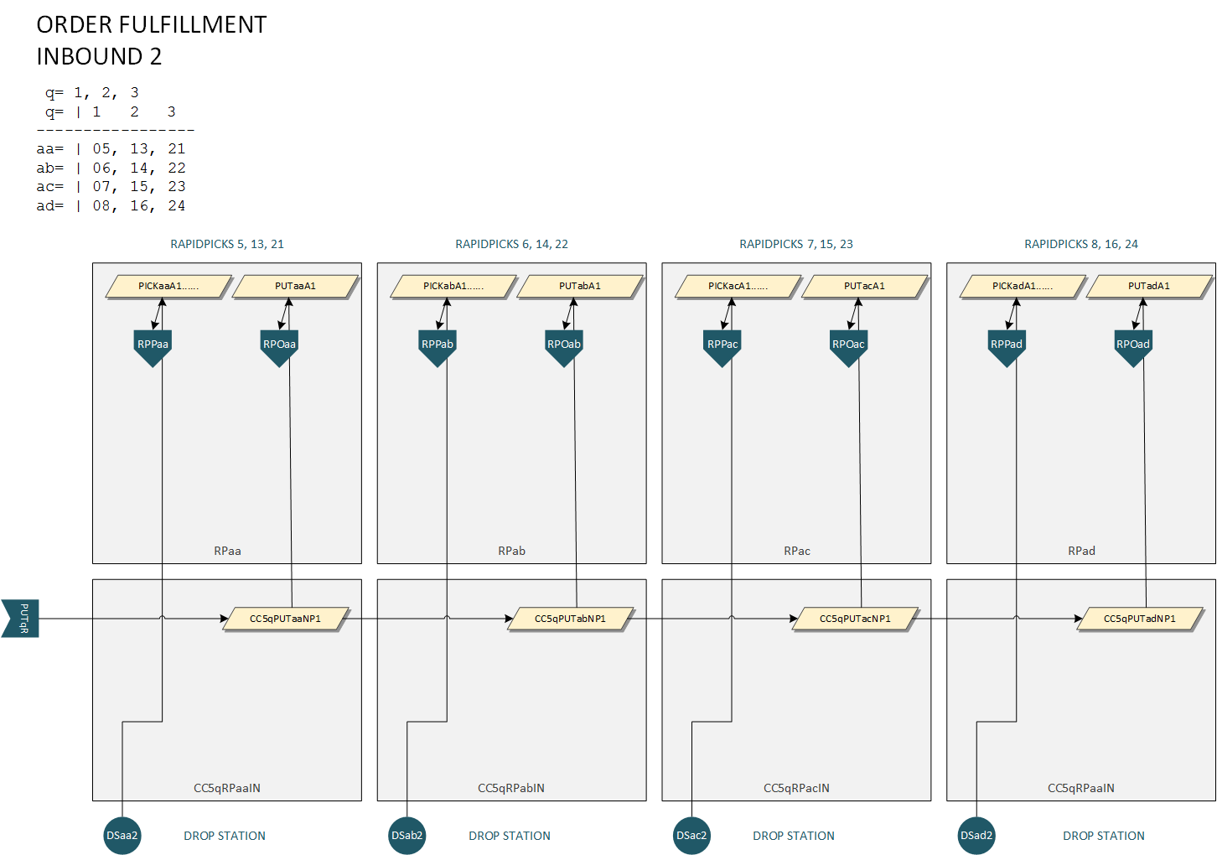

### Outbound 1

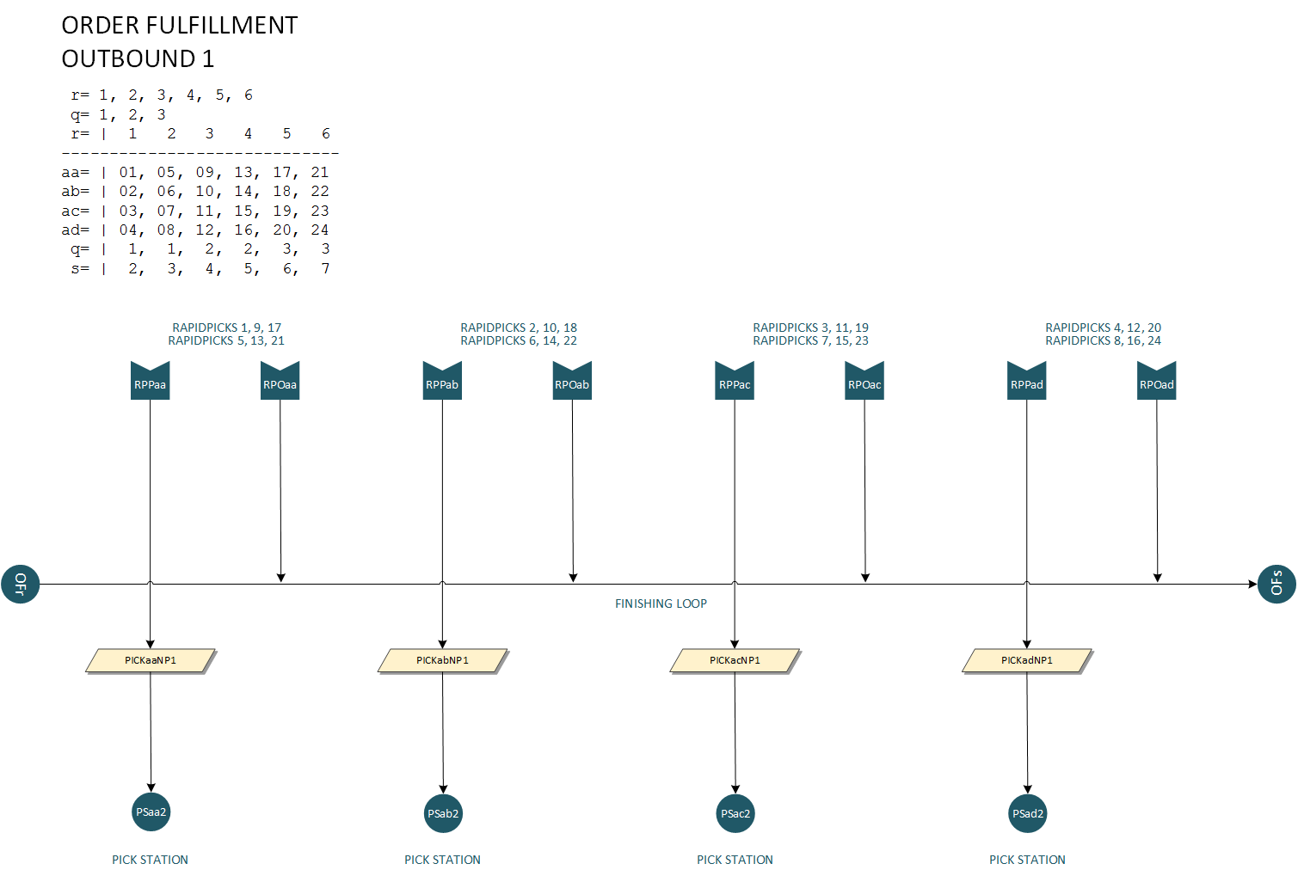

### Finishing Return 1

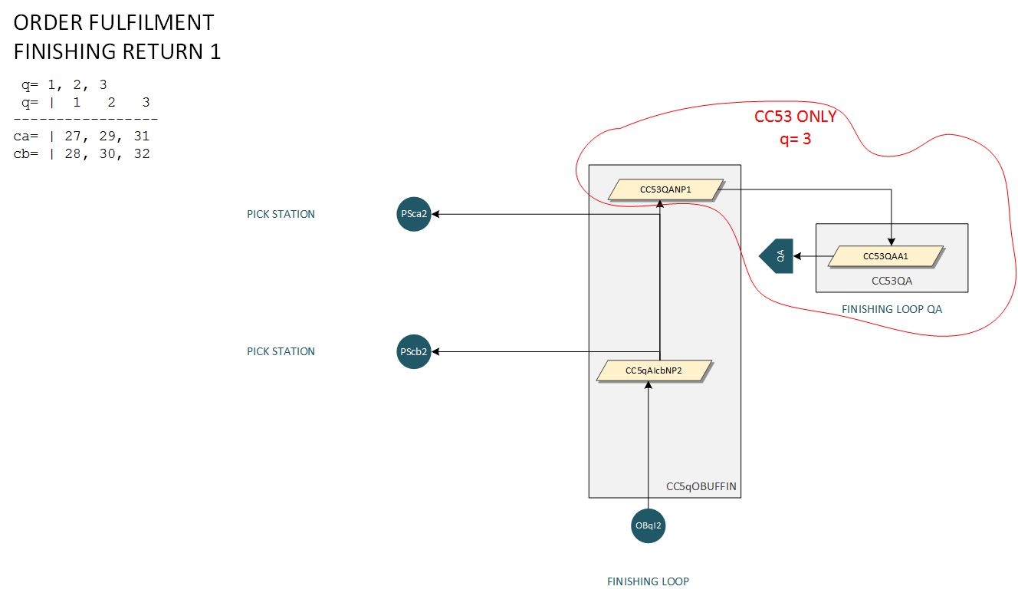

## Multishuttle (Product)

### Product 1

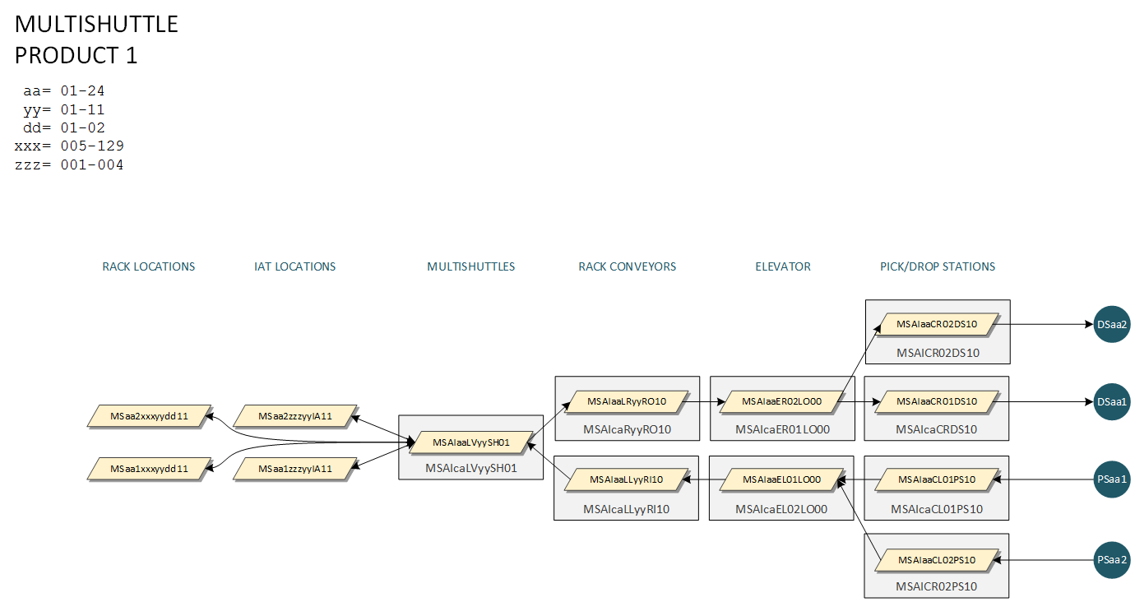

## Finishing

### Finishing Loop

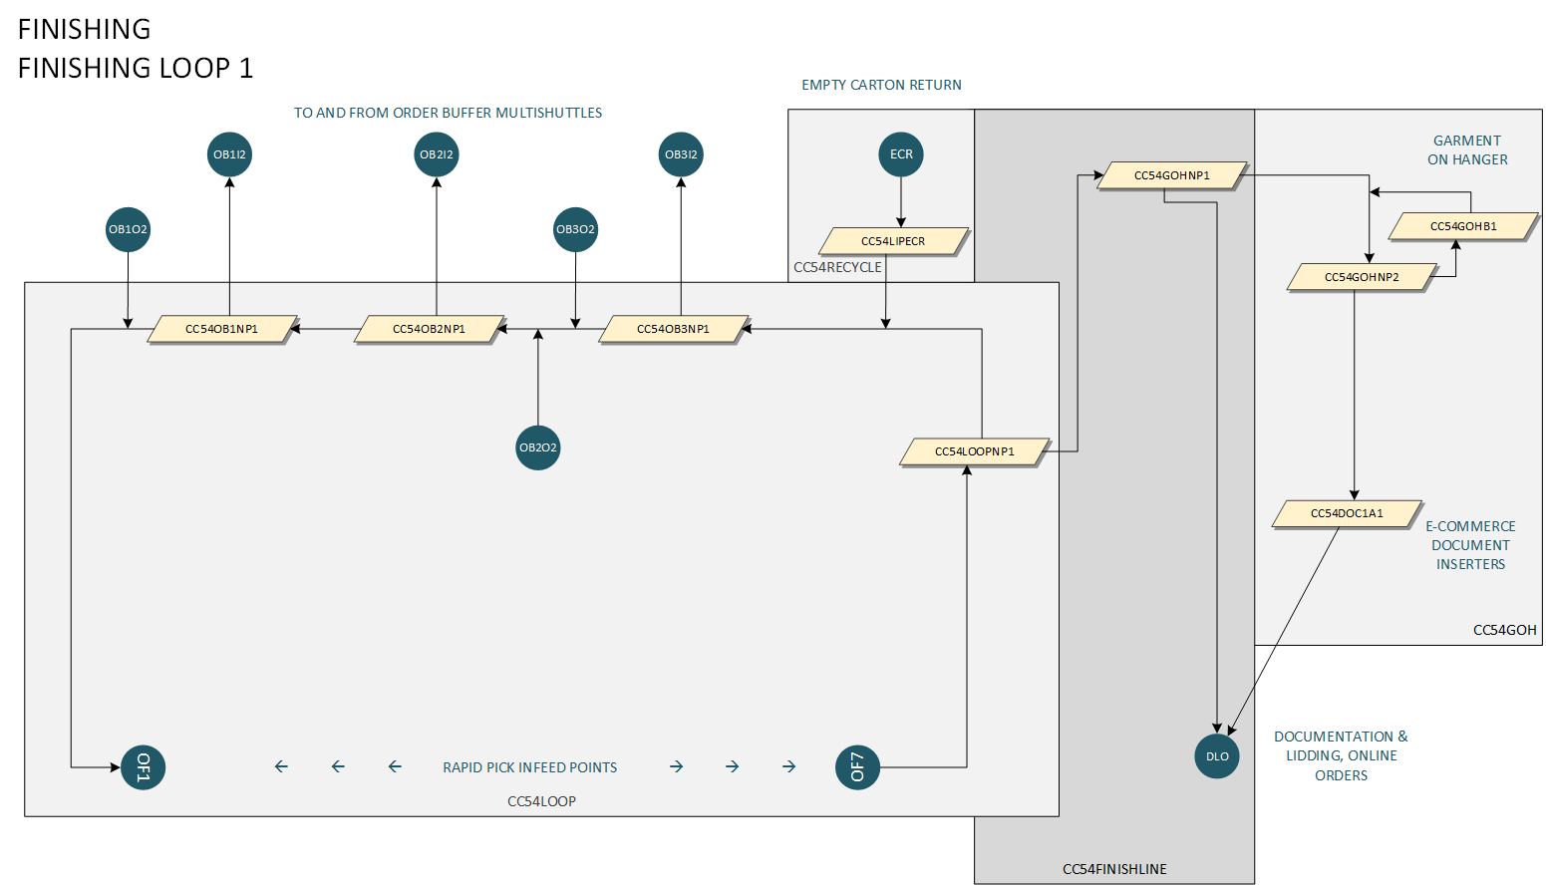

## Documentation & Lidding

### Online Orders, Document Insertion & QA 1

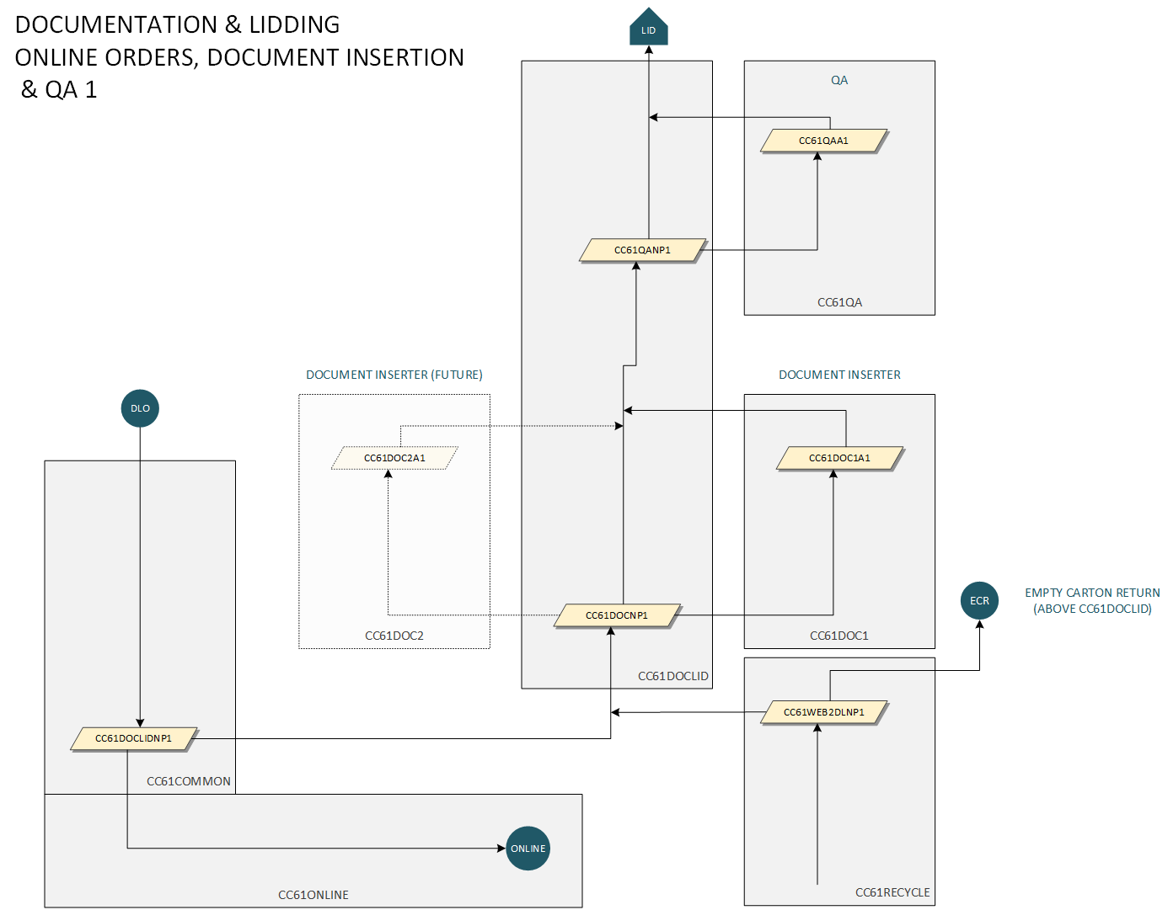

### Lidding & Despatch LPA

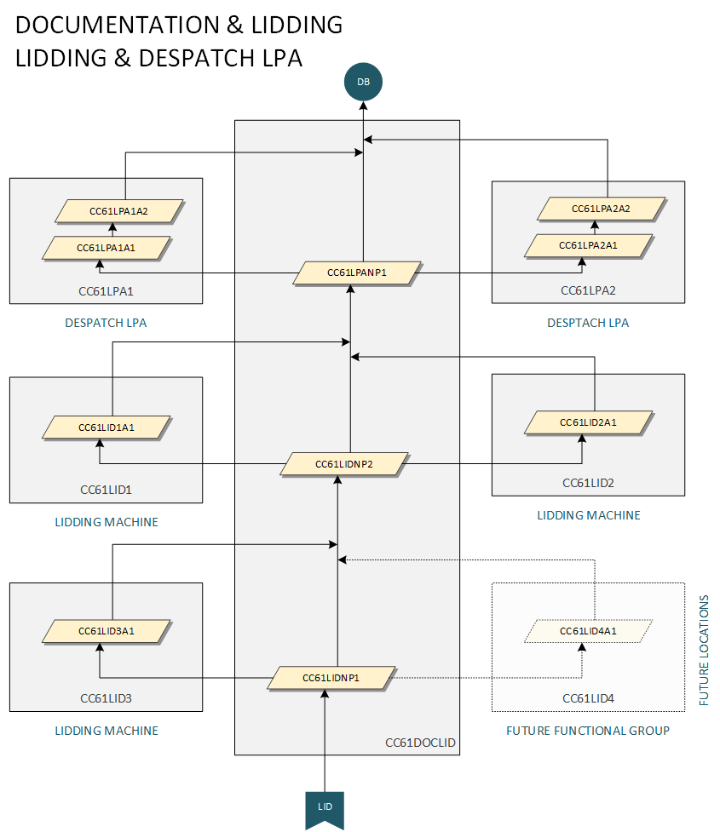

### Online Order Packing

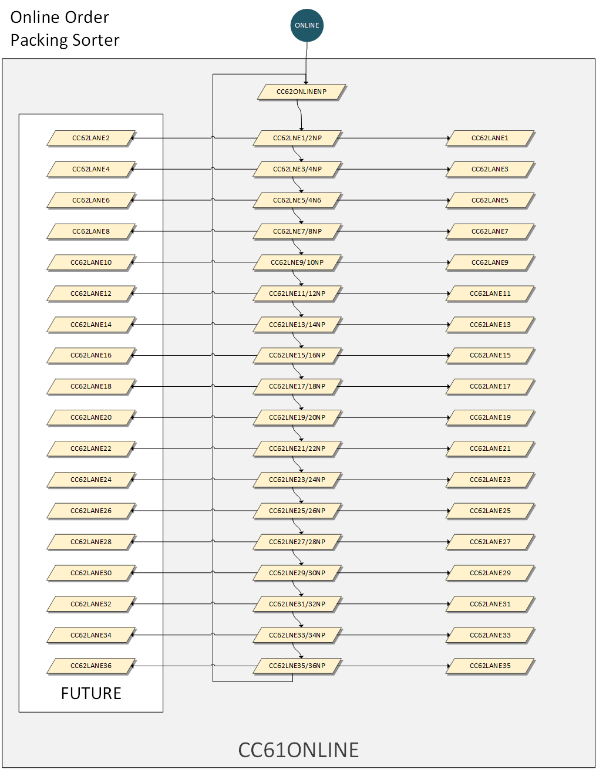

## Sorter

### Despatch Buffer 1

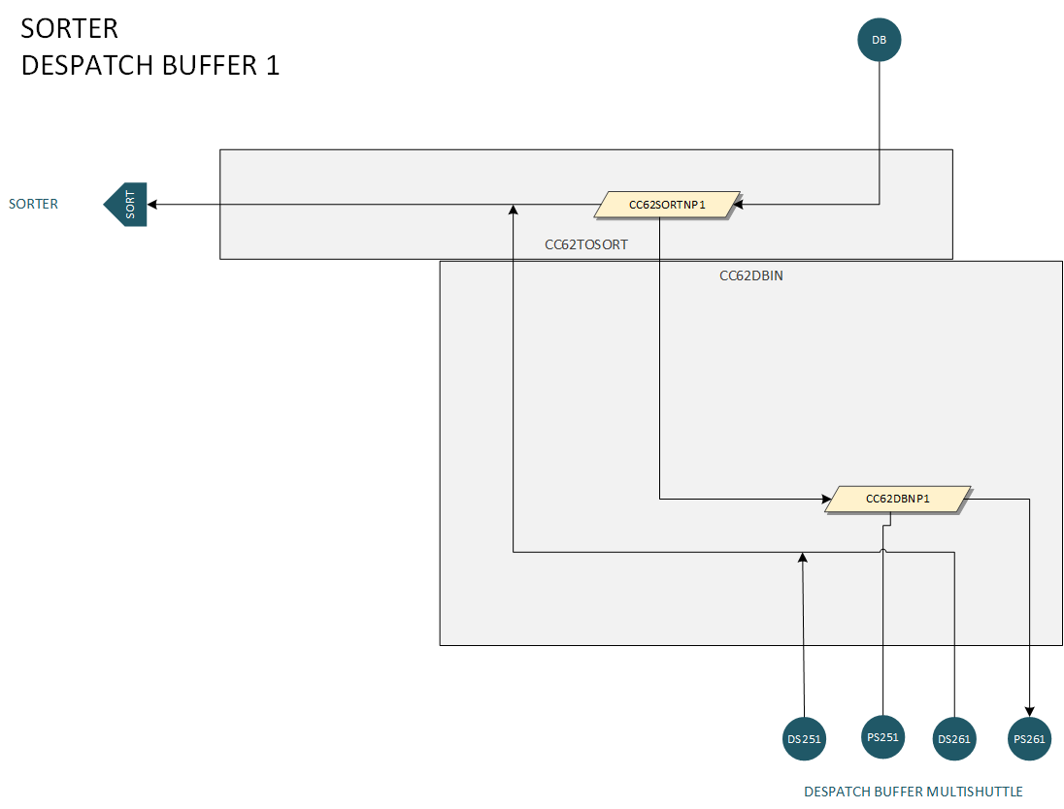

### Sorter 1

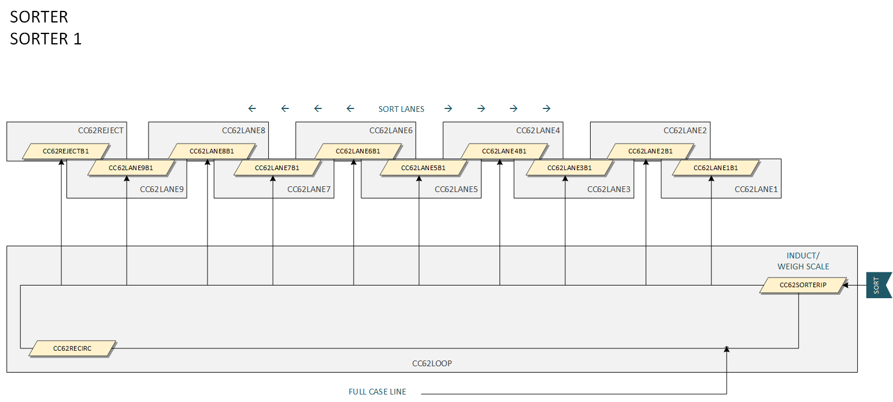

## Multishuttle (Despatch Buffer)

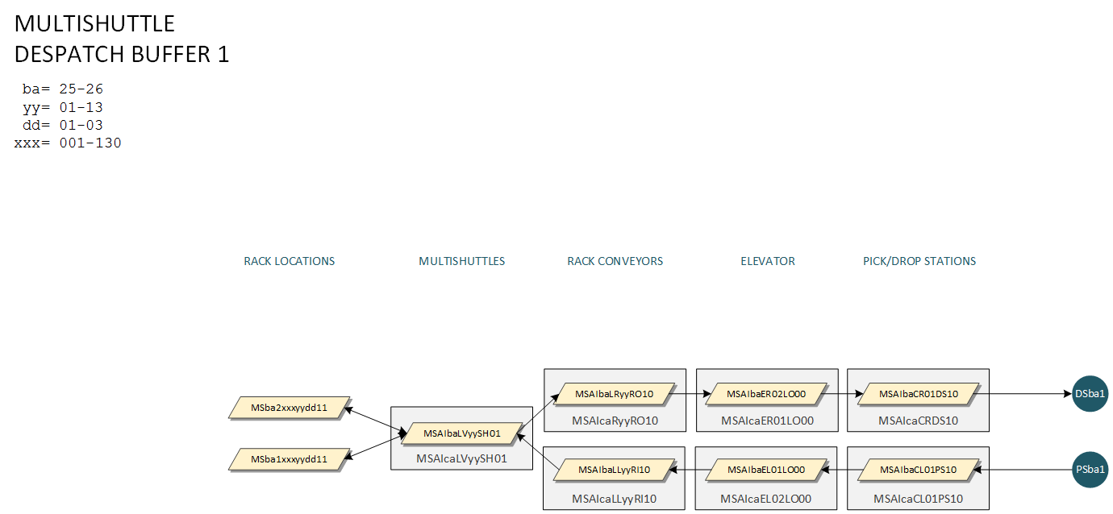

## Decant

